**Contains Duplicate**

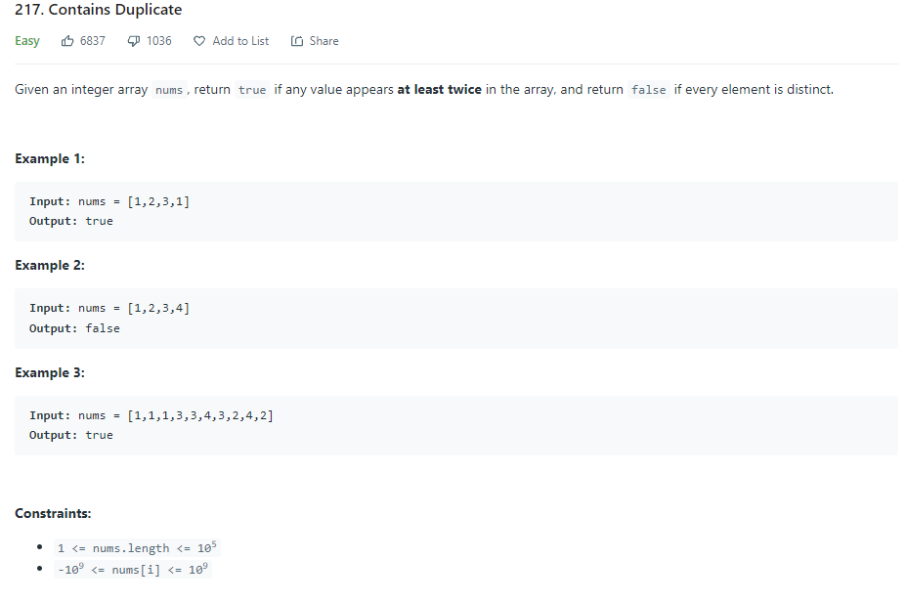

def containsDuplicate(self, nums: List[int]) -> bool:

hashset = set()

for n in nums:

if n in hashset:

return True

hashset.add(n)

return False

Iterate through array of integers and add each integer to hashset. If integer is already present in hashset, you know there is a duplicate and return false

def containsDuplicate(self, nums: List[int]) -> bool:

return len(nums) != len(set(nums))

Use Set constructor to create a set from the array, if lengths are not the same you know there was a duplicate in array

**Valid Anagram**

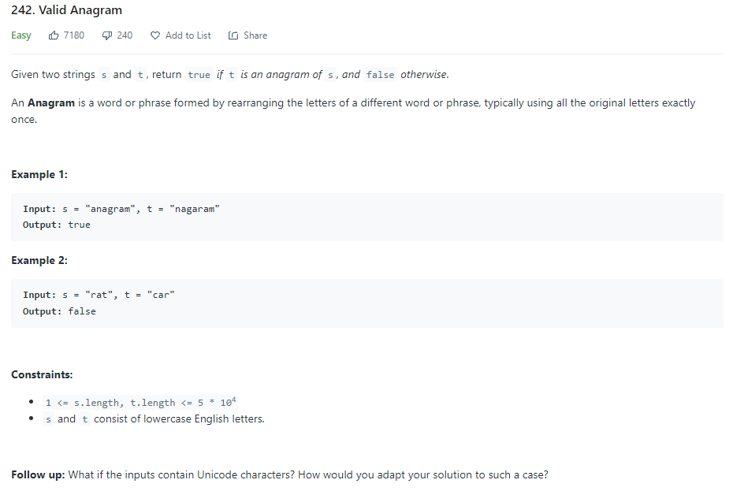

def isAnagram(self, s: str, t: str) -> bool:

if len(s) != len(t):

return False

countS = {}

countT = {}

for i in range(len(s)):

countS[s[i]] = 1 + countS.get(s[i], 0)

countT[t[i]] = 1 + countT.get(t[i], 0)

for c in countS:

if countS[c] != countT.get(c, 0):

return False

return True

Create hashmap for each string, with KEY being character and VALUE being the count. Compare the two hashmaps to determine if each has the same exact characters. (can also just use Counter method in python)

def isAnagram(self, s: str, t: str) -> bool:

return sorted(s) == sorted(t)

Use pythons built-in sorted method to sort the two strings into array of characters in order and confirm they are the exact same arrays.

**Two Sum**

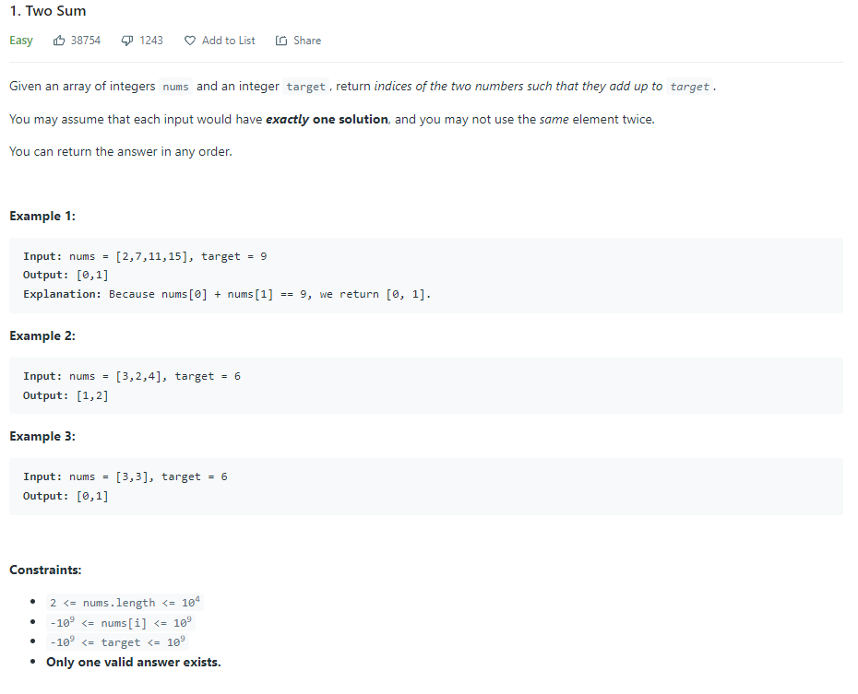

def twoSum(self, nums: List[int], target: int) -> List[int]:

hashmap = {} # val : index

for i, n in enumerate(nums):

diff = target - n

if diff in hashmap:

return [hashmap[diff], i]

hashmap[n] = i

Create hashmap with KEY being element in nums, VALUE being index. Because we know there is always only 1 solution, find the difference between target and n for each n in nums. If that difference is in hashmap, return the indexes of n and difference (in hashmap)

* Example work shown on paper

**Group Anagrams**

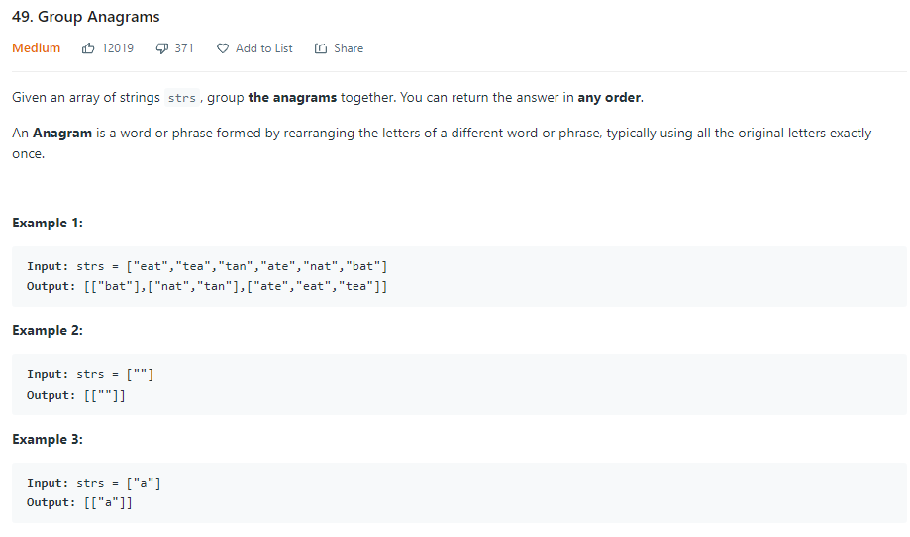

def groupAnagrams(self, strs: List[str]) -> List[List[str]]:

result = defaultdict(list) # mapping charCount to list of Anagrams

for s in strs:

count = [0] * 26 # counting each character count

for c in s:

count[ord(c) - ord("a")] += 1 # ord function returns integer ASCII value of character

result[tuple(count)].append(s) # tuple because cant use list as key

return result.values() # O(m*n), values() returns a list of all values available in given dictionary

For each string in the array, create a counting array that counts number of occurrences of each letter. Then, use a tuple of the count of each character (1,0,0,0,1,0,0,0,0,0,0,0,0,0,0,0,0,0,0,1,0,0,0,0,0,0 example for EAT, ATE, TEA) as the key in result list and append the string there. Return the VALUES of dictionary (strings that are values in key/value pairs)

* Example work shown on paper

**Top K Frequent Elements**

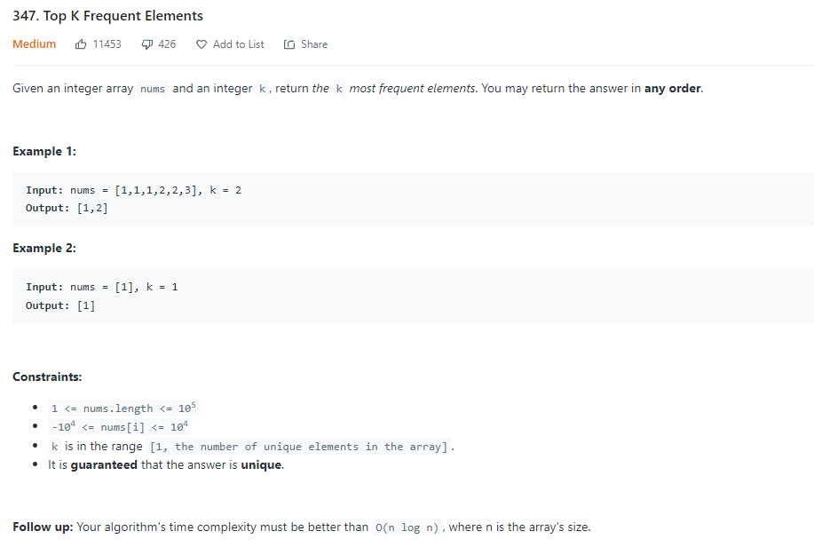

def topKFrequent(self, nums: List[int], k: int) -> List[int]:

count = {}

freq = [[] for i in range(len(nums) + 1)]

for n in nums:

count[n] = 1 + count.get(n, 0) # if n doesnt already exist, give it default value 0

for n, c in count.items():

freq[c].append(n)

result = []

for i in range(len(freq)-1, 0, -1): # for length of frequency - 1(last index), go up until 0 and decrement 1)

for n in freq[i]:

result.append(n)

if len(result) == k:

return result

Create hashmap to count occurrences of each value. Create frequency array, index is frequency and value is list of values that occur that number of times. Go through input array nums and count number of occurrences. Get key/value pair of dictionary in count and append the n (value) to freq array at index c (count of n). go through freq array in descending order (start with numbers that occur most frequently) and add to result array until you have k numbers to return

**Product of Array Except Self**

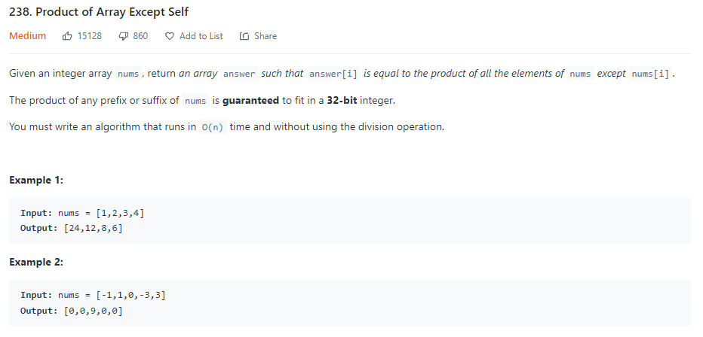

def productExceptSelf(self, nums: List[int]) -> List[int]:

res = [1] * (len(nums))

prefix = 1

for i in range(len(nums)):

res[i] = prefix

prefix *= nums[i]

postfix = 1

for i in range(len(nums) - 1, -1, -1):

res[i] *= postfix

postfix *= nums[i]

return res

initialize result array with n length and set each value to 1. Set prefix to 1, and go through for each i in length of input array nums, update the result array position for the prefix (product of all numbers before that position). Then, do the same for postfixes for product of numbers after that position, but this time update result array indexes by combining the prefixes and postfixes.

**Valid Sudoku**

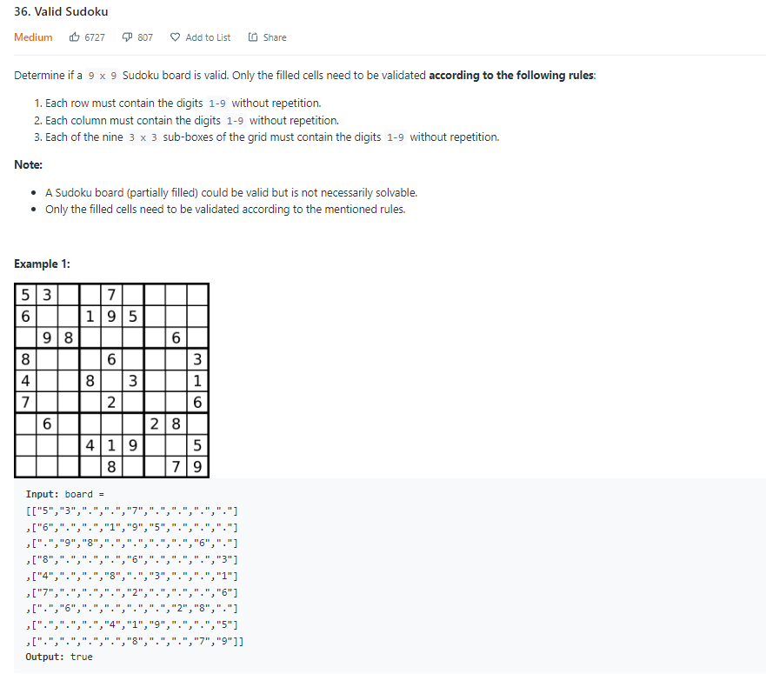

def isValidSudoku(self, board: List[List[str]]) -> bool:

for i in range(9):

row = board[i]

hashset = set()

counter = 0

for j in row:

if j != '.':

hashset.add(j)

counter += 1

#print("counter = ", counter)

#print("j =", j)

if counter != len(hashset):

return False

# Checking if every column is valid

for i in range(9):

column = []

for j in range(9):

column.append(board[j][i])

hashset = set()

counter = 0

for num in column:

if num != '.':

hashset.add(num)

counter += 1

if counter != len(hashset):

return False

# Checking if every box is valid

xaxis = 0

yaxis = 0

boxcounter = 0

while boxcounter < 9:

#while xaxis <= 8:

if yaxis == 9:

yaxis = 0

xaxis += 3

box = []

while len(box) < 9:

for i in range(xaxis, xaxis+3):

for j in range(yaxis, yaxis+3):

print([i, j])

box.append(board[j][i])

print(box)

hashset = set()

counter = 0

boxcounter += 1

yaxis += 3

for num in box:

if num != '.':

hashset.add(num)

counter += 1

if counter != len(hashset):

return False

return True

My Solution: Go through each row, column, and box and use hashsets to determine if there are any duplicate values in each respective row, column, or box. If there are, return false.

def isValidSudoku(self, board: List[List[str]]) -> bool:

columns = collections.defaultdict(set)

rows = collections.defaultdict(set)

boxes = collections.defaultdict(set)

for row in range(9):

for column in range(9):

if board[row][column] == ".":

continue

if (board[row][column] in rows[r] or

board[row][column] in columns[c] or

board[row][column] in boxes[(row // 3, column // 3)]):

return False

columns[column].add(board[row][column])

rows[row].add(board[row][column])

boxes[(row // 3, column // 3)].add(board[row][column])

return True

NeetCode Solution: Same theory, but much quicker and uses less memory.

**Longest Consecutive Sequence**

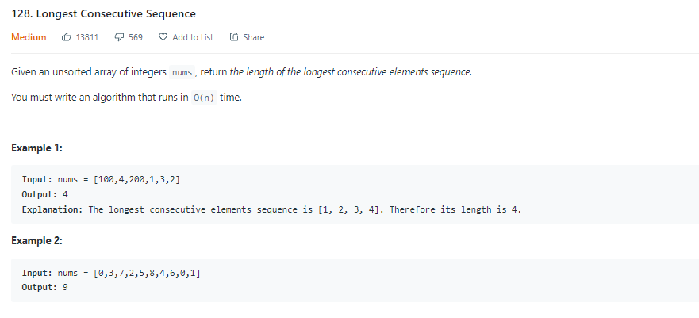

def longestConsecutive(self, nums: List[int]) -> int:

numSet = set(nums)

longest = 0

for n in nums:

# check if n is start of a sequence (if n-1 does not exist)

if (n-1) not in numSet:

length = 0

while (n + length) in numSet:

length += 1

longest = max(length, longest)

return longest

Turn unsorted array into a set. Find numbers in array that are the start of a sequence. See how long that sequence is and keep track of which sequence is the longest.

**Valid Palindrome**

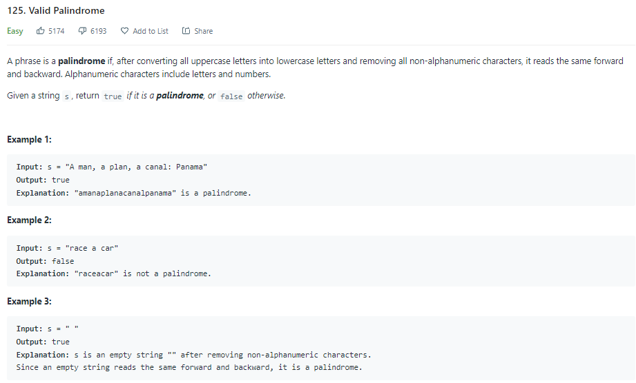

def isPalindrome(self, s: str) -> bool:

string = ""

for letter in s:

if letter.isalpha() or letter.isnumeric():

string += letter.lower()

print(string)

left = 0

right = len(string)-1

while left < right:

if string[left] != string[right]:

return False

left += 1

right -= 1

return True

Simplify string to only letters and numbers. Create two pointers, one starting at beginning of string and other starting at end of string. While left pointer index is less than right pointer index, keep checking to make sure corresponding letters are equal. If not, return false.

**Two Sum II – Input Array is Sorted**

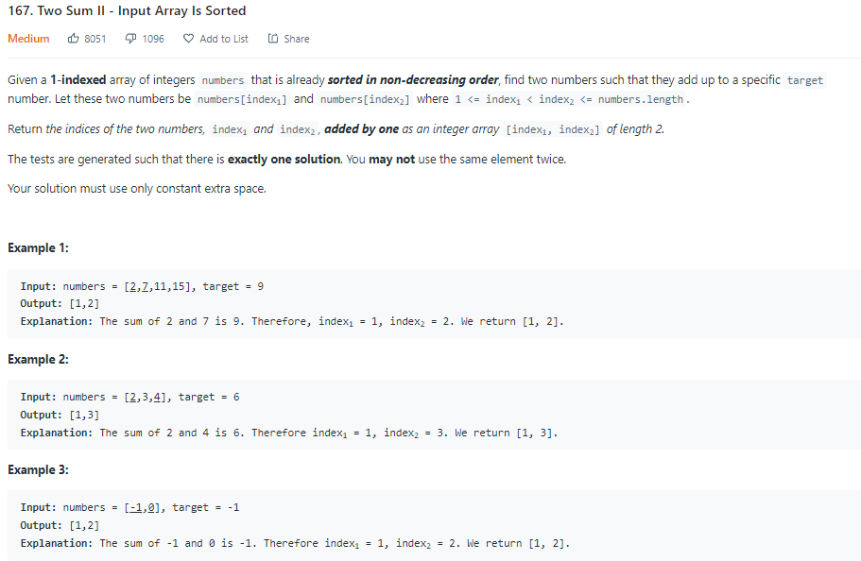

def twoSum(self, numbers: List[int], target: int) -> List[int]:

l, r = 0, len(numbers)-1

while l < r:

if numbers[l] + numbers[r] == target:

return [l+1, r+1]

elif numbers[l] + numbers[r] > target:

r -= 1

else:

l += 1

Because array is sorted, we can use two pointers, and move to the left or right in array depending on sum compared to target until you find the two numbers that add up to target

**3Sum**

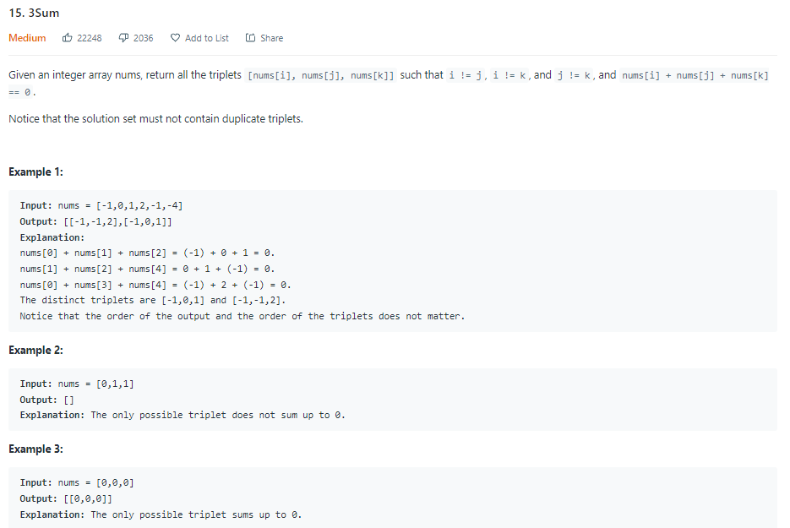

def threeSum(self, nums: List[int]) -> List[List[int]]:

result = []

nums.sort()

for i, a in enumerate(nums):

if i > 0 and a == nums[i - 1]: # checks if value is same as the previous (we dont want to reuse values)

continue

l, r = i+1, len(nums)-1

while l < r:

threeSum = a + nums[l] + nums[r]

if threeSum > 0:

r -= 1

elif threeSum < 0:

l += 1

else:

result.append([a, nums[l], nums[r]])

l += 1

while nums[l] == nums[l-1] and l < r:

l += 1

return result

Sort the array first. Then, find first value and then use Two Sum Pointer method to find other values in sets.

**Container With Most Water**

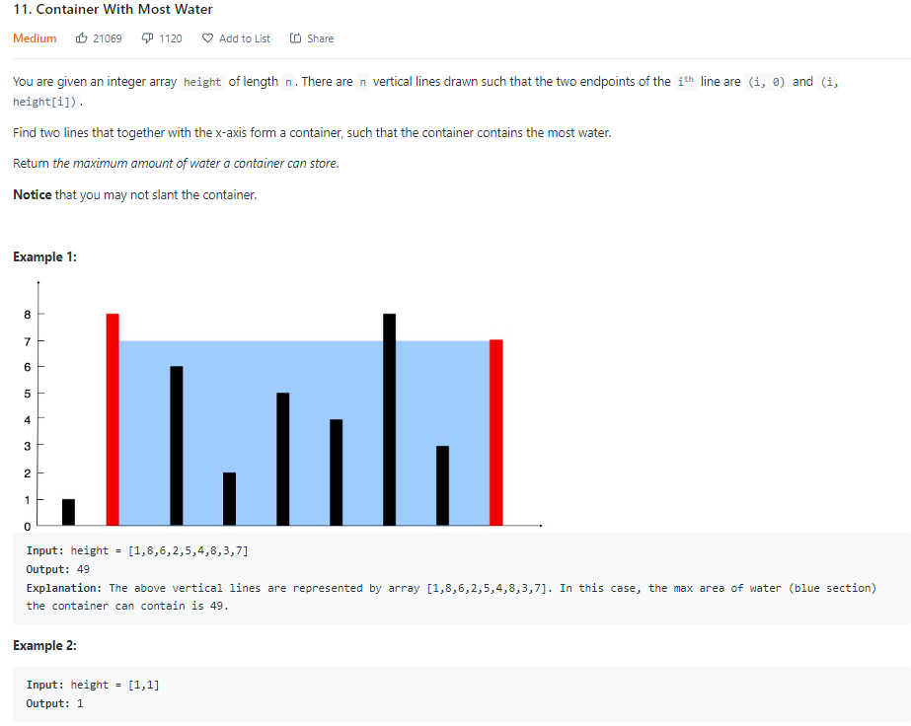

def maxArea(self, height: List[int]) -> int:

result = 0

l, r = 0, len(height)-1

while l < r:

area = (r-l) * min(height[l], height[r])

result = max(result, area)

if height[l] < height[r]:

l += 1

elif height[1] > height[r]:

r -= 1

else:

r -= 1

return result

Use left and right pointer, find the area of the two heights and then move left pointer to right if left height is smaller than right height, and vice versa until all heights are checked. Two pointer solution here is O(n) whereas a brute force of all combinations would have been O(n^2)

**Trapping Rain Water**

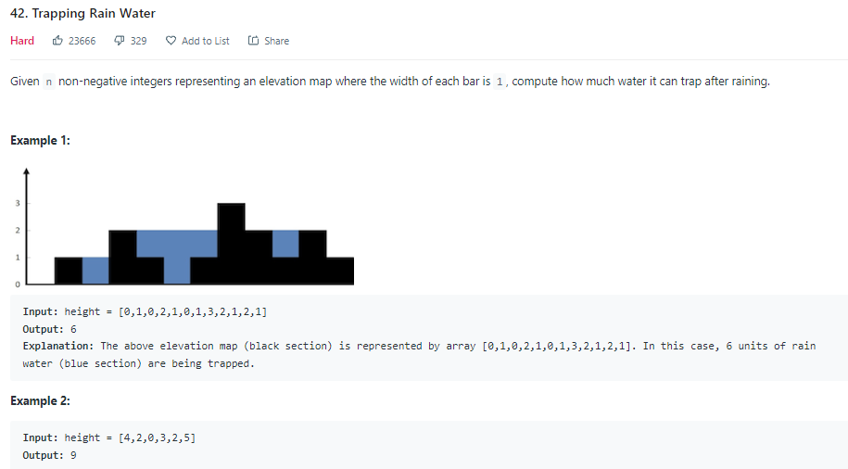

def trap(self, height: List[int]) -> int:

if not height:

return 0

result = 0

l, r = 0, len(height)-1

maxL, maxR = height[l], height[r]

while l < r:

if maxL < maxR:

l += 1

maxL = max(maxL, height[l])

result += maxL - height[l]

else:

r -= 1

maxR = max(maxR, height[r])

result += maxR - height[r]

return result

Go through array with two pointers, and save the highest left and right value that has been found thus far. At each element of height array, subtract the height from the max of the edges to get amount of water held at each element spot. 2 pointer system ensures heights of each side are close/even.

Time complexity is O(n) and memory complexity is O(1) for this algorithm

**Best Time to Buy and Sell Stock**

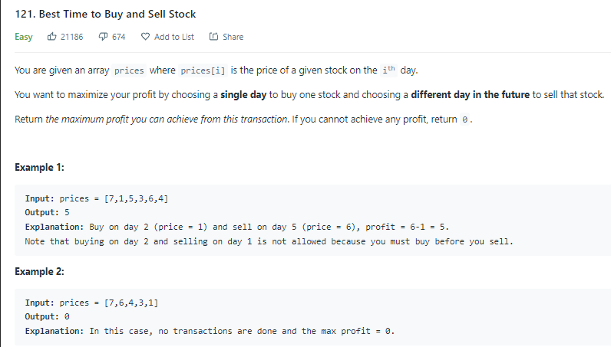

def maxProfit(self, prices: List[int]) -> int:

result = 0

l, r = 0, 1 # l = buy, r = sell

while r < len(prices):

if prices[l] < prices[r]:

profit = prices[r]-prices[l]

result = max(result, profit)

else:

l = r

r += 1

return result

Use two pointers, starting at index 0 and index 1, and for each price in array, if prices[l] is less than prices[r], update the result to be the maximum of result and prices[r]-prices[l]. If it is not less than, move the l pointer up to where r is. Always move r pointer to right by 1 each iteration of loop.

**Longest Substring Without Repeating Characters**

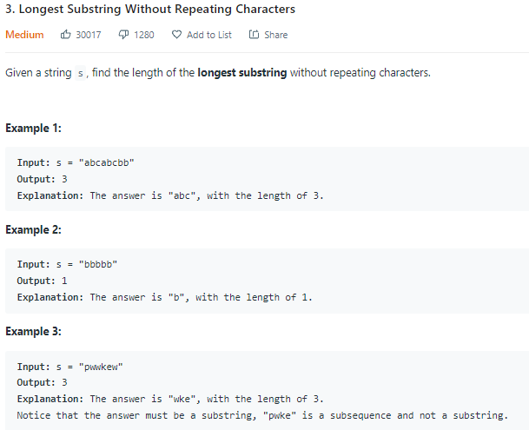

def lengthOfLongestSubstring(self, s: str) -> int:

substring = set()

l = 0

result = 0

for r in range(len(s)):

while s[r] in substring:

substring.remove(s[l])

l += 1

substring.add(s[r])

result = max(result, r - l + 1)

return result

Sliding Window Technique which moves two pointers and uses a set to ensure no duplicates. If the letter is not in set, add it to the set and then update the result to be the maximum of the current result and the length of the current window (r-l-1). If letter is in the substring, remove it and then move the left pointer to the right one.

**Longest Repeating Character Replacement**

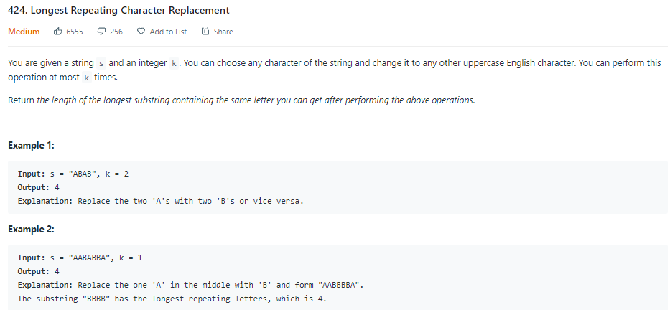

def characterReplacement(self, s: str, k: int) -> int:

count = {}

result = 0

l = 0

for r in range(len(s)):

count[s[r]] = 1 + count.get(s[r], 0)

while (r-l+1) - max(count.values()) > k:

count[s[l]] -= 1

l += 1

result = max(result, r-l+1) # r-l+1 is always length of window in sliding window problems

return result

Use a hashmap to keep track of counts of each character in string. Use sliding window technique and increase window size if window size minus the count of most frequent character is less than K.

def characterReplacement(self, s: str, k: int) -> int:

count = {}

res = 0

l = 0

maxf = 0

for r in range(len(s)):

count[s[r]] = 1 + count.get(s[r], 0)

maxf = max(maxf, count[s[r]])

if (r - l + 1) - maxf > k:

count[s[l]] -= 1

l += 1

res = max(res, r - l + 1)

return res

Very subtle change that increases runtime slightly but is harder to see and not expected on an interview. Keeping the maximum frequency in a variable makes it so you algorithm no longer needs to go through entire hashmap to find the count of most frequent character.

**Permutation in String**

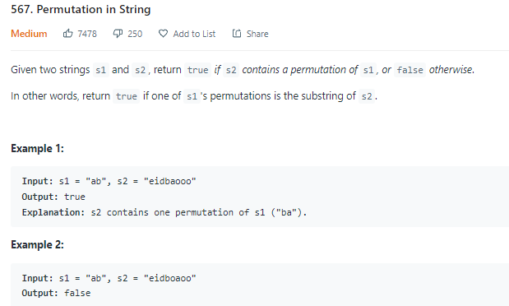

def checkInclusion(self, s1: str, s2: str) -> bool:

if len(s1) > len(s2):

return False

s1Count = [0] * 26

s2Count = [0] * 26

for i in range(len(s1)):

s1Count[ord(s1[i]) - ord("a")] += 1

s2Count[ord(s2[i]) - ord("a")] += 1

matches = 0

for i in range(26):

matches += 1 if s1Count[i] == s2Count[i] else 0

l = 0

for r in range(len(s1), len(s2)):

if matches == 26:

return True

index = ord(s2[r]) - ord("a")

s2Count[index] += 1

if s1Count[index] == s2Count[index]:

matches += 1

elif s1Count[index] + 1 == s2Count[index]:

matches -= 1

index = ord(s2[l]) - ord("a")

s2Count[index] -= 1

if s1Count[index] == s2Count[index]:

matches += 1

elif s1Count[index] - 1 == s2Count[index]:

matches -= 1

l += 1

return matches == 26 # returns true if 26 matches, false otherwise

First, create 2 count arrays to keep track of frequency of each letter a-z. Then, use ord to update the counts of each element in count arrays based on the letter in the strings. Then, use sliding window method and update the count arrays each time you slide window. If at any point you have 26 matches, return True. Else, return False. NOTE: matches variable allows you to store number of matches in an int variable so that you don’t have to compare 2 hashmaps to each other every single iteration of the sliding window loop. This turns time complexity from O(26*n) to O(n). ALSO: Could have used hashmaps instead of count arrays for this problem. (Can try to rewrite it in future with hashmaps instead for more practice)

**Minimum Window Substring**

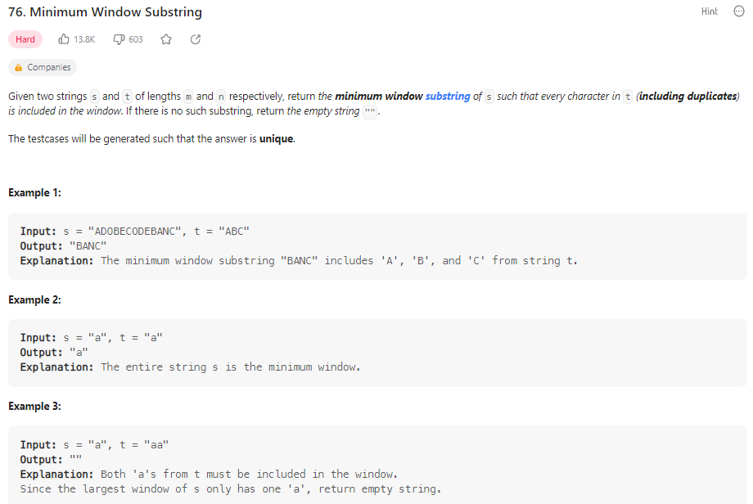

def minWindow(self, s: str, t: str) -> str:

        if t == "":

            return ""

        countT, window = {}, {} # two empty hashmaps

        for c in t:

            countT[c] = 1 + countT.get(c, 0) # if c exists in T, will get value. otherwise use default value of 0

        have, need = 0, len(countT) # countT gives unique characters in t

        res, resLen = [-1, -1], float("infinity") # just initializing both

        l = 0 # left pointer

        for r in range(len(s)):

            c = s[r]

            window[c] = 1 + window.get(c, 0)

            if c in countT and window[c] == countT[c]:

                have += 1

            while have == need:

                # update result

                if (r - l + 1) < resLen: # (r - 1 + 1 = size of window)

                    res = [l, r] # window

                    resLen = (r - l + 1)

                # pop from left of window

                window[s[l]] -= 1 # removes left-most character in window

                if s[l] in countT and window[s[l]] < countT[s[l]]: # will show if character we removed was one that was needed

                    have -= 1

                l += 1 # must shift l by 1 since we removed character from window

        l, r = res

        return s[l:r+1] if resLen != float("infinity") else ""

Create two empty hashmaps keeping the count of characters in T and the count of characters in the current window. Fill the countT hashmap with count. Store two variables, have = 0 to show how many matching characters window has with count, and need = length of count. Go through the string S and add each new character to window. If it was needed in count and there are now the correct number of that character in window, increase have by 1. While have == need, if the window is shorter than current longest window found (starts infinity), update result and result length. Then remove the left most character and keep going to try to find shorter window that meets conditions.

**Sliding Window Maximum**

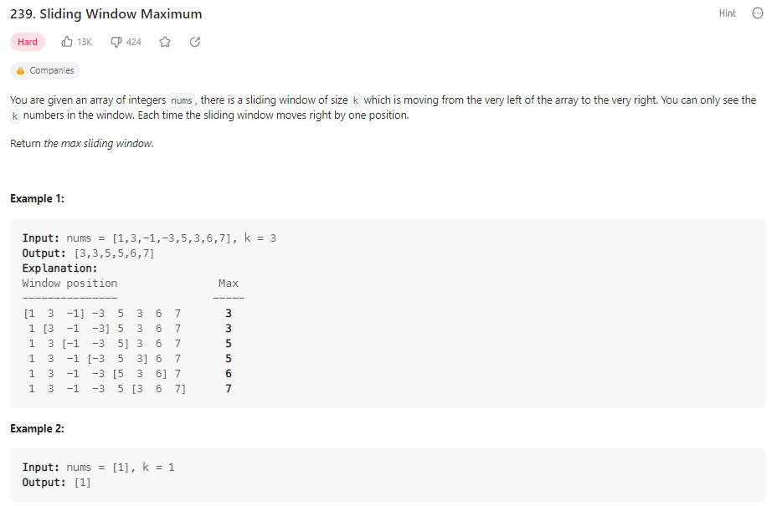

    def maxSlidingWindow(self, nums: List[int], k: int) -> List[int]:

        output = []

        q = collections.deque() # creates a queue that contains indices

        l = r = 0

        while r < len(nums):

            # pop smaller values from q

            while q and nums[q[-1]] < nums[r]: # while q is not empty and right-most value is less than one we are inserting

                q.pop()

            q.append(r)

            # remove left value from window

            if l > q[0]:

                q.popleft()

            if (r + 1) >= k:

                output.append(nums[q[0]])

                l += 1

            r += 1

        return output

Create empty output array. Create a queue using python’s deque (doubly ended queue). Set left and right pointers to 0. Add first value of nums to queue. Go through nums and update the deque so that largest number stays. Then add it to output. O(n)

def maxSlidingWindow(self, nums: List[int], k: int) -> List[int]:

        output = []

        l, r = 0, k-1

        while r < len(nums):

            window = [nums[l:r+1]]

            maximum = max(window)

            output.append(maximum)

            l += 1

            r += 1

        return output

BRUTE FORCE: Go through each window, find the max and add it to output. Time complexity is worse - O(K * (n-k))

**Valid Parentheses**

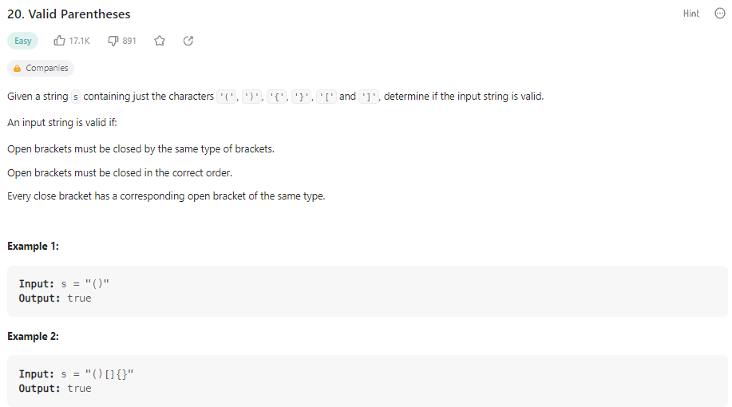

    def isValid(self, s: str) -> bool:

        stack = [] # just a list in python

        closeToOpen = {")" : "(", "}" : "{", "]" : "["} # hashmap to map closed brackets to open brackets, keys are the closing brackets

        for c in s:

            if c in closeToOpen: # if c is a closed bracket

                if stack and stack[-1] == closeToOpen[c]: # if stack is not empty (close cant be first), and the last in stack is corresponding open

                    stack.pop()

                else:

                    return False

            else:

                stack.append(c) # can add any open brackets

        return True if not stack else False

Create an empty stack (list in python). Create a hashmap to map the closed brackets to open brackets (keys of hashmap are the closing brackets, values are open brackets). Go through each character in the input string. If character is a close bracket, make sure that it is not the first in the stack and that the current last character of stack is corresponding open bracket. If so, pop that open bracket and move on. If not, return false. If the character is an open bracket, add it to stack. At the end, return true if the stack is empty, otherwise return false.

**Min Stack**

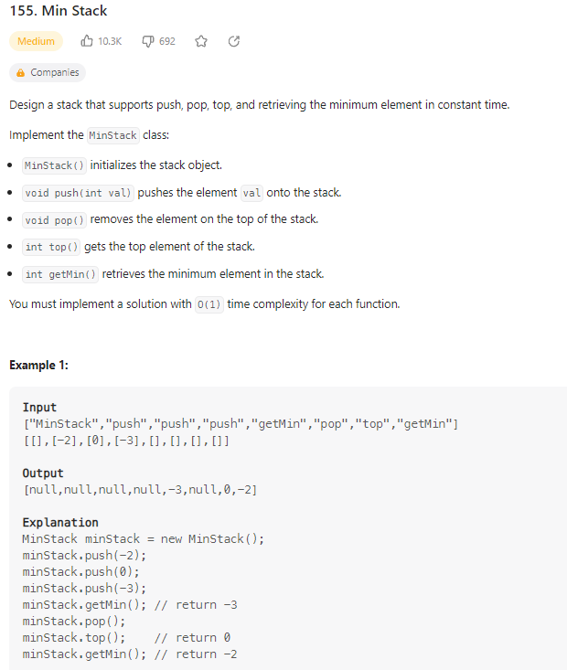

class MinStack:

    def __init__(self):

        self.stack = []

        self.minStack = []

    def push(self, val: int) -> None:

        self.stack.append(val)

        val = min(val, self.minStack[-1] if self.minStack else val)

        self.minStack.append(val)

    def pop(self) -> None:

        self.stack.pop()

        self.minStack.pop()

    def top(self) -> int:

        return self.stack[-1]

    def getMin(self) -> int:

        return self.minStack[-1]

Constructor creates two stacks (lists in python). One for the stack, and one to keep track of the minimum value at all indices of the stack. (So that getMin() can be run in O(1) time without having to go through the entire stack). Push appends value to stack and also appends the minimum of val and current top of minstack to update minStack. Pop() just pops (removes) top value of each stack. Top() returns top value on stack. getMin() returns top value on minStack.

**Evaluate Reverse Polish Notation**

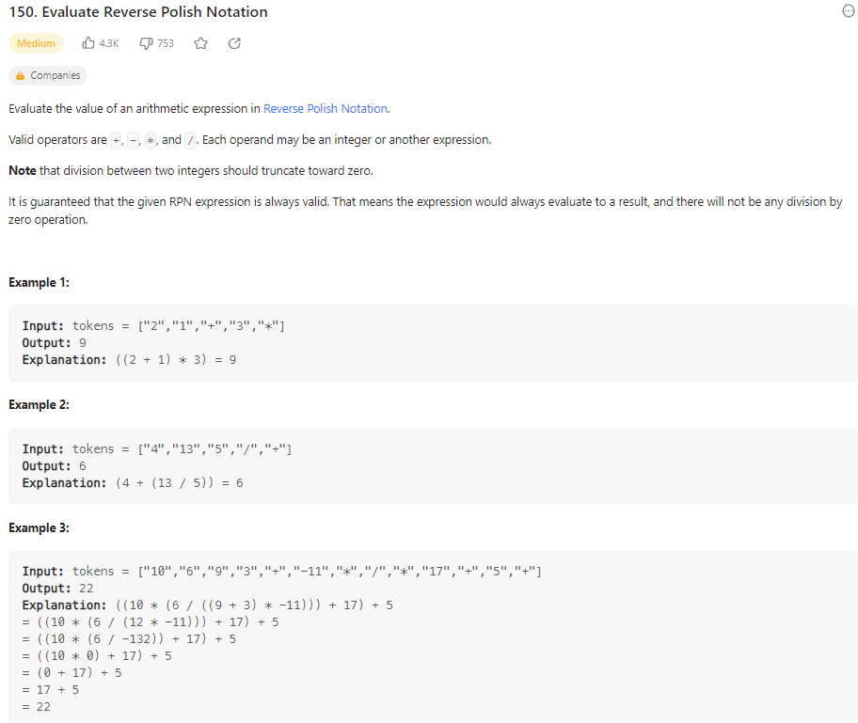

    def evalRPN(self, tokens: List[str]) -> int:

        stack = []

        for c in tokens:

            if c == "+":

                stack.append(stack.pop() + stack.pop())

            elif c == "-":

                a, b = stack.pop(), stack.pop() # must keep order intact for - and /

                stack.append(b-a)

            elif c == "*":

                stack.append(stack.pop() * stack.pop())

            elif c == "/":

                a, b = stack.pop(), stack.pop() # must keep order intact for - and /

                stack.append(int(b/a)) # int will truncate the float result towards 0

            else:

                stack.append(int(c))

        return stack[0]

Create a stack and go through each character in tokens list. If it is an operator, do appropriate operation between previous two numbers in stack, then replace them both with the result. Return first (and only remaining) number from stack at the end.

def evalRPN(self, tokens: List[str]) -> int:

        stack = []

        operators = ["+", "-", "*", "/"]

        ouput = 0

        for c in tokens:

            if c not in operators:

                stack.append(int(c))

            elif c == "+":

                x = stack[-2] + stack[-1]

                stack.pop()

                stack.pop()

                stack.append(x)

            elif c == "-":

                x = stack[-2] - stack[-1]

                stack.pop()

                stack.pop()

                stack.append(x)

            elif c == "*":

                x = stack[-2] * stack[-1]

                stack.pop()

                stack.pop()

                stack.append(x)

            elif c == "/":

                x = stack[-2] / stack[-1]

                if x < 0:

                    x = ceil(x)

                if x > 0:

                    x = floor(x)

                stack.pop()

                stack.pop()

                stack.append(x)

        return stack[0]

This was my first attempt at problem. Code works, but there is a shorter more concise way to do it (green version above)

**Generate Parentheses**

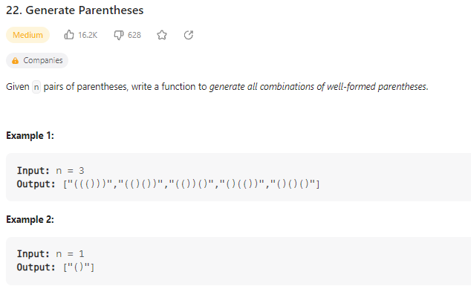

    def generateParenthesis(self, n: int) -> List[str]:

        # Only add open paranthesis if open < n

        # Only add closing paranthesis if closed < open

        # Valid if open == close == n

        stack = []

        result = []

        def generating(openN, closedN):

            if openN == closedN == n:

                result.append("".join(stack))

                return

            if openN < n:

                stack.append("(")

                generating(openN+1, closedN)

                stack.pop()

            if closedN < openN:

                stack.append(")")

                generating(openN, closedN+1)

                stack.pop()

        generating(0,0)

        return result

Recursive function. Create an empty stack and a result array. Define the recursive function (generating) and pass in the openN and closedN values. If number of open = number of closed = n, take the characters of stack, join them to an empty string and append it to result. Then return. (end recursive function). If openN < n, add an open paranthesis to stack, and run it again recursively with updated openN value. Clear the stack. If closedN is less than openN, add a closed paranthesis to stack and then run it again recursively with updated closedN value. Clear the stack. Start by calling function with 0,0 values and return result array.

**Daily Temperatures**

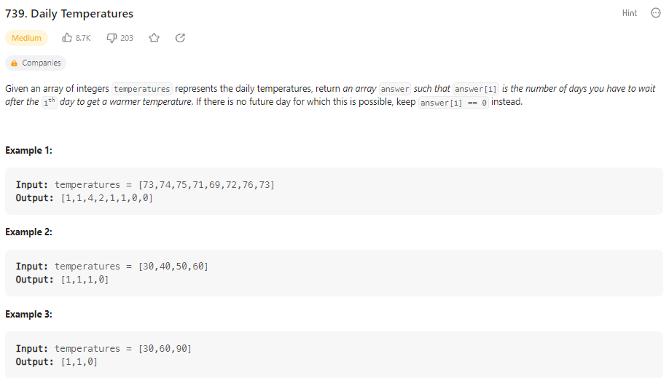

    def dailyTemperatures(self, temperatures: List[int]) -> List[int]:

        stack = [] # pair: [temp, index]

        output = [0] * len(temperatures)

        for i, t in enumerate(temperatures):

            while stack and t > stack[-1][0]: # while stack is not empty and t is greater than the temp at top of stack(0 bc temp is first value in enumerated pair)

                stackT, stackInd = stack.pop()

                output[stackInd] = (i - stackInd)

            stack.append([t, i])

        return output

Create a stack that will store pairs, [temp, index]. Create output array length of the input temperatures initialized to 0. Use enumerate to get an index and temp pair. While stack is not empty and t is greater than the temp at top of stack (stack[-1][0] .. [-1] to get top of stack, [0] because it is the first element of pair in stack), pop that pair from stack and update output array at that index with the difference in days (i- stackInd) to find how many days it took to get higher temp). Then, add that temp to the stack.

**Car Fleet**

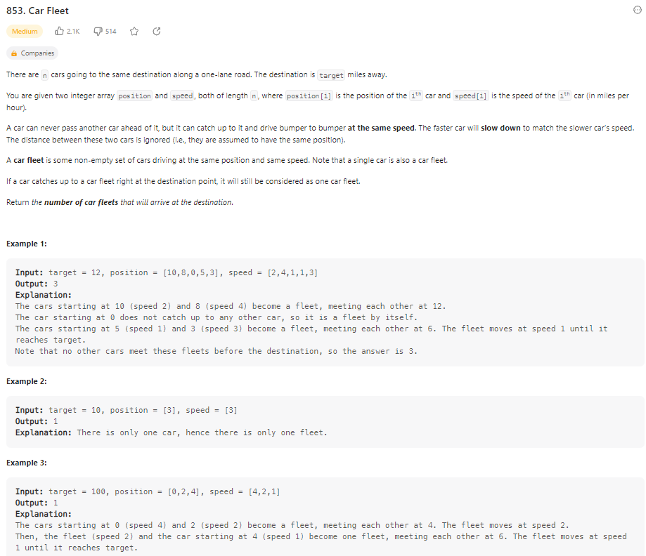

    def carFleet(self, target: int, position: List[int], speed: List[int]) -> int:

        pair = [[p, s] for p, s in zip(position, speed)] # zip uses list comprehension in python to create a array of pairs

        stack = []

        for p, s in sorted(pair)[::-1]: # Reverse Sorted Order, ()right to left on a timeline of distance to target position)

            stack.append((target - p) / s)

            if len(stack) >= 2 and stack[-1] <= stack[-2]:

                stack.pop()

        return len(stack)

Create an array of pairs of each cars position and speed using zip() python list comprehension. Create an empty stack. Sort the car pairs in reverse order of position, (highest position first). For each pair, find the time it would take to get to target destination by (target – p) // s (/ for decimal division), then add it to stack. If the length of stack is 2 or higher, and the time for top car on stack to reach destination is less than the time for car ahead of it (behind it in stack), pop the slower car / top car. At the end, return the length of stack.

**Largest Rectangle in Histogram**

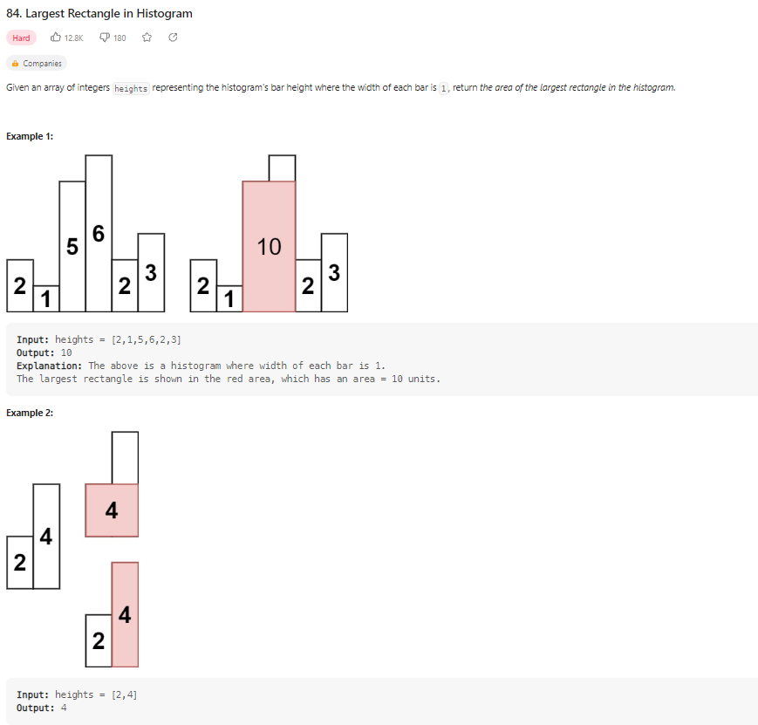

    def largestRectangleArea(self, heights: List[int]) -> int:

        maxArea = 0

        stack = [] # pair of elements: (index, height)

        for i, h in enumerate(heights):

            start = i

            while stack and stack[-1][1] > h: # check if height of last height in stack is higher, therefore cant be extended anymore and need to pop it

                index, height = stack.pop()

                maxArea = max(maxArea, height * (i - index)) # from start to index of what we just popped

                start = index

            stack.append((start, h))

        for i, h in stack: # these are the ones that could be extended to end of histogram

            maxArea = max(maxArea, h * (len(heights) - i))

        return maxArea

Set maxArea to 0. Create a stack for pair of (index, height) for each element. Start = i (the index of starting point). While the stack is not empty and the height of top height on stack is greater than the one we are at, pop from the stack and store the index and height. Then, calculate the max area, update start to be the index that was popped and then append the new pair to stack. At the end, go through remaining heights in stack (these all could be extended to end) and find max areas of each going across the histogram. Return maxArea when stack is empty.

**Binary Search**

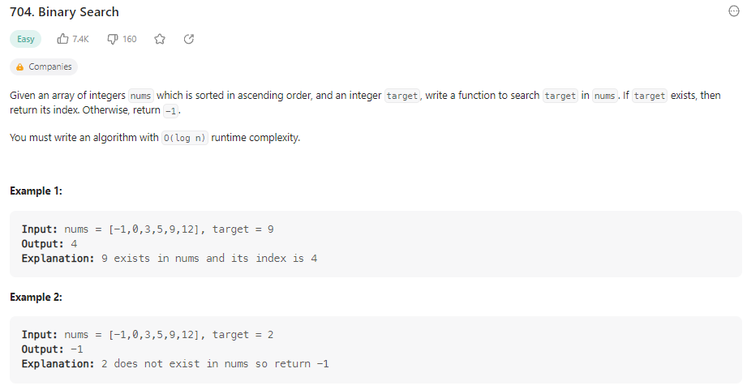

    def search(self, nums: List[int], target: int) -> int:

        l, r = 0, len(nums) - 1

        while l <= r:

            m = l + ((r - l) // 2)  # (l + r) // 2 can lead to overflow

            if nums[m] > target:

                r = m - 1

            elif nums[m] < target:

                l = m + 1

            else:

                return m

        return -1

Set two pointers, l = 0 all the way to left and r = len(nums) – 1 all the way to right. While l <= r, find the middle index. If the number at middle index is greater than target, shift r to the spot before middle index (cuts the right half of array away). If number at middle index is less than target, move the left index to 1 spot after middle (cuts the left half of array off). If it is equal, return m. Return -1 if you target doesn’t exist.

**Search a 2D Matrix**

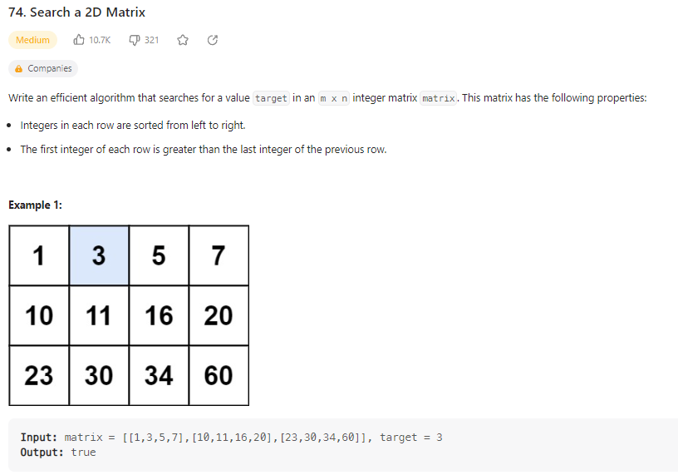

    def searchMatrix(self, matrix: List[List[int]], target: int) -> bool:

        ROWS, COLS = len(matrix), len(matrix[0])

        # beginning of a vertical binary search on the first values of rows to find the correct row to search

        top, bot = 0, ROWS - 1

        while top <= bot:

            row = (top + bot) // 2

            if target > matrix[row][-1]:

                top = row + 1

            elif target < matrix[row][0]:

                bot = row - 1

            else:

                break

        if not (top <= bot):

            return False

        # beginning of horizontal binary search on the correct row found

        row = (top + bot) // 2

        l, r = 0, COLS - 1

        while l <= right:

            m = (l+r) // 2

            if target > matrix[row][m]:

                l = m + 1

            elif target < matrix[row][m]:

                r = m - 1

            else:

                return True

        return False

First run a binary search on the first column to find proper row to search. Then do binary search on that row to find if target is present.

**Koko Eating Bananas**

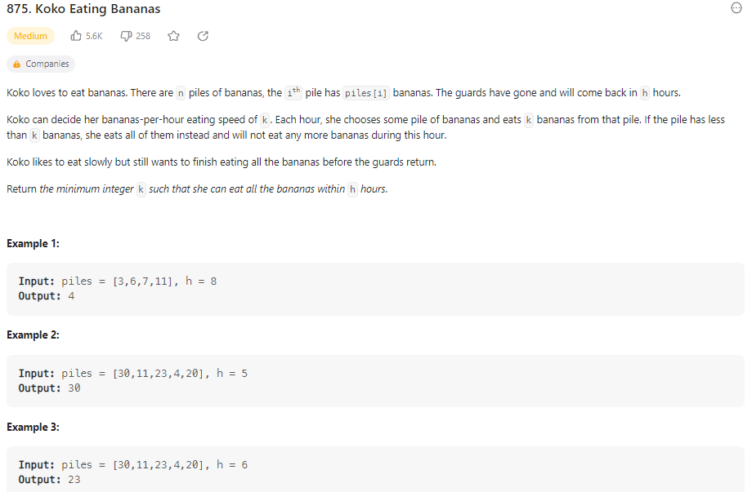

def minEatingSpeed(self, piles: List[int], h: int) -> int:

        l, r = 1, max(piles)

        res = r

        while l <= r:

            k = (l+r) // 2

            hours = 0

            for p in piles:

                hours += math.ceil(p/k)

            if hours <= h:

                res = min(res, k)

                r = k - 1

            else:

                l = k + 1

        return res

Set pointers of l = 1, r = max number in piles. Set k to be half of the max pile. Then use binary search to find k (rate of bananas per hour needed).

**Search in Rotated Sorted Array**

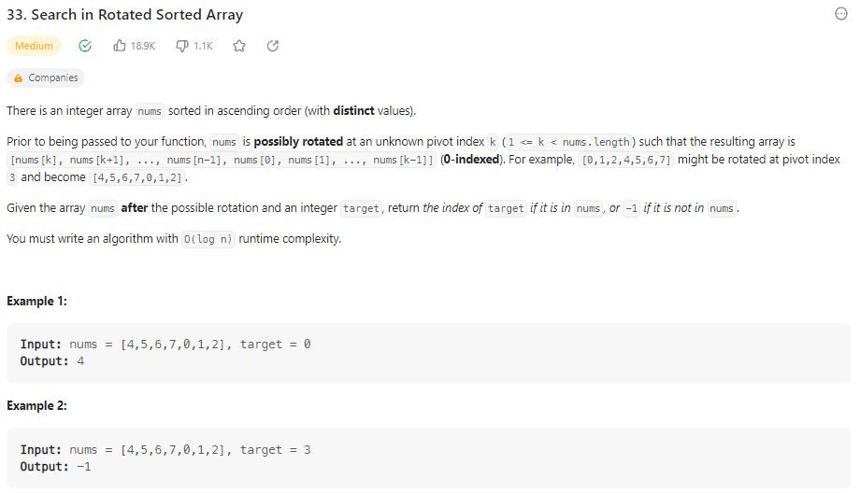

def search(self, nums: List[int], target: int) -> int:

        l, r = 0, len(nums) - 1

        while l <= r:

            mid = (l + r) // 2

            if target == nums[mid]:

                return mid

            # left sorted portion

            if nums[l] <= nums[mid]:

                if target > nums[mid] or target < nums[l]:

                    l = mid + 1

                else:

                    r = mid - 1

            #right sorted portion

            else:

                if target < nums[mid] or target > nums[r]:

                    r = mid - 1

                else:

                    l = mid + 1

        return -1

**Find Minimum in Rotated Sorted Array**

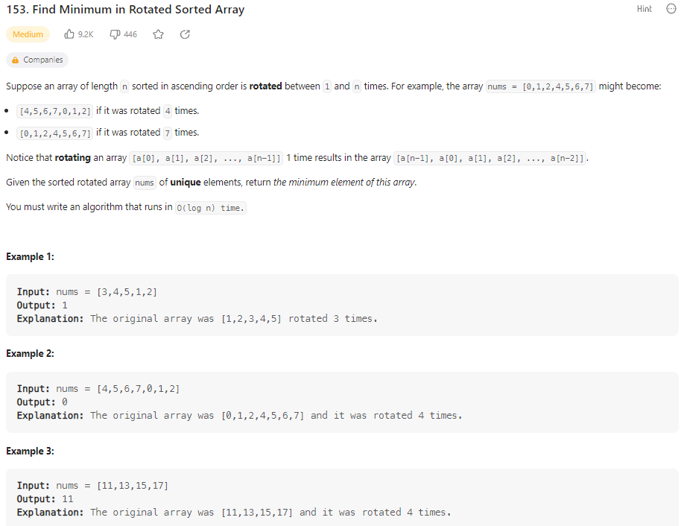

def findMin(self, nums: List[int]) -> int:

        res = nums[0]

        l, r = 0, len(nums)-1

        while l <= r:

            if nums[l] < nums[r]:

                res = min(res, nums[l])

                break

            mid = (l+r) // 2

            res = min(res,nums[mid])

            if nums[mid] >= nums[l]:

                l = mid + 1

            else:

                r = mid - 1

        return res

Initialize result variable and set it to any number in array (choose first element). If the left most value is less than right most value, we know it is sorted and update the result to the minimum of current result and left most value. If not, use binary search and keep searching the side of array that was the left half of original sorted array. (if mid is greater than left, move left pointer to mid+1, else move r to mid-1).

**Time Based Key-Value Store**

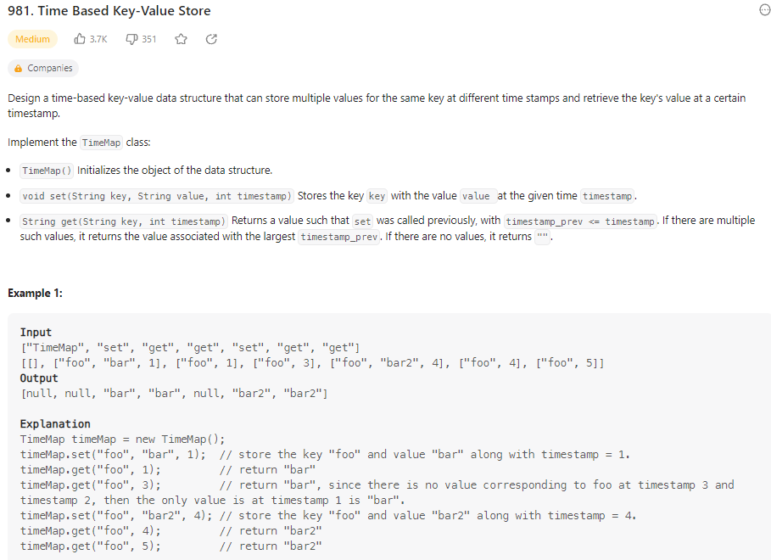

def __init__(self):

        self.store = {} # key = string, value = list of pairs(list) - [value, timestamp]

    def set(self, key: str, value: str, timestamp: int) -> None:

        if key not in self.store:

            self.store[key] = [] # could also just use default dic instead of this line in python

        self.store[key].append([value,timestamp])

    def get(self, key: str, timestamp: int) -> str:

        res = "" # if no value, return "" according to problem

        values = self.store.get(key, [])

        # binary search

        l, r = 0, len(values)-1

        while l <= r:

            m = (l + r) // 2 # // is integer division

            if values[m][1] <= timestamp: # index 1 because we want timestamp of the pair, 2nd element in list

                res = values[m][0]

                l = m + 1 # want to search right portion if its less than result

            else:

                r = m - 1

        return res

def __init__(self) is the constructor which initializes time-based key-value data structure object as a hash map. Set function adds the key value pair to the hashmap if its not there, or appends it to the pre-existing key if already exists. Get function creates a blank string res, and gets the values at the key that is given. Then, using binary search, find the key/value pair that is closes to the timestamp entered but hasn’t passed yet. (why we use <=). Values[m][0] is the value and values[m][1] is the timestamp in pair that is stored in hashmap as value.

**Median of Two Sorted Arrays**  
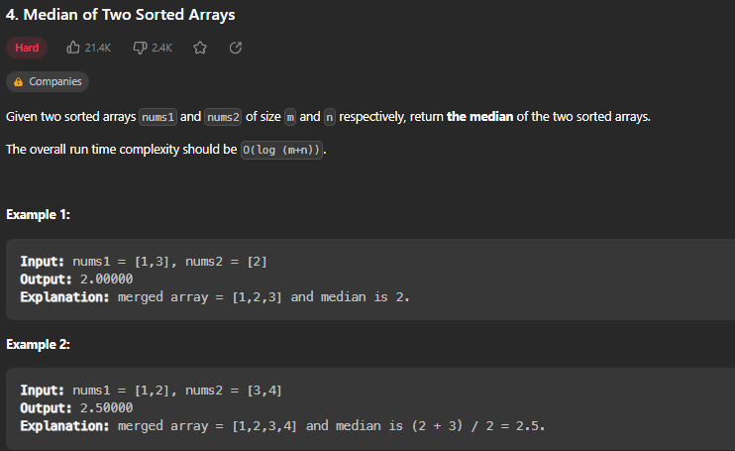

def findMedianSortedArrays(self, nums1: List[int], nums2: List[int]) -> float:

        A, B = nums1, nums2

        total = len(nums1) + len(nums2)

        half = total // 2

        # Time Complexity = O(log(min(n,m)) because we run binary on the smaller of the 2 arrays

        if len(B) < len(A):

            A, B = B, A # makes sure that A is always the smaller of arrays by swapping if not

        # First, run binary search on A, the smaller array

        l, r = 0, len(A)-1

        while True:

            i = (l + r) // 2 # A

            j = half - i - 2 # B, minus 2 is to account for both arrays starting at 0 index when we want index of midpoint

            Aleft = A[i] if i >= 0 else float("-infinity")

            Aright = A[i+1] if (i+1) < len(A) else float("infinity")

            Bleft = B[j] if j >= 0 else float("-infinity")

            Bright = B[j+1] if (j+1) < len(B) else float("infinity")

            if Aleft <= Bright and Bleft <= Aright: # means partition is correct

                # odd

                if total % 2:

                    return min(Aright, Bright)

                # even

                return (max(Aleft, Bleft) + min(Aright, Bright)) / 2 # decimal division

            elif Aleft > Bright:

                r = i - 1

            else:

                l = i + 1 # have to adjust left partition by 1

Find left and right partitions of each array by doing binary search on smaller array, then comparing edges of the partitions to edges of other partitions to find the median. Drawing of example problem on paper.

**Reverse Linked List**

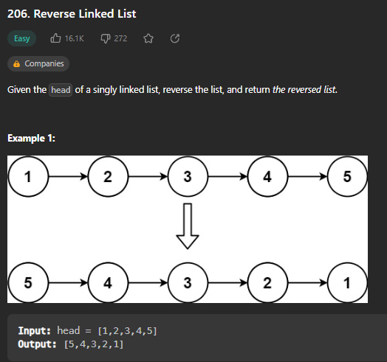

def reverseList(self, head: Optional[ListNode]) -> Optional[ListNode]:

        prev, curr = None, head

    # Time Complexity = O(n), Memory = O(1)

        while curr: # while current pointer isnt null (end of linked list)

            nxt = curr.next # saves value before you break linked list

            curr.next = prev

            prev = curr

            curr = nxt

        return prev

Iterative Approach: Set previous to null, and current to the head (start of list). Then, while curr (curr is not null, therefore we haven’t gone through whole list), store the curr.next in a value called nxt. Then, set curr.next to prev, set prev to curr, and set curr to the value stored in nxt (move curr to next node). Once curr is null, you’ve gotten to end of list and you can return prev (aka the last node you reached). Iterative approach is the best for Time Complexity / Memory, but someone could ask how to do it recursively….

def reverseList(self, head: Optional[ListNode]) -> Optional[ListNode]:

        # Recursive: Time Complexity O(n), Memory O(n)

        if not head:

            return None

        newHead = head

        if head.next: # can keep reversing

            newHead = self.reverseList(head.next)

            head.next.next = head # reverses the link between next node and head

        head.next = None

        return newHead

Recursive function that stores the newHead as head, then calls the function again recursively until no more head.nexts are found. (Slower and more memory, but a good practice of recursion)

**Merge Two Sorted Lists**

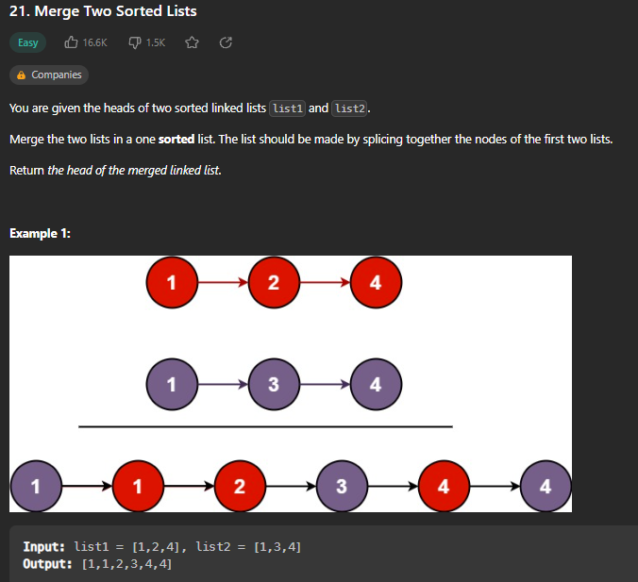

def mergeTwoLists(self, list1: Optional[ListNode], list2: Optional[ListNode]) -> Optional[ListNode]:

        dummy = ListNode() # creates a dummy node, common practice, so that you dont have any edge case errors

        tail = dummy

        while list1 and list2:

            if list1.val < list2.val:

                tail.next = list1

                list1 = list1.next

            else:

                tail.next = list2

                list2 = list2.next

            tail = tail.next

        if list1:

            tail.next = list1

        elif list2:

            tail.next = list2

        return dummy.next

Create a dummy node to begin output list. Then, while both lists still have values, add smaller node as tail.next and move current node to be the next in that list. If one list runs out of nodes, add the remainder of other list to output list. Return dummy.next.

**Reorder List**

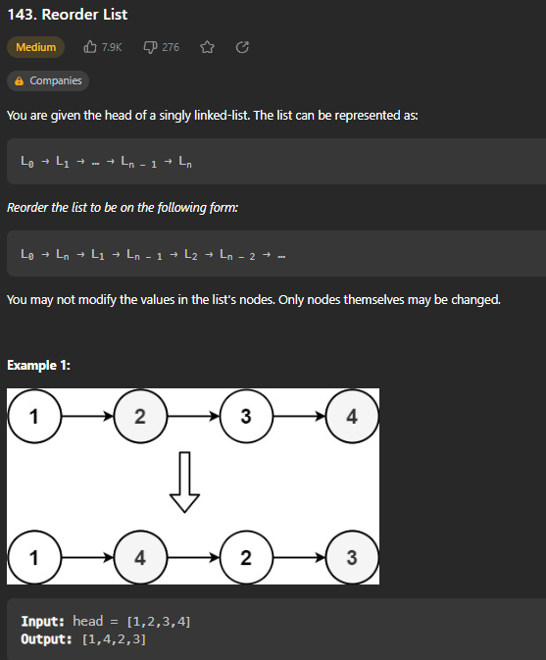

def reorderList(self, head: Optional[ListNode]) -> None:

     # Do not return anything, modify head in-place instead.

        # find middle of list

        slow, fast = head, head.next # used to find the middle of list

        while fast and fast.next:

            slow = slow.next

            fast = fast.next.next

        # reverse second half

        second = slow.next # second half would start 1 to right of slow pointer

        slow.next = None # splitting into two lists, so marks end of first list

        prev = None

        while second:

            temp = second.next

            second.next = prev

            prev = second

            second = temp

        # merge two halves

        first, second = head, prev

        while second:

            temp1, temp2 = first.next, second.next

            first.next = second

            second.next = temp1

            first, second = temp1, temp2

Splits the linked list into two separate halves, and reverses the order of links of second half. Then, merge the two lists together.

**Remove Nth Node From End of List**

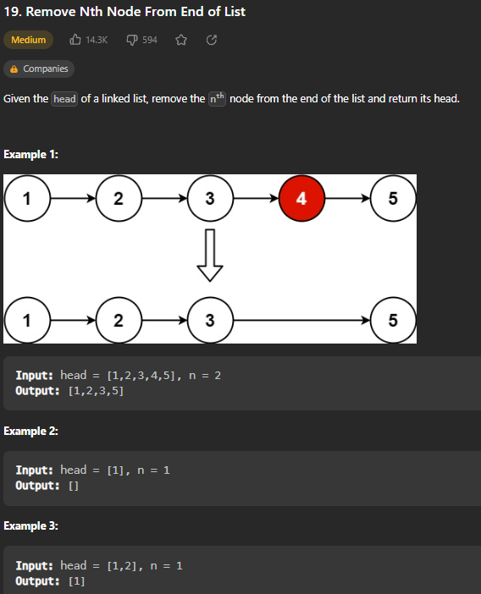

def removeNthFromEnd(self, head: Optional[ListNode], n: int) -> Optional[ListNode]:

        dummy = ListNode(0, head)

        left = dummy

        right = head

        while n > 0 and right:

            right = right.next

            n -= 1

        while right:

            left = left.next

            right = right.next

        # delete node

        left.next = left.next.next

        return dummy.next

Create a dummy node with any value (0) and have next be the head. Then, create two pointers, left = dummy and right = head. Then, increment right’s starting point by n times. Then, while right is not None (haven’t made it to end of list), move both pointers over one. To delete the proper node, set left.next to left.next.next (essentially skip over the node we want to remove). Return dummy.next.

**Copy List with Random Pointer**

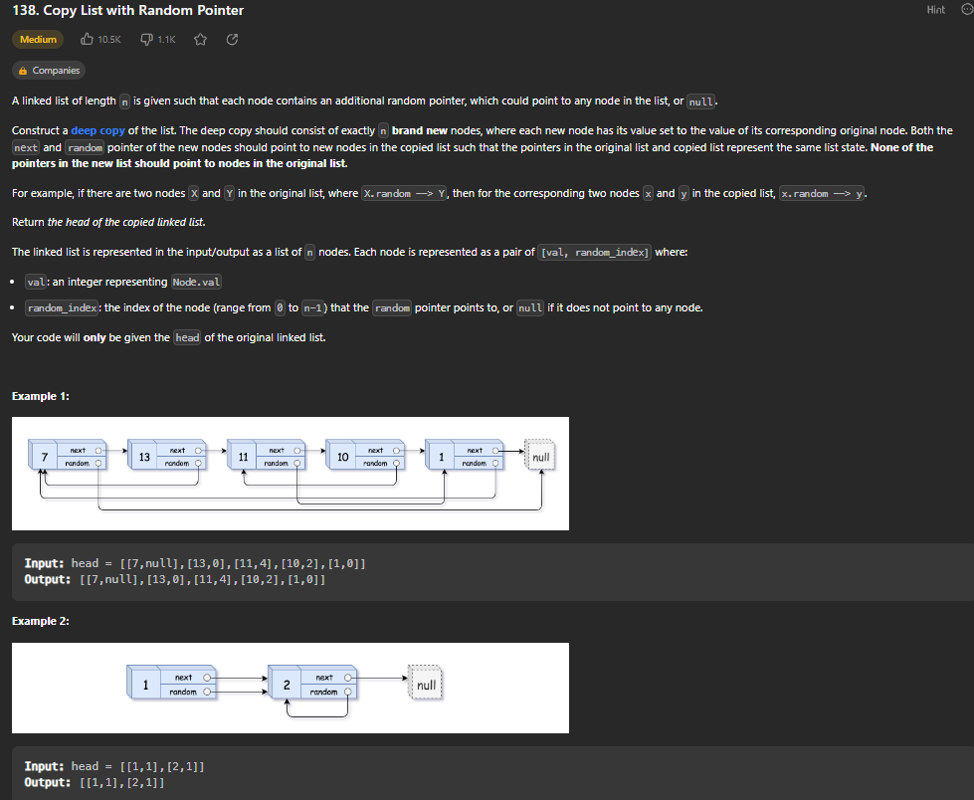

def copyRandomList(self, head: 'Optional[Node]') -> 'Optional[Node]':

        oldToCopy = { None : None } # none maps to none for case node.next is null

        cur = head

        while cur: # filling copies of nodes to hashmap

            copy = Node(cur.val)

            oldToCopy[cur] = copy

            cur = cur.next

        cur = head

        while cur: # going back through and setting the pointers for next and random

            copy = oldToCopy[cur]

            copy.next = oldToCopy[cur.next]

            copy.random = oldToCopy[cur.random]

            cur = cur.next

        return oldToCopy[head]

Create a hashmap to store the nodes, map None to None. Set cur to head. Go through the list twice. First time, we are filling the hashmap with copies of the nodes in linked list. Second time through, we will set the random and next pointers.

**Add Two Numbers**

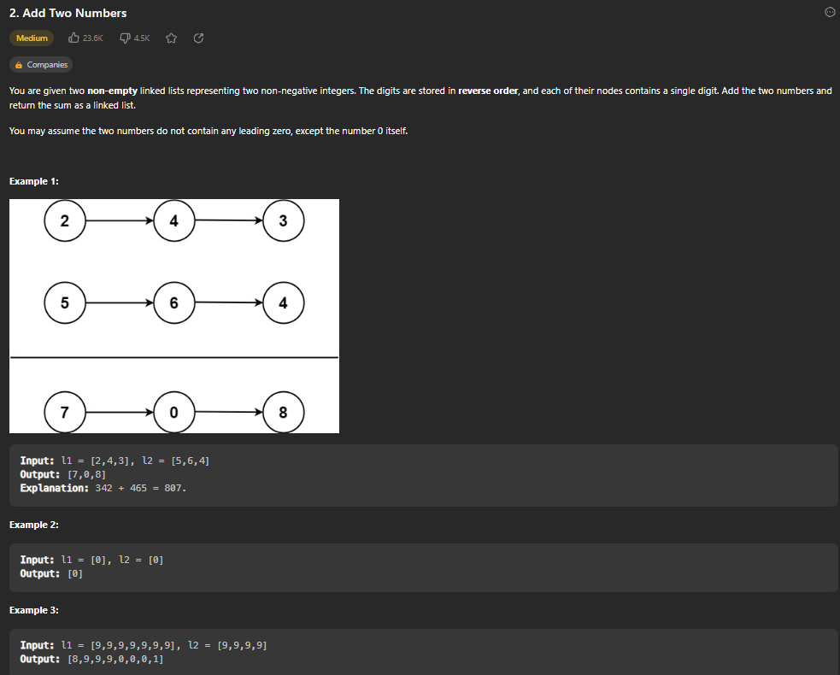

def addTwoNumbers(self, l1: Optional[ListNode], l2: Optional[ListNode]) -> Optional[ListNode]:

        dummy = ListNode()

        cur = dummy

        carry = 0

        while l1 or l2 or carry:

            v1 = l1.val if l1 else 0

            v2 = l2.val if l2 else 0

            # new digit

            val = v1 + v2 + carry

            carry = val // 10

            val = val % 10

            cur.next = ListNode(val)

            # update pointers

            cur = cur.next

            l1 = l1.next if l1 else None

            l2 = l2.next if l2 else None

        return dummy.next

Create a dummy ListNode for output. Set cur to dummy and create a carry value and set it to 0. Then, go through and add l1 and l2 and carry and set that value to new node, however if it is greater than 10 use mod to get the ones place digit.

**Linked List Cycle**

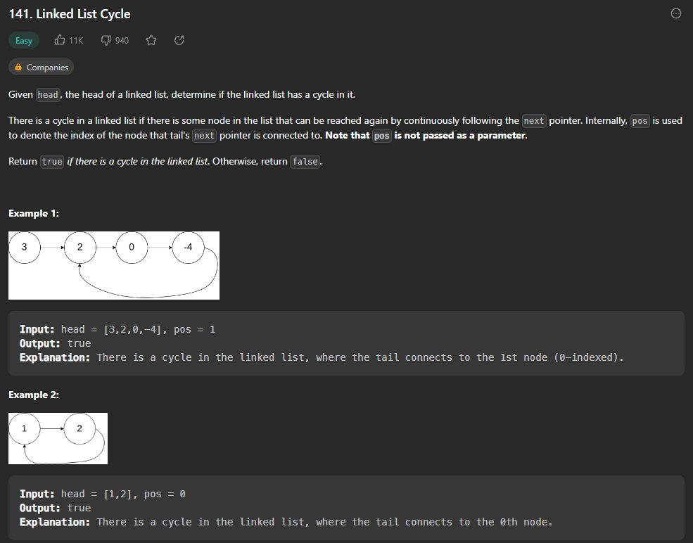

def hasCycle(self, head: Optional[ListNode]) -> bool:

        # Floyd's Tortoise and Hare Algorithm

        slow, fast = head, head

        while fast and fast.next:

            slow = slow.next

            fast = fast.next.next

            if slow == fast:

                return True

        return False

Floyd’s Tortoise and Hare Algorithm. If you use two pointers, slow and fast, and they ever meet at the same spot, it is a cycle. Think circle with a set diameter, and have slow pointer move by 1 and fast pointer move by 2. Eventually, formula of diameter + 1 – 2 will reach 0, hence they are at same spot. This works in O(n) time.

**Find the Duplicate Number (Floyd’s Cycle Detection Algorithm)**

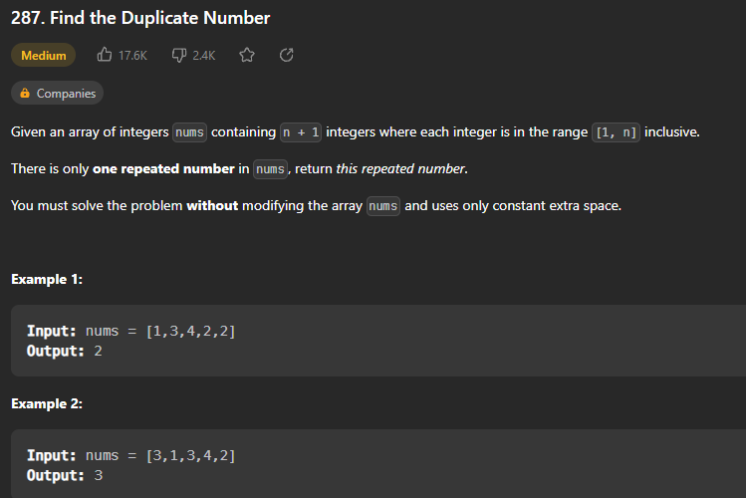

def findDuplicate(self, nums: List[int]) -> int:

        slow, fast = 0, 0

        while True:

            slow = nums[slow]

            fast = nums[nums[fast]] # advances fast twice

            if slow == fast:

                break

        slow2 = 0

        while True:

            slow = nums[slow]

            slow2 = nums[slow2]

            if slow == slow2:

              return slow

Floyd’s Cycle Detection Algorithm – Because the integers are within the range of [1, n], you can consider the input array as a cycle that maps from one integer to another by element number. First, have a slow and fast pointer set to 0 and until slow and fast are equal, continually update slow to nums[slow] and fast to nums[nums[fast]]. Once they meet, Start a new slow pointer at the beginning again, and iterate them once each until they meet. At this point, slow and slow2 will always be at the same element / part of cycle. This is proved with the following drawings below:

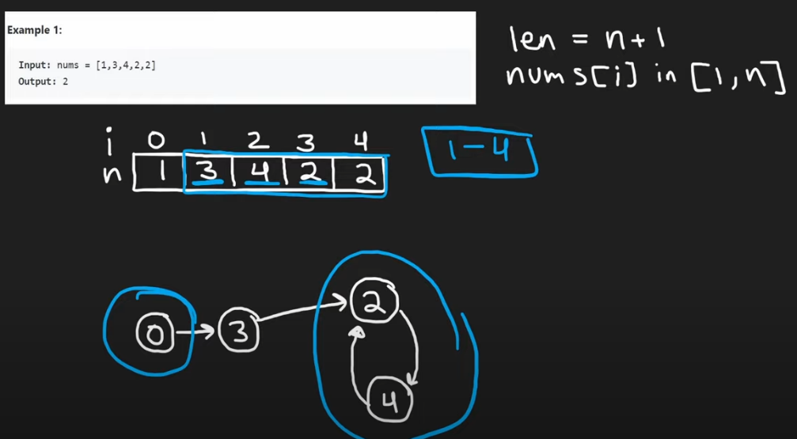

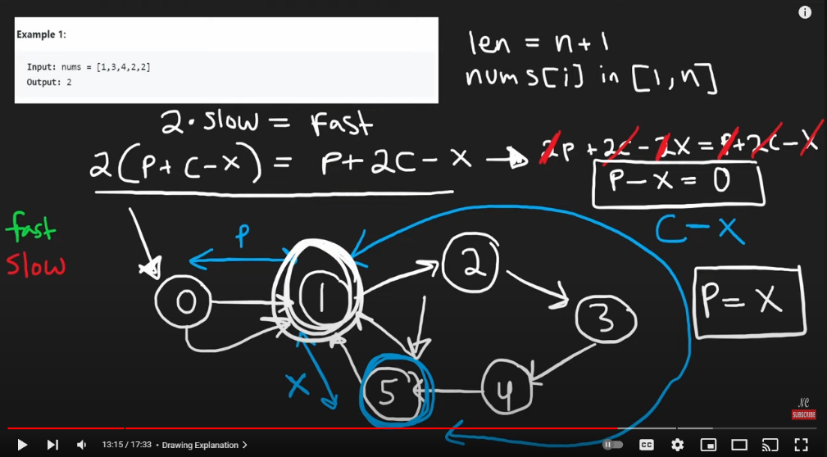

In this example, because P is less than the length of the cycle, this is the prove that eventually both pointers will meet at the same place. If p was longer than the rest of cycle:

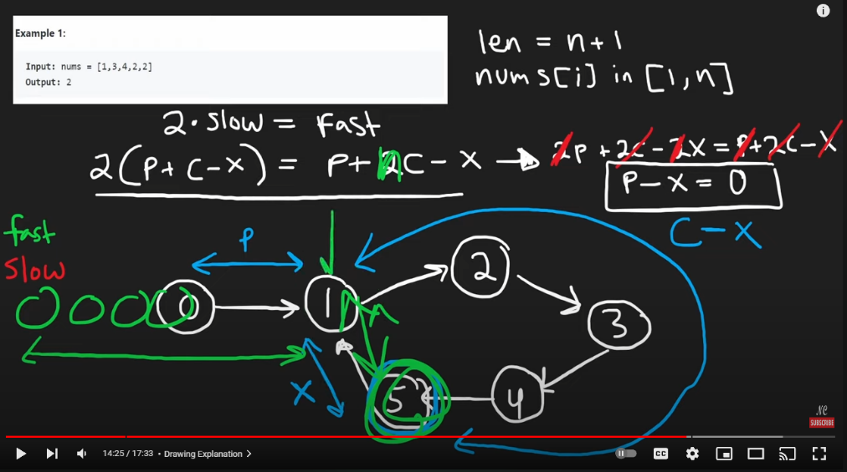

Prisoners Riddle (some similar concepts): [**https://www.youtube.com/watch?v=iSNsgj1OCLA&ab_channel=Veritasium**](https://www.youtube.com/watch?v=iSNsgj1OCLA&ab_channel=Veritasium)

**LRU Cache**

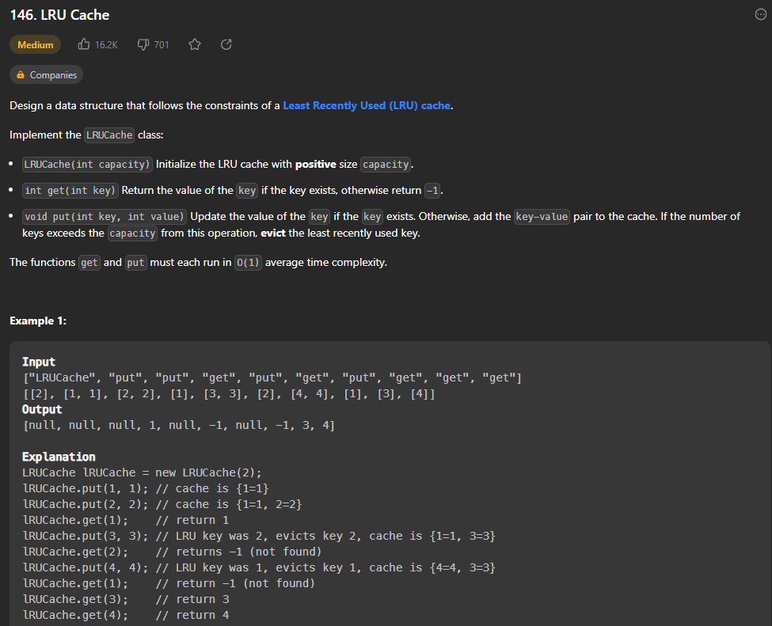

class Node:

    def __init__(self, key, val):

        self.key, self.val = key, val

        self.prev = self.next = None

class LRUCache:

    def __init__(self, capacity: int):

        self.cap = capacity

        self.cache = {} # map key to nodes

        self.left, self.right = Node(0,0), Node(0,0) # pointers to store LRU and MRU

        self.left.next, self.right.prev = self.right, self.left # connects the two

    def remove(self, node): # helper function to remove node from list

        prev, nxt = node.prev, node.next

        prev.next, nxt.prev = nxt, prev

    def insert(self, node): # helper function to insert node at right

        prev, nxt = self.right.prev, self.right

        prev.next = nxt.prev = node

        node.next, node.prev = nxt, prev

    def get(self, key: int) -> int:

        if key in self.cache:

            self.remove(self.cache[key])

            self.insert(self.cache[key])

            return self.cache[key].val

        return -1

    def put(self, key: int, value: int) -> None:

        if key in self.cache:

            self.remove(self.cache[key])

        self.cache[key] = Node(key, value)

        self.insert(self.cache[key])

        if len(self.cache) > self.cap:

            # remove from linked list and delete LRU from hashmap

            lru = self.left.next

            self.remove(lru)

            del self.cache[lru.key]

# Your LRUCache object will be instantiated and called as such:

# obj = LRUCache(capacity)

# param_1 = obj.get(key)

# obj.put(key,value)

Create a node class to help with entire function. Use a hashmap to store the cache and linked list to track the LRU and MRU. Create helper function insert and remove to help with the put method.

**Merge k Sorted Lists**

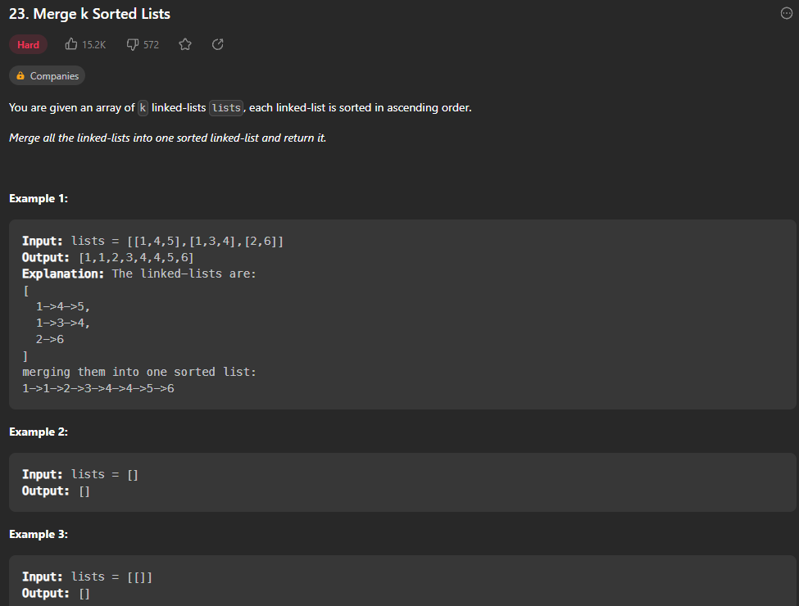

def mergeKLists(self, lists: List[Optional[ListNode]]) -> Optional[ListNode]:

        if not lists or len(lists) == 0:

            return None

        while len(lists) > 1:

            mergedLists = []

            for i in range(0, len(lists), 2): # inc is 2 bc we want to do pairs (merges 0 and 1, then 2 and 3, etc til end)

                l1 = lists[i]

                l2 = lists[i+1] if (i+1) < len(lists) else None

                mergedLists.append(self.mergeList(l1, l2))

            lists = mergedLists

        return lists[0]

    def mergeList(self, l1, l2):

        dummy = ListNode()

        tail = dummy

        while l1 and l2:

            if l1.val < l2.val:

                tail.next = l1

                l1 = l1.next

            else:

                tail.next = l2

                l2 = l2.next

            tail = tail.next

        if l1:

            tail.next = l1

        if l2:

            tail.next = l2

        return dummy.next

Create helper function mergeList that merges 2 linked lists. Then, go through list of lists and merge 2 at a time and append it to a new list.

**Reverse Nodes in k-Group**

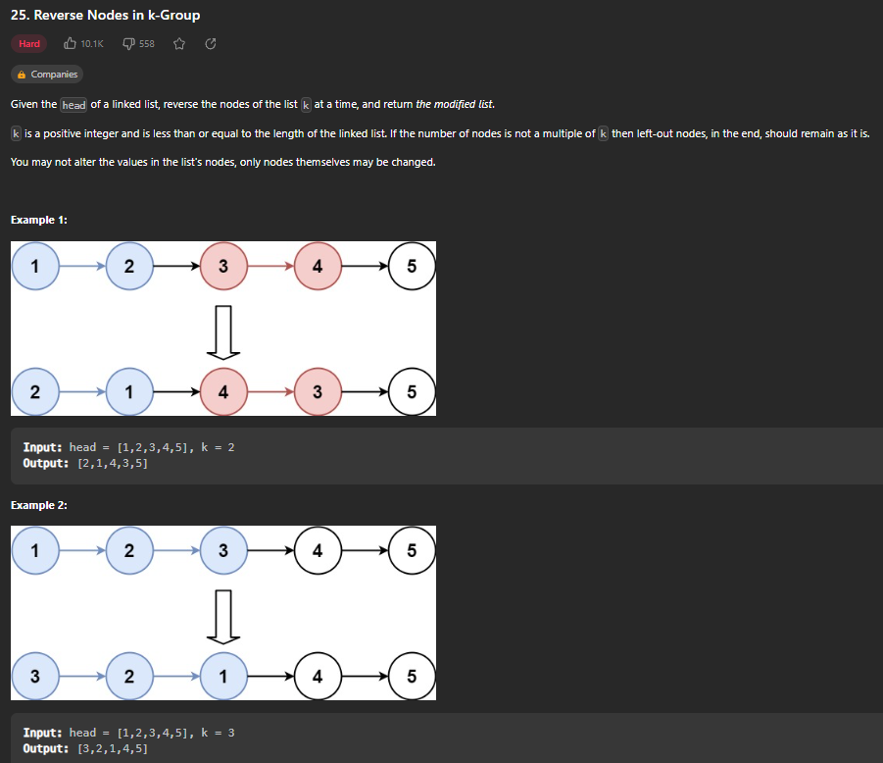

def reverseKGroup(self, head: Optional[ListNode], k: int) -> Optional[ListNode]:

        dummy = ListNode(0, head)

        groupPrev = dummy # saves one node before the group we are currently reversing

        while True:

            kth = self.getKth(groupPrev, k)

            if not kth:

                break

            groupNext = kth.next

            # reversing group

            prev, curr = kth.next, groupPrev.next

            while curr != groupNext:

                tmp = curr.next

                curr.next = prev

                prev = curr

                curr = tmp

            tmp = groupPrev.next

            groupPrev.next = kth

            groupPrev = tmp

        return dummy.next

    def getKth(self, curr, k): # helper function to find kth node

        while curr and k > 0:

            curr = curr.next

            k -= 1

        return curr

Create dummy node because we are altering the head node. Then, create a groupPrev node variable to store the location of the node before the group we are currently reversing. Create helper function to find the Kth node, and then use it to store the Kth node in a variable. If not kth statement will break if there weren’t enough nodes left (should remain as is according to problem). Once we have current group, reverse it just like any other linked list reversal. Then, continue on to next group and keep going until a group is not big enough to meet k amount of nodes.

**Invert Binary Tree**

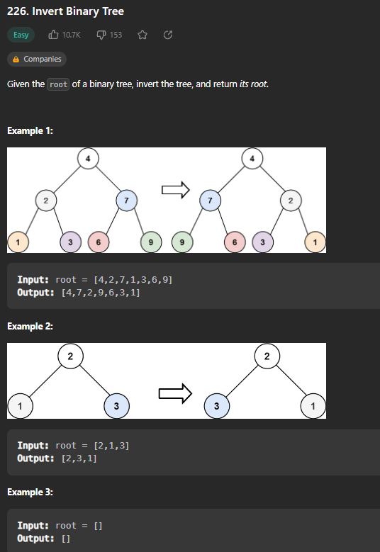

def invertTree(self, root: Optional[TreeNode]) -> Optional[TreeNode]:

        if not root:

            return None

        # swap children

        tmp = root.left

        root.left = root.right

        root.right = tmp

        self.invertTree(root.left)

        self.invertTree(root.right)

        return root

Swap the children of each root recursively throughout the entire tree.

PRE-ORDER TRAVERSAL: ROOT -> LEFT -> RIGHT

POST-ORDER TRAVERSAL: LEFT -> RIGHT -> ROOT

LEVEL-ORDER / IN-ORDER TRAVERSAL: LEFT -> ROOT -> RIGHT

**Maximum Depth of Binary Tree**

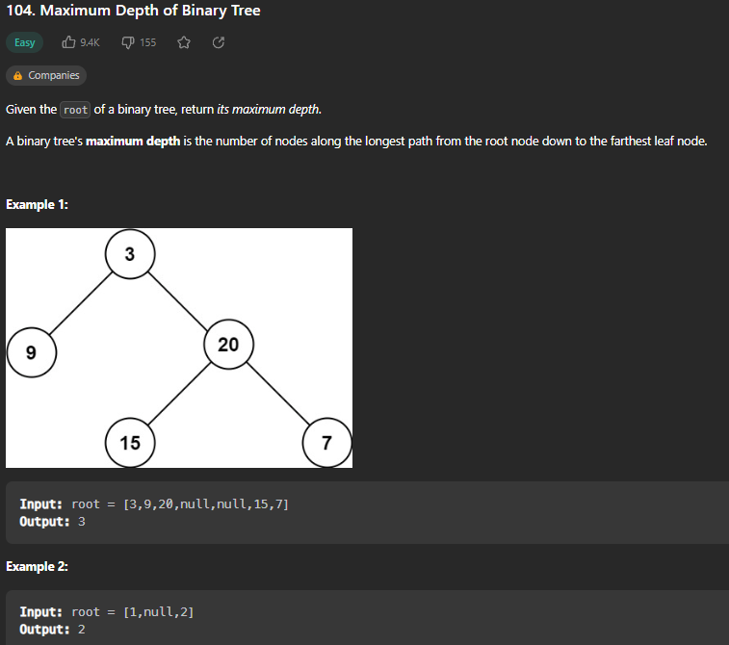

RECURSIVE DEPTH FIRST SEARCH

def maxDepth(self, root: Optional[TreeNode]) -> int:

        if not root:

            return 0

        return 1 + max(self.maxDepth(root.left), self.maxDepth(root.right))

Recursively return 1 + the max of the lengths of each subtree throughout entire tree

ITERATIVE BREADTH FIRST SEARCH

def maxDepth(self, root: Optional[TreeNode]) -> int:

        if not root:

            return 0

        level = 0

        q = deque([root])

        while q: # until it is empty

            for i in range(len(q)):

                node = q.popleft()

                if node.left:

                    q.append(node.left)

                if node.right:

                    q.append(node.right)

            level += 1

        return level

Essentially level-order traversal. Counting the number of levels there are in the tree. Normally uses a queue (put root in queue, then go through each node in queue and remove it and replace it with children. Continue until no more children. Each time you remove and replace, increment a counter.)

ITERATIVE DEPTH FIRST SEARCH

def maxDepth(self, root: Optional[TreeNode]) -> int:

        stack = [[root, 1]] # node and its depth, start at 1

        result = 0

        while stack:

            node, depth = stack.pop()

            if node:

                result = max(result, depth)

                stack.append([node.left, depth + 1])

                stack.append([node.right, depth + 1])

        return result

Use a stack and Pre-Order traversal. Add root to stack, storing the node and the depth. Then pop the node and add its children to stack. Continue popping from top of stack and adding children to stack along with the depth. Return the largest depth.

**Diameter of Binary Tree**

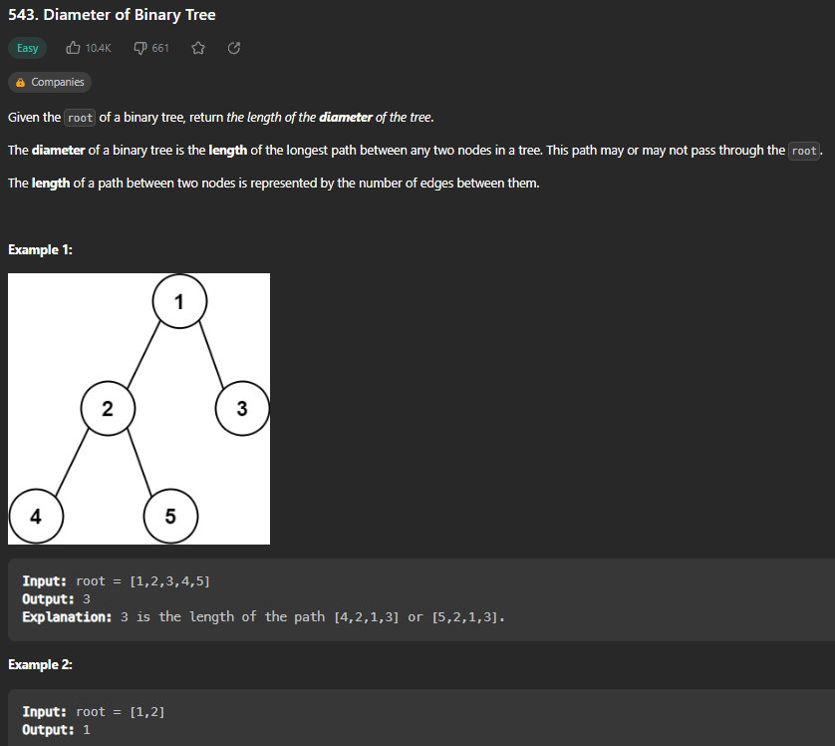

def diameterOfBinaryTree(self, root: Optional[TreeNode]) -> int:

        res = [0]

        def dfs(root):

            if not root:

                return -1

            left = dfs(root.left)

            right = dfs(root.right)

            res[0] = max(res[0], 2 + left + right)

            return 1 + max(left, right)

        dfs(root)

        return res[0]

Recursive function that finds the height and diameter of each subtree and returns the max diameter of each tree. Start at bottom of tree.

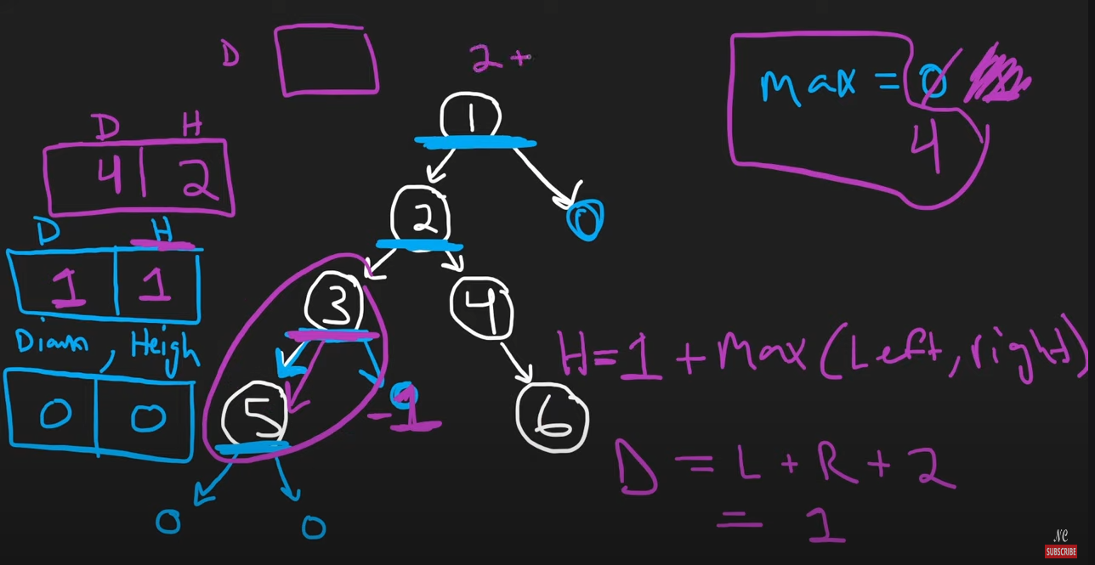

**Balanced Binary Tree**

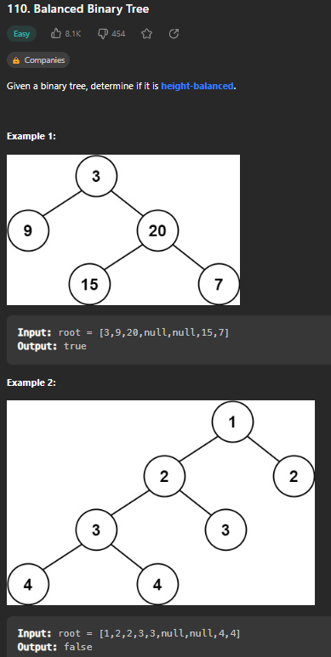

def isBalanced(self, root: Optional[TreeNode]) -> bool:

        def dfs(root):

            if not root: return [True, 0]

            left, right = dfs(root.left), dfs(root.right)

            balanced = (left[0] and right[0] and abs(left[1] - right[1]) <= 1)

            return [balanced, 1 + max(left[1], right[1])] # returns t/f for balanced and height of tree)

        return dfs(root)[0]

Use Recursive Depth First Search to traverse through the entire tree. At each subtree, return the height of subtrees and whether the subtrees are balanced. If any subtree ever evaluates to false or the absolute value of the left and right heights are more than 1, return false.

**Same Tree**

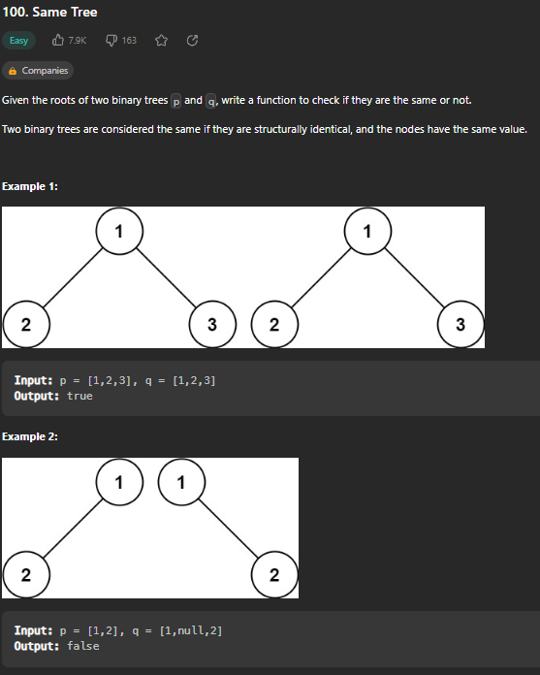

def isSameTree(self, p: Optional[TreeNode], q: Optional[TreeNode]) -> bool:

        if not p and not q:

            return True

        if p and q and p.val == q.val:

            return (self.isSameTree(p.left, q.left) and self.isSameTree(p.right, q.right))

        return False

Recursive Depth First Search comparing the value of each node to the corresponding value of other tree’s node. Return true if trees are the same.

**Subtree of Another Tree**

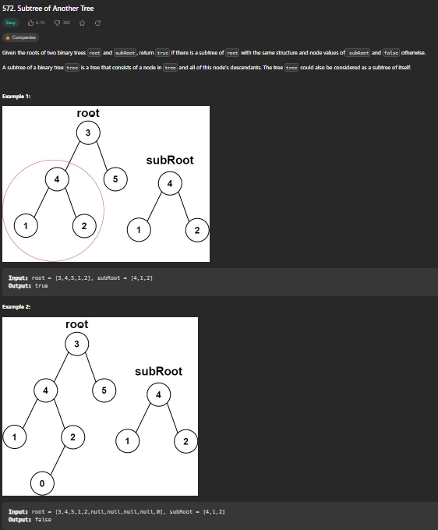

def isSubtree(self, root: Optional[TreeNode], subRoot: Optional[TreeNode]) -> bool:

        if not subRoot:

            return True

        if not root:

            return False

        if self.sameTree(root, subRoot):

            return True

        return (self.isSubtree(root.left, subRoot) or self.isSubtree(root.right, subRoot))

    def sameTree(self, root, subRoot):

        if not root and not subRoot:

            return True

        if  root and subRoot and root.val == subRoot.val:

            return (self.sameTree(root.left, subRoot.left) and self.sameTree(root.right, subRoot.right))

        return False

Prepare edge cases first. If there is no subtree, then return true (empty tree can always be found in a non-empty tree). If there is no root tree, return false. If the root and subtree are the same, return True. Use recursive helper function to check each subtree throughout entire tree.

**Lowest Common Ancestor of Binary Search Tree**

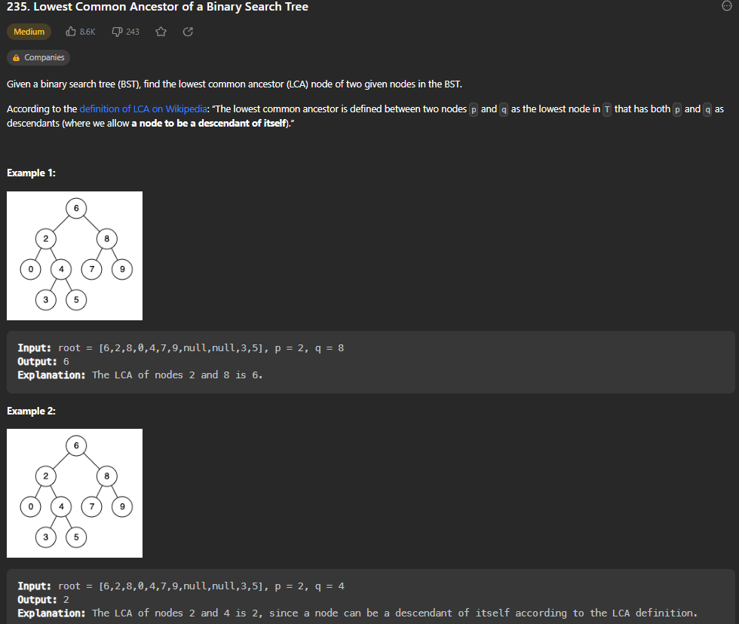

def lowestCommonAncestor(self, root: 'TreeNode', p: 'TreeNode', q: 'TreeNode') -> 'TreeNode':

        cur = root

        while cur:

            if p.val > cur.val and q.val > cur.val:

                cur = cur.right

            elif p.val < cur.val and q.val < cur.val:

                cur = cur.left

            else:

                return cur

Set current to the root. Then, if p.val and q.val are bigger than current, move to right, else move to left. At the end, return current. NOTE: This simple solution is possible because we are guaranteed that there is an ancestor, and binary search tree tells us which order to go. Time Complexity is O(logn) as is most binary search trees.

**Binary Tree Level Order Traversal**

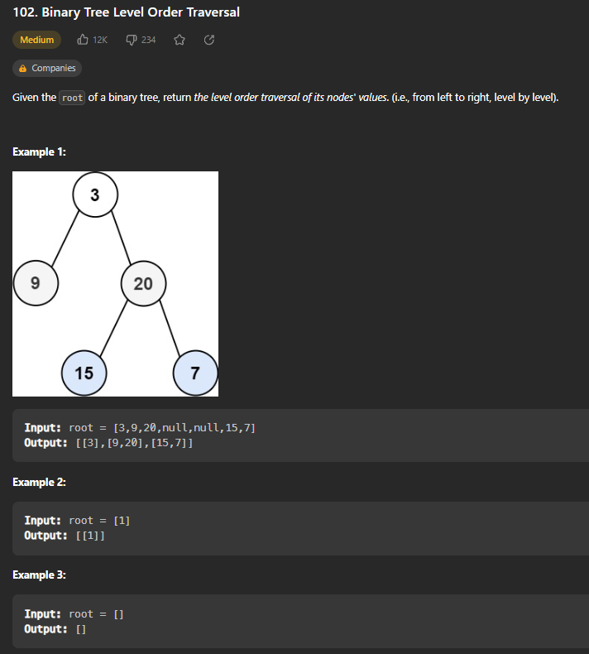

def levelOrder(self, root: Optional[TreeNode]) -> List[List[int]]:

        output = []

        q = deque([root])

        while q:

            level = []

            for i in range(len(q)):

                node = q.popleft()

                if node:

                    q.append(node.left)

                    q.append(node.right)

                    level.append(node.val)

            if level:

                output.append(level)

        return output

Use Breadth First Search. Create a queue and insert the root into it. Also create an empty list called output. Create a list variable to hold the values of current level. While there are nodes in the queue, pop a node, add its children to the queue, and append it to level list. Once that level is done, add it to the output.

**Binary Tree Right Side View**

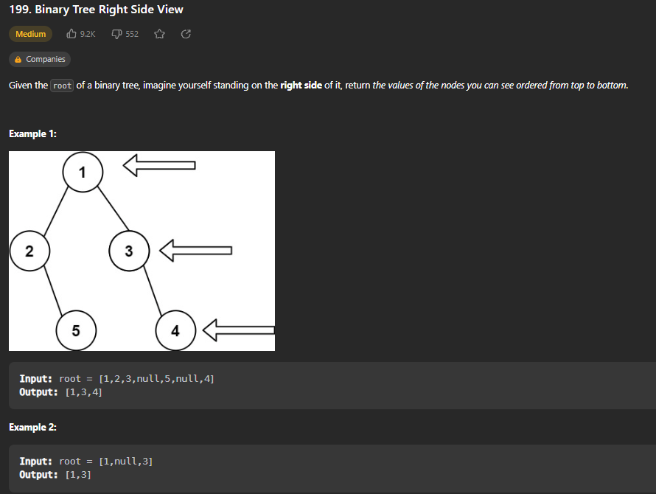

def rightSideView(self, root: Optional[TreeNode]) -> List[int]:

        output = []

        q = deque([root])

        while q:

            qlen = len(q)

            for i in range(len(q)):

                node = q.popleft()

                if node:

                    if node.left:

                        q.append(node.left)

                    if node.right:

                        q.append(node.right)

            if node:

                output.append(node.val)

        return output

Use Breadth First Search. Create a queue and insert the root into it. Also create an empty list called output. While there are nodes in the queue, pop a node and add its children to the queue. Append the final node of each level to output list and return it.

**Count Good Nodes in Binary Tree**

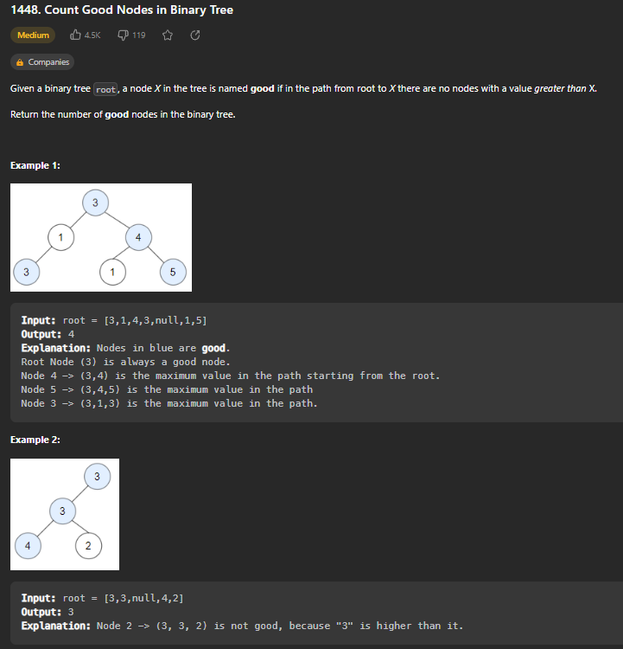

def goodNodes(self, root: TreeNode) -> int:

        def dfs(node, maxVal):

            if not node:

                return 0 # empty tree has no good nodes

            result = 1 if node.val >= maxVal else 0

            maxVal = max(maxVal, node.val) # updates maxVal

          result += dfs(node.left, maxVal)

            result += dfs(node.right, maxVal)

            return result

        return dfs(root, root.val) # root always counts as a good node

Use Recursive Depth First Search. If there is no node, return 0 because an empty tree has no good nodes. Store the maximum value seen so far so that we can compare it to values of each node visited recursively. If node is >= maxVal, increase result count.

**Validate Binary Search Tree**

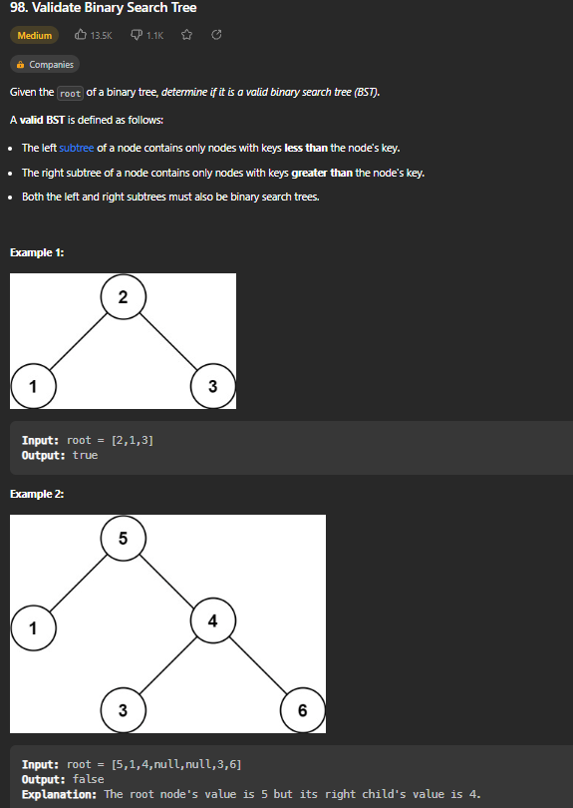

def isValidBST(self, root: Optional[TreeNode]) -> bool:

        def valid(node, left, right): # pass in nodes and left/right boundaries

            if not node: #empty BST is still a BST

                return True

            if not (node.val < right and node.val > left):

                return False

            return (valid(node.left, left, node.val) and valid(node.right, node.val, right))

        return valid(root, float("-inf"), float("inf"))

Create helper function that passes in the node, and left and right boundaries (negative and positive infinity for root). Then, if no node, return true. If the node is less than right or node is greater than left, return false. Then, return recursive result for left node with boundaries being the left and node.val, and same for right. Start recursion by calling function with negative and positive infinities as boundaries.

**Kth Smallest Element in a Binary Search Tree**

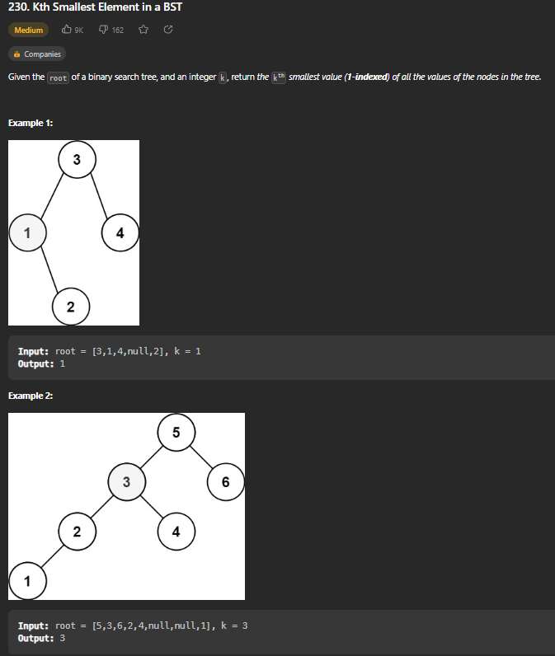

def kthSmallest(self, root: Optional[TreeNode], k: int) -> int:

        n = 0 # number of nodes visited

        stack = []

        cur = root

        while cur or stack:

            while cur:

                stack.append(cur)

                cur = cur.left

            cur = stack.pop()

            n += 1

            if n == k:

                return cur.val

            cur = cur.right

Create n variable to track number of nodes visited. Create empty stack and set cur to root. While cur is present or the stack is not empty, append cur to stack and then move cur to the left. Once at left most, pop from the stack and set it to cur. Increase n by 1, and if n is equal to k, return that current node’s value. If not, move cur to the right node and keep going.

**Construct Binary Tree from Preorder and Inorder Traversal**

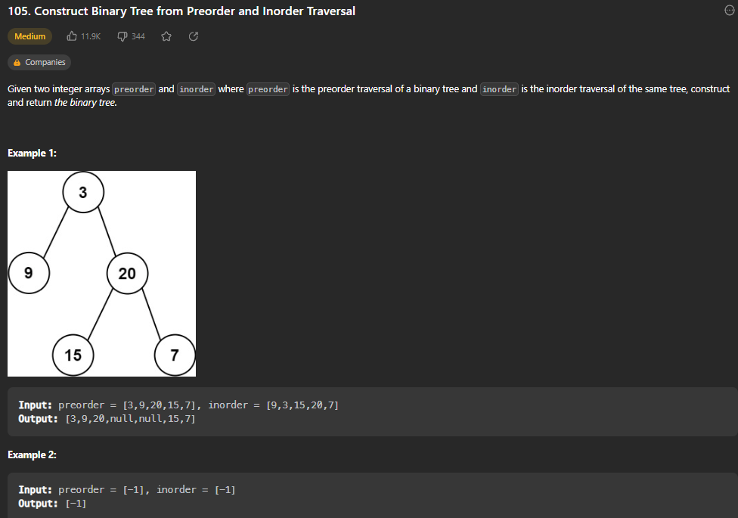

def buildTree(self, preorder: List[int], inorder: List[int]) -> Optional[TreeNode]:

        if not preorder or not inorder:

            return None

        root = TreeNode(preorder[0])

        mid = inorder.index(preorder[0])

        root.left = self.buildTree(preorder[1:mid+1], inorder[:mid]) # mid + 1 noninclusive, so right up to mid

        root.right = self.buildTree(preorder[mid+1:], inorder[mid+1:])

        return root

Important Facts: The first node in preorder is always the root. From there, any node to the left of this root in the inorder traversal is the left subtree, and any node to the right of this root in inorder traversal is the right subtree. Use a recursive function to create the binary tree.

**Binary Tree Maximum Path Sum**

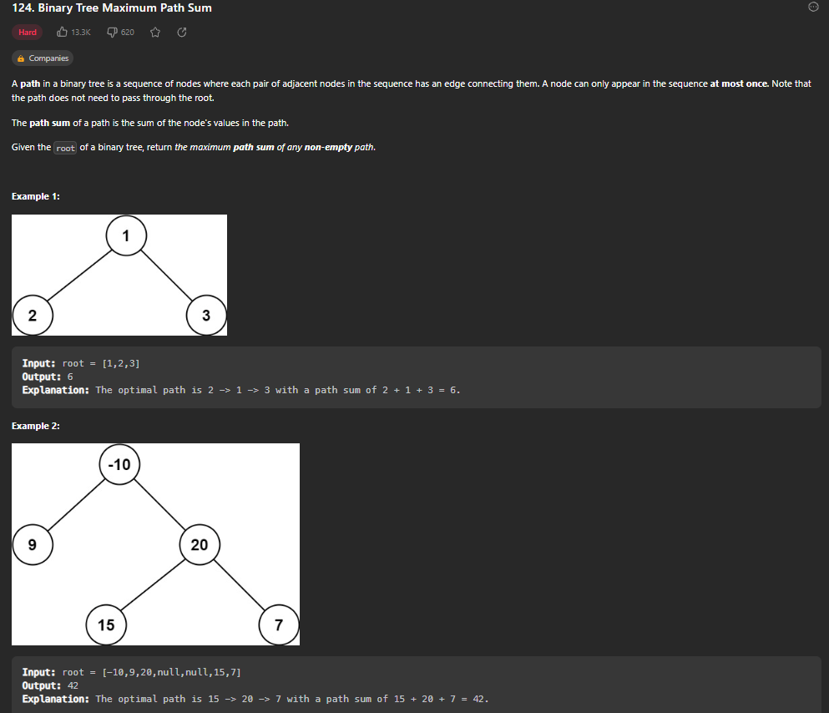

def maxPathSum(self, root: Optional[TreeNode]) -> int:

        res = [root.val]

        # returns max path sum without splitting

        def dfs(root):

            if not root:

                return 0

            leftMax = dfs(root.left)

            rightMax = dfs(root.right)

            leftMax = max(leftMax, 0)

            rightMax = max(rightMax, 0)

            # compute max path sum WITH split

            res[0] = max(res[0], root.val + leftMax + rightMax)

            return root.val + max(leftMax, rightMax)

        dfs(root)

        return res[0]

Use a global variable res to keep updating the max as each recursive call is executed. Calculate the maximum path possible from the left and right of each node recursively, and then return the max of those values + the root at each node.

**Serialize and Deserialize Binary Tree**

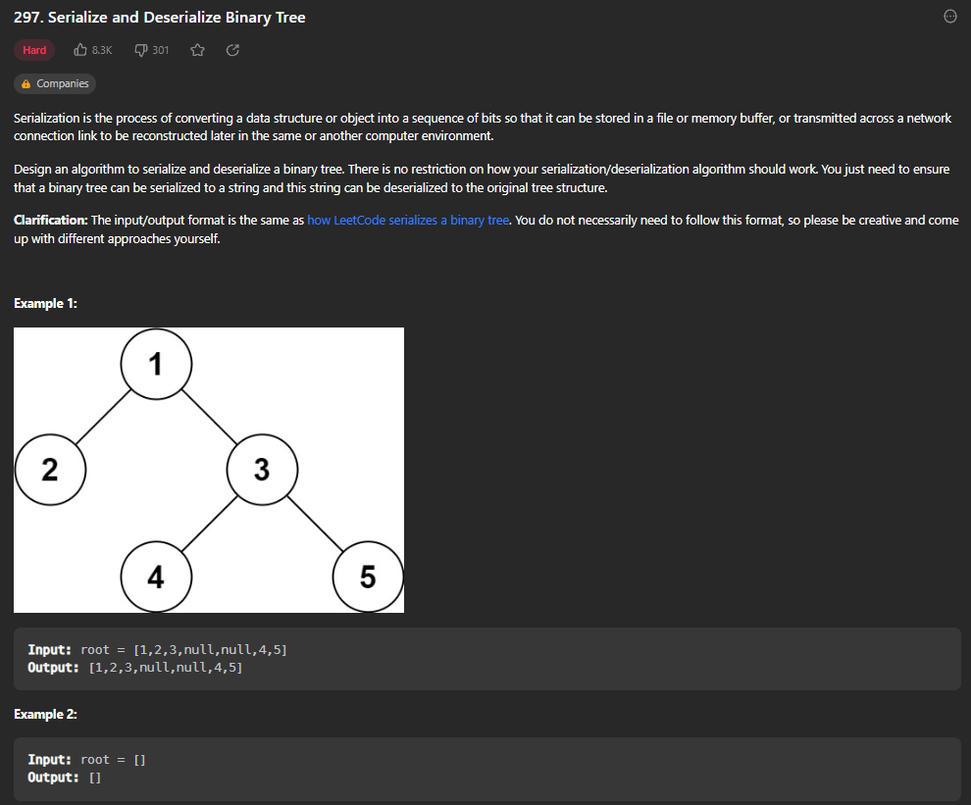

def serialize(self, root):

        res = []

        def dfs(node):

            if not node:

                res.append("n")

                return

            res.append(str(node.val))

            dfs(node.left)

            dfs(node.right)

        dfs(root)

        return ",".join(res)

    def deserialize(self, data):

        vals = data.split(",")

        self.i = 0

        def dfs():

            if vals[self.i] == "n":

                self.i += 1

                return None

            node = TreeNode(int(vals[self.i]))

            self.i += 1

            node.left = dfs()

            node.right = dfs()

            return node

        return dfs()

Create a result list. To serialize, call dfs recursively and append the value (turned into a string) to the result list, then call it on left and right nodes. Start the function by calling it on root and then use join function to create the string that is returned. To deserialize, create vals list and use split function to turn string into a list. Set self.i to 0 to start. Then recursively call dfs that creates the nodes based on values given and then run same on the left and right. Return the result of dfs at the end.

**Implement Tries (Prefix Tree)**

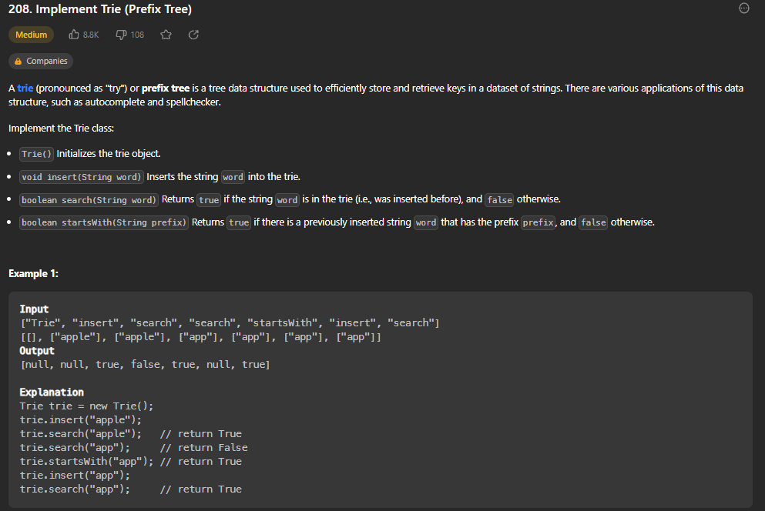

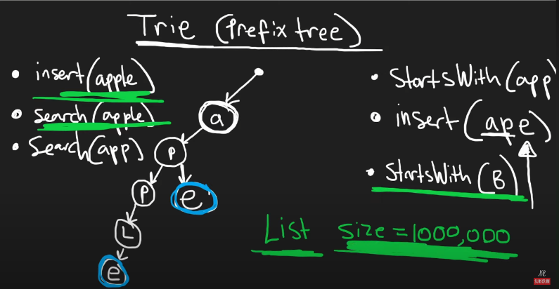

class TrieNode:

    def __init__(self):

        self.children = {}

        self.endOfWord = False

class Trie:

    def __init__(self):

        self.root = TrieNode()

    def insert(self, word: str) -> None:

        cur = self.root

        for c in word:

            if c not in cur.children:

                cur.children[c] = TrieNode()

            cur = cur.children[c]

        cur.endOfWord = True

    def search(self, word: str) -> bool:

        cur = self.root

        for c in word:

            if c not in cur.children:

                return False

            cur = cur.children[c]

        return cur.endOfWord # will return true if last letter cur arrives at is also end of word

    def startsWith(self, prefix: str) -> bool:

        cur = self.root

        for c in prefix:

            if c not in cur.children:

                return False

            cur = cur.children[c]

        return True

Tries sometimes better than hashmap/hashset because it allows to search for prefixes. (startswith() function is much more efficient with a trie, instead of looking through a list of 1,000,000 words O(n), can just go by letter and find it in O(1). First, create a TrieNode class with two variables, a hashmap of children and a boolean value to denote if node is end of a word. For constructor, just create a blank TrieNode as the root. To insert a word, create a cur pointer at the root. Then, for each letter in the word, if that letter is not in the current node’s children, create a new node in that current node’s children hashmap. At the end, set the last node current pointer visits as the end of word. For search function, set current pointer to the root. Then for each letter, check if it is in the current node’s children. If it isn’t, return false. If it is, move the current pointer down to the next node. At the end, if you haven’t returned false for a letter not existing, return the value of the last node’s endOfWord variable, because this will tell whether the exact word exists (rather than a prefix). For startsWith function, do the same thing but this time just return true at the end if a prefix exists.

**Design Add and Search Words Data Structure**

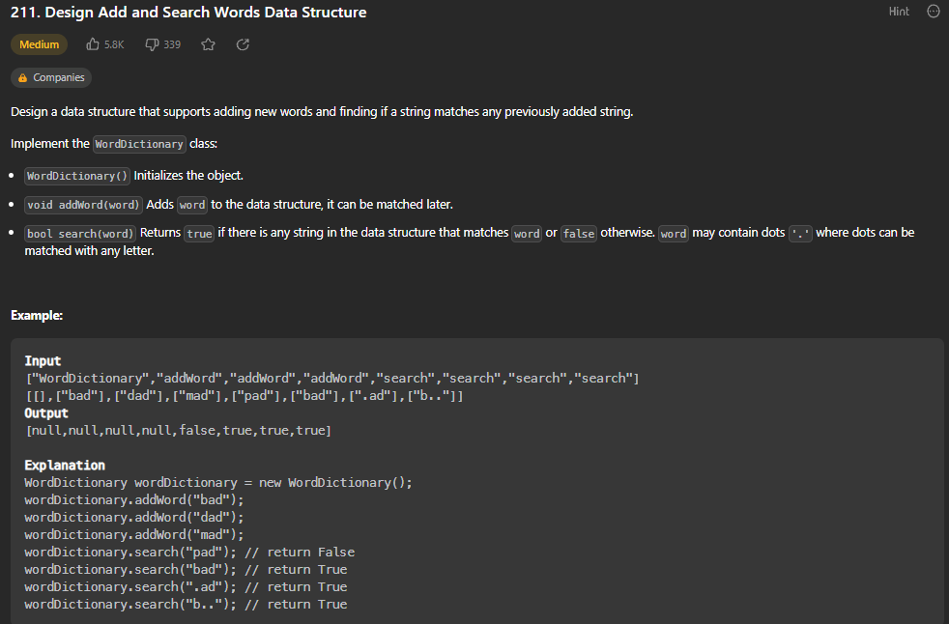

class TrieNode:

    def __init__(self):

        self.children = {}

        self.endOfWord = False

class WordDictionary:

    def __init__(self):

        self.root = TrieNode()

    def addWord(self, word: str) -> None:

        cur = self.root

        for c in word:

            if c not in cur.children:

                cur.children[c] = TrieNode()

            cur = cur.children[c]

        cur.endOfWord = True

    def search(self, word: str) -> bool:

        def dfs(j, root):

            cur = root

            for i in range(j, len(word)):

                c = word[i]

                if c == ".":

                    for child in cur.children.values():

                        if dfs(i+1, child):

                            return True

                    return False

                else:

                    if c not in cur.children:

                        return False

                    cur = cur.children[c]

            return cur.endOfWord

        return dfs(0, self.root)

Same as previous problem, except for the search function. Use a recursive dfs function that uses j to keep track of level of trie essentially. If the character is a “.”, you need to go through the children of the current node and see if there is a match to the next letter in word you’re searching for. For the first dfs call, j is 0 for start of word.

**Word Search II**

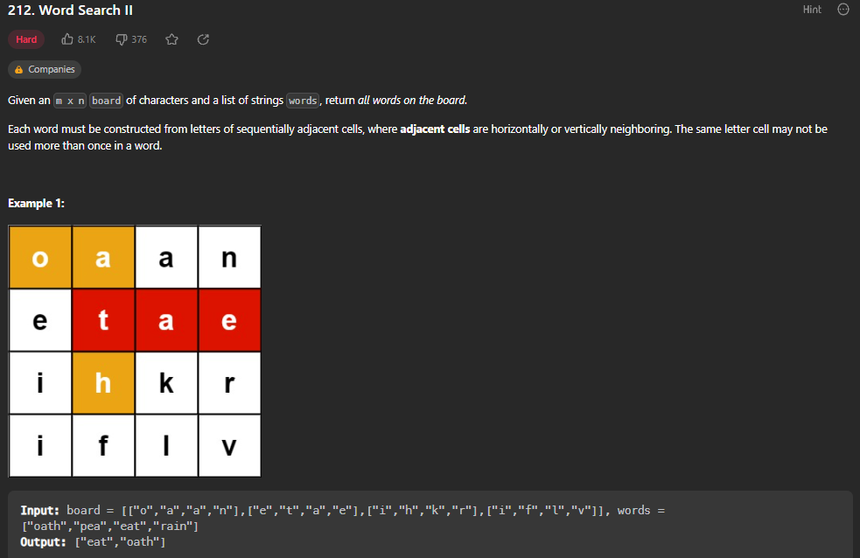

class TrieNode:

    def __init__(self):

        self.children = {}

        self.endOfWord = False

    def addWord(self, word):

        cur = self

        for c in word:

            if c not in cur.children:

                cur.children[c] = TrieNode()

            cur = cur.children[c]

        cur.endOfWord = True

class Solution:

    def findWords(self, board: List[List[str]], words: List[str]) -> List[str]:

        root = TrieNode()

        for w in words:

            root.addWord(w)

        ROWS, COLS = len(board), len(board[0])

        res, visit = set(), set()

        def dfs(r, c, node, word):

            if (r < 0 or c < 0 or r == ROWS or c == COLS or (r, c) in visit or board[r][c]  not in node.children):

                return

            visit.add((r, c))

            node = node.children[board[r][c]]

            word += board[r][c]

            if node.endOfWord:

                res.add(word)

            dfs(r-1, c, node, word)

            dfs(r+1, c, node, word)

            dfs(r, c-1, node, word)

            dfs(r, c+1, node, word)

            visit.remove((r, c))

        for r in range(ROWS):

            for c in range(COLS):

                dfs(r, c, root, "")

        return list(res)

Create TrieNode class with a function to add a word to the trie. In findWords function, first create the root node as an empty TrieNode. Then, for each word in the list of words, add it to the trie with the TrieNode addword function. Now, set a ROW and COL pointer, and create two sets to store the result and visited. Now, use a recursive dfs passing in the current row, column, node, and word. If row/column is out of bounds, or the node at (r,c) is in visited or the node is not in children, exit the dfs. Else, Add the row,col to visit set. Since we got to new character, set node to children of the node we just visited. Add the new letter to the word (that is passed in as parameter). If this node is end of word, add it to the result set. Else, do dfs recursively on the adjacent nodes to this node and then remove it from the visited set. Then, go through every position on the grid and call dfs from each starting position, with the word initially being empty.

**Kth Largest Element in a Stream**

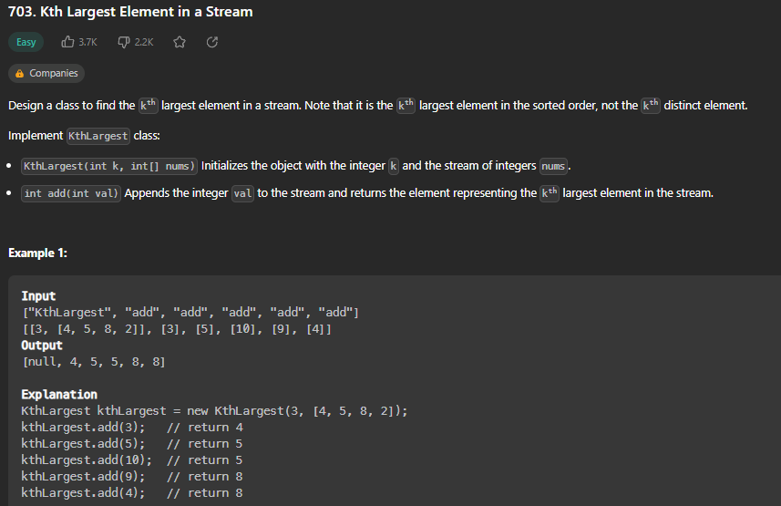

class KthLargest:

    def __init__(self, k: int, nums: List[int]):

        # min heap with K largest integers

        self.minHeap, self.k = nums, k

        heapq.heapify(self.minHeap) # turns array into heap

        while len(self.minHeap) > k:

            heapq.heappop(self.minHeap)

    def add(self, val: int) -> int:

        heapq.heappush(self.minHeap, val)

        if len(self.minHeap) > self.k:

            heapq.heappop(self.minHeap)

        return self.minHeap[0]

Min Heap can add/pop at O(log n) and find the minimum at O(1). Turning an array into a heap is O(n) with heapify function. For a max heap, we would multiply everything by -1. Goal is to create a heap the length of K so that when we return the minimum of the heap, it is also the Kth element. To initialize the heap, first name an array (self.minHeap) and k (self.k). Then, use heapq python module and heapify on the array. Now, while the heap is larger than k, we want to pop the minimum from it. In add function, we will add the value no matter what with heappush, and then if the size is bigger than k, we pop minimum again. With heaps, the minimum is always stored at 0 index, so return self.minHeap[0].

**Last Stone Weight**

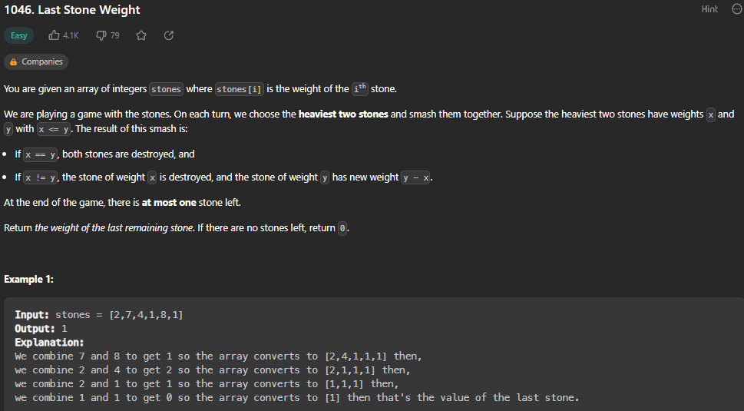

def lastStoneWeight(self, stones: List[int]) -> int:

        stones = [-s for s in stones] # multiply each stone by -1 for Max Heap Functionality

        heapq.heapify(stones)

        while len(stones) > 1:

            first = heapq.heappop(stones)

            second = heapq.heappop(stones)

            if second > first:

                heapq.heappush(stones, first - second)

        stones.append(0)

        return abs(stones[0])

Create a Max Heap by using the heapify function on a list of the stone weights, converted to negative numbers because python does not have a max heap function, only min heap. Then, while there are more than 1 stone, pop the two biggest (front of max heap) and re-add the difference between the two stones as a new smaller stone. If they are same weight, don’t add anything because we’ve already popped both and they are destroyed. At the end of while loop, add a 0 weight stone, so that if both stones were destroyed there is a 0 in the heap to return. Return the absolute value of stones[0].

A heap is a special tree structure where each parent node is less than or equal to child node. (Min Heap). Import heapq module in python.

Heapify – Converts a regular list to a heap. In the resulting Heap, the smallest element gets pushed to index position 0. But rest of data elements are not necessarily sorted.

Heappush – Adds an element to the heap without altering the current heap

Heappop – ALWAYS Returns the smallest data element from heap

Heapreplace – Replaces the smallest data element with a new value supplied in function

**K Closest Points to Origin**

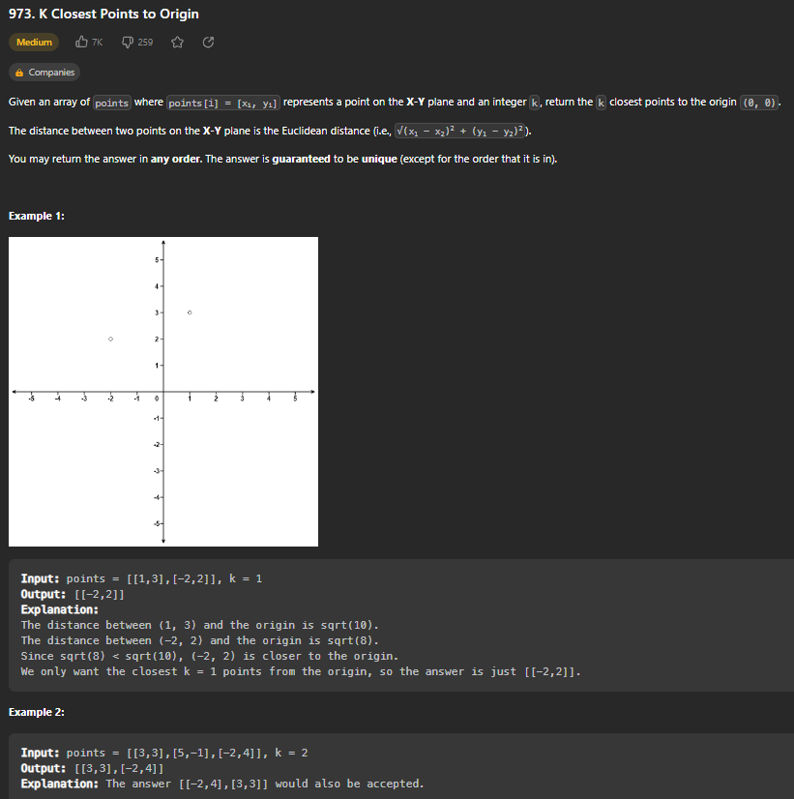

def kClosest(self, points: List[List[int]], k: int) -> List[List[int]]:

        minHeap = []

        result = []

        for x, y in points:

            distance = (x**2) + (y**2)

            minHeap.append([distance, x, y])

        heapq.heapify(minHeap)

        while k > 0:

            point = heapq.heappop(minHeap)

            result.append([point[1], point[2]])

            k -= 1

        return result

Min heap to store the points, with distance stored in 0 element of each list item. Return list of k points.

**Kth Largest Element in an Array**

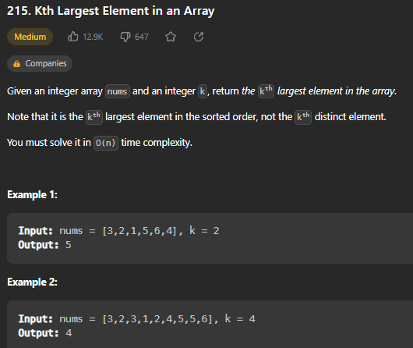

def findKthLargest(self, nums: List[int], k: int) -> int:

        k = len(nums)-k # the index we're looking for

        def quickSelect(l, r):

            pivot, p = nums[r], l

            for i in range(l, r): # not including r

                if nums[i] <= pivot:

                    nums[p], nums[i] = nums[i], nums[p]

                    p += 1

            nums[p], nums[r] = nums[r], nums[p]

            if p > k:

                return quickSelect(l, p-1)

            elif p < k:

                return quickSelect(p+1, r)

            else:

                return nums[p] # we know nums[p] is kth largest element

        return quickSelect(0, len(nums)-1)

Quick Select (much like quick sort algorithm) used to partition array and find the kth largest. Use the last number in array as pivot, and set p pointer to left pointer. For each number from start to r-1, if the number is less than or equal to pivot, swap them. Then, move p pointer to right. Then, swap nums[p] with nums[r]. If p > k, run again on left partition, elif p < k do on right partition, else return nums[p] because this has to be the kth largest element. REVIEW QUICK SORT ALGORITHM FOR THIS.

**Task Scheduler**

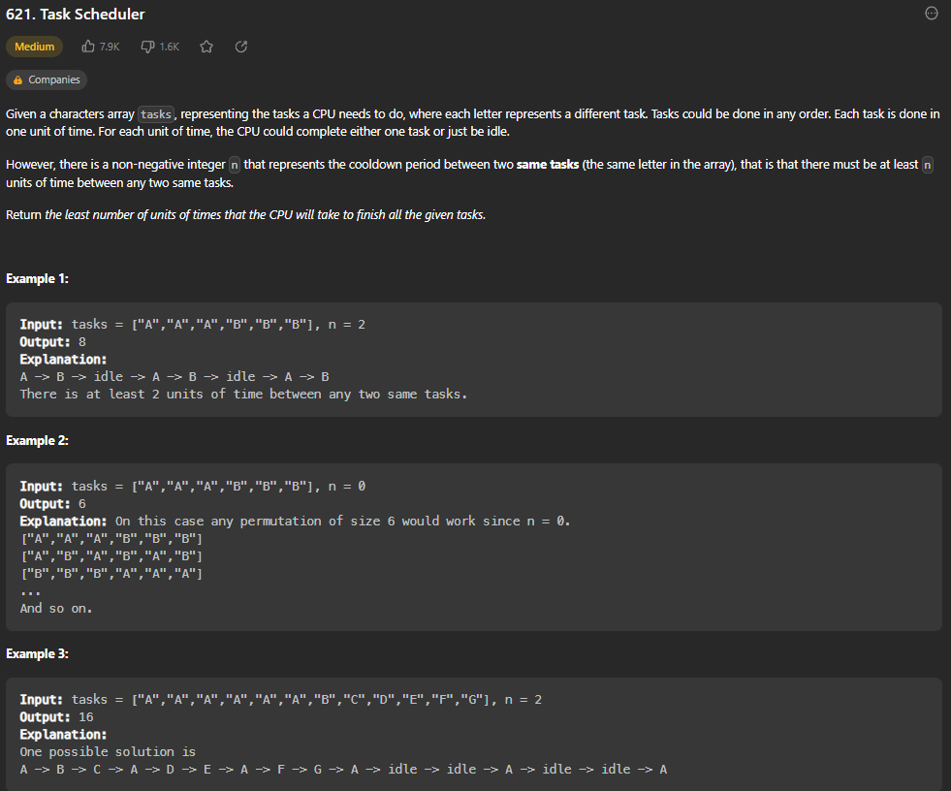

def leastInterval(self, tasks: List[str], n: int) -> int:

        count = Counter(tasks) # creates counter hashmap

        maxHeap = [-cnt for cnt in count.values()] # creates an array from the count hashmap

        heapq.heapify(maxHeap) # creates heap

        time = 0

        q = deque() # double ended queue # pairs of [-cnt, idleTime]

        while maxHeap or q:

            time += 1

            if maxHeap:

                cnt = 1 + heapq.heappop(maxHeap) # reduces count by 1 bc using negatives for maxHeap functionality

                if cnt:

                    q.append([cnt, time+n]) # adds the new count and the next time task is available to queue

            if q and q[0][1] == time:

                heapq.heappush(maxHeap, q.popleft()[0]) # because task is now available, add the count back to heap

        return time

Use Counter function to create hashmap with a count of all the tasks. Then, create an array with negative values of those counts (negative so that we can use a max heap). Then use heapify to turn it into a heap. Set time to 0 and create a deque. Essentially we will pop the largest task from heap, reduce the count of that task by 1, and then add it back to queue with the next available time for it to be used. Then we will check front of queue and if that task can be added back to heap, do it. Keep continuing and incrementing the time until heap and q are both empty.

**Design Twitter**

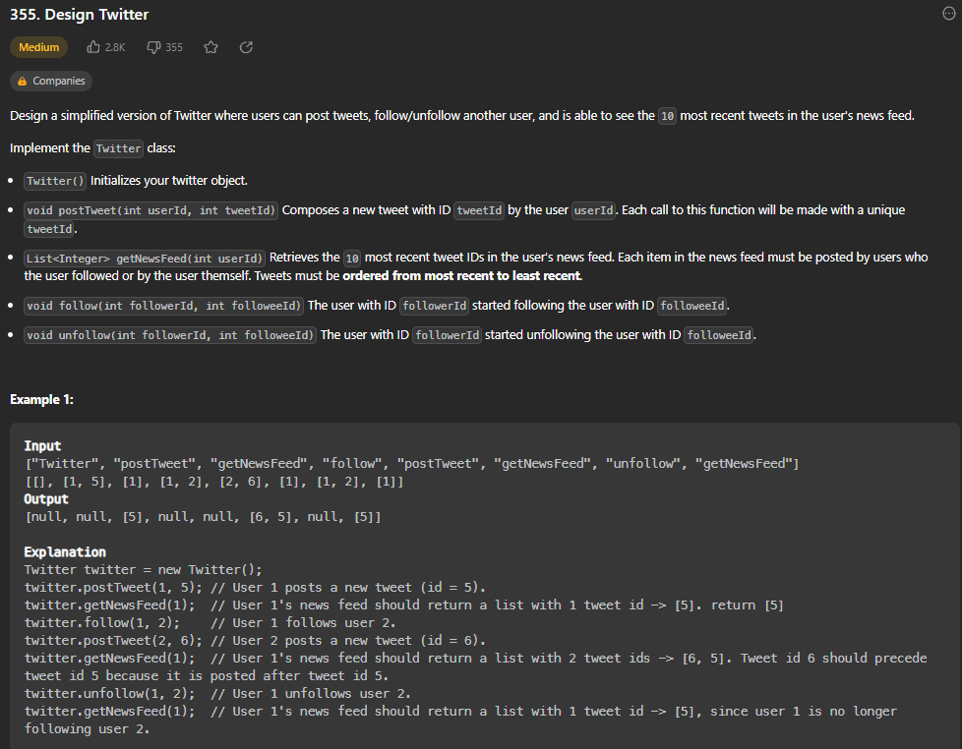

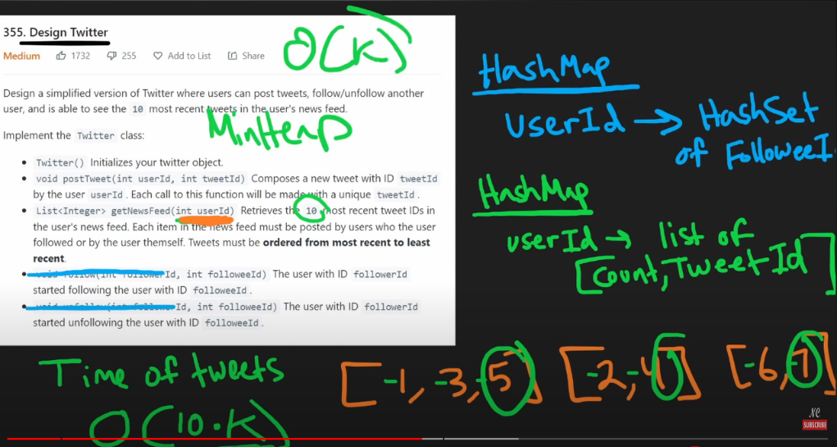

def __init__(self):

        self.time = 0

        self.tweetMap = defaultdict(list) # userId mapped to list of [time, tweetId]

        self.followMap = defaultdict(set) # userId mapped to set of followeeId

        # using default dicts (hashmaps) with python modules

    def postTweet(self, userId: int, tweetId: int) -> None:

        self.tweetMap[userId].append([self.time, tweetId])

        self.time -= 1 # decrement because we want negative times to use maxHeap functionality

    def getNewsFeed(self, userId: int) -> List[int]:

        res = [] # ordered starting from recent

        minHeap = [] # just a list for now

        self.followMap[userId].add(userId) # adds themselves to the user list so their own tweets also show

        for followeeId in self.followMap[userId]:

            if followeeId in self.tweetMap:

                index = len(self.tweetMap[followeeId]) - 1

                time, tweetId = self.tweetMap[followeeId][index]

                minHeap.append([time, tweetId, followeeId, index - 1]) # include followeeId bc we want to get the next most recent tweet for this user, and index - 1 to tell which tweet to add

        heapq.heapify(minHeap)

        while minHeap and len(res) < 10:

            time, tweetId, followeeId, index = heapq.heappop(minHeap)

            res.append(tweetId)

            if index >= 0:

                time, tweetId = self.tweetMap[followeeId][index]

                heapq.heappush(minHeap, [time, tweetId, followeeId, index - 1])

        return res

    def follow(self, followerId: int, followeeId: int) -> None:

        self.followMap[followerId].add(followeeId)

    def unfollow(self, followerId: int, followeeId: int) -> None:

        if followeeId in self.followMap[followerId]:

            self.followMap[followerId].remove(followeeId)

HashSet allows add and remove follower list at O(1). Merge K Sorted List concepts used for getNewsFeed() function. Constructor will keep track of a time, starting at 0, and create a hashmap (TWEETMAP) mapping a userId to a LIST of [time, tweetId], as well as a hashmap (FOLLOWMAP) mapping a userId to a SET of followeeIds. (Set used so that add/remove can be O(1). To follow or unfollow, simply add or remove the that followeeId from the followerId’s set. To post a tweet, go to the hashmap of user’s tweets and append a new list, with the current time and tweetId. Then, update the time (would be +1, but we use -1 because we want negative times for maxheap functions.) To get the news feed, first create a blank list called res. Then create another list that will turn into the minheap. We use same concepts as Merge K Sorted Lists here. First add the user’s own tweets to the set so that their own tweets show. Now, for each followeeId in the user’s followMap, if that followeeId has tweets posted, store the index (length of the tweetmap -1, in order to find that users most recent tweet index), the time and tweetId of the most recent tweet at said index, and add it to the minheap LIST (hasn’t been heapify’d yet). After doing this for every followeeId, heapify the list. Then use Merge K Sorted Lists concept. While the minheap isn’t empty (tweets still exist) and we haven’t found 10 tweets yet (len(res) < 10), pop from the heap (will pop the most recent tweet with minimum time), and store that tweets time, tweetId, followId, and index. Add the tweetId to the result list. If index is greater or equal to 0 (still more tweets for this followee), go get the next tweet and push it to the heap (index – 1). At the end, return res.

**Find Median from Data Stream**

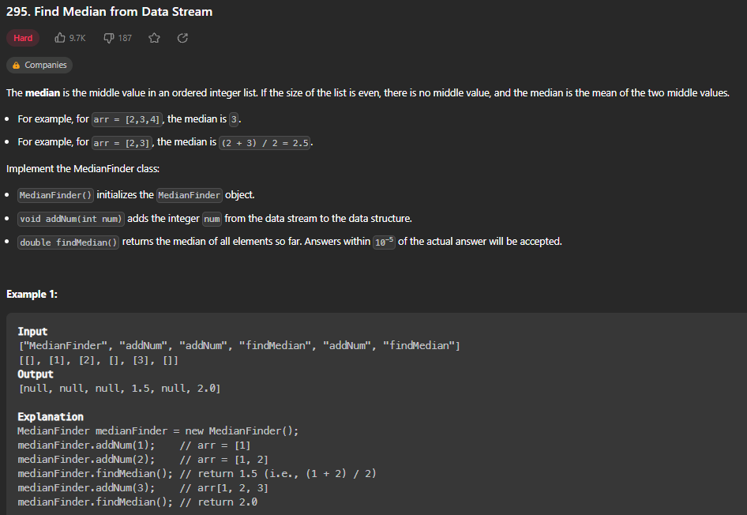

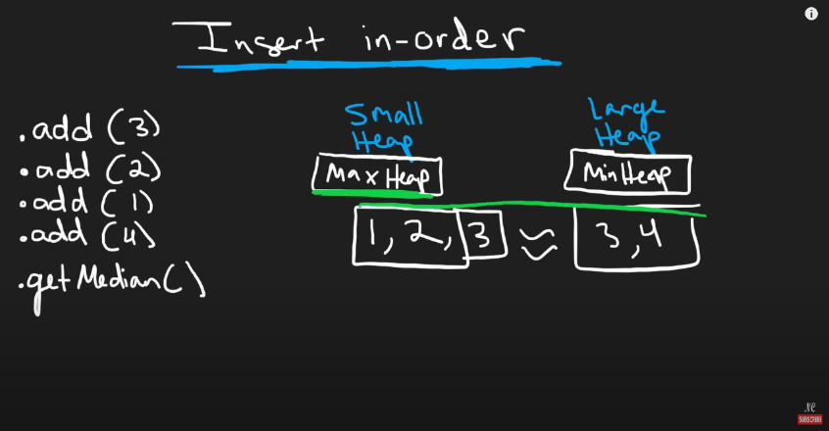

def __init__(self):

        # using two heaps, small (maxheap) and large (minheap)

        self.small, self.large = [], []

    def addNum(self, num: int) -> None:

        heapq.heappush(self.small, -1 * num) # add number to the small heap, negative 1 for max heap

        # next, make sure every num in small is <= every in large

        if (self.small and self.large and (-1 * self.small[0]) > self.large[0]): # multiply the max of small heap by -1 again, and compare it to min of large heap

            val = -1 * heapq.heappop(self.small) # making it a positive number for minheap

            heapq.heappush(self.large, val)

        # check for uneven size

        if len(self.small) > len(self.large) + 1:

                val = -1 * heapq.heappop(self.small) # making it a positive number for minheap

                heapq.heappush(self.large, val)

        if len(self.large) > len(self.small) + 1:

                val = heapq.heappop(self.large) # making it a negative number for maxheap

                heapq.heappush(self.small, -1 * val)

    def findMedian(self) -> float:

        if len(self.small) > len(self.large):

            return -1 * self.small[0]

        if len(self.large) > len(self.small):

            return self.large[0]

        return (((-1 * self.small[0]) + self.large[0]) / 2)

Note: Adding or removing from heap is O(log n) and finding the min/max is O(1). Use a max heap (small heap) and min heap (large heap) to keep track of the middle of data stream. Always add the new number to the small heap. Then, make sure every num in small is less than or equal to every num in large. If not, remove it from small heap and add it to large heap or vice versa. To find median, if small heap is bigger than large heap, then the median is the maxof small heap (small[0]) and vice versa if large is bigger than small. If same size, add the two values together and divide by 2.

def __init__(self):

        self.nums = []

    def addNum(self, num: int) -> None:

        self.nums.append(num)

    def findMedian(self) -> float:

        store = []

        if len(self.nums) % 2:

            mid = (len(self.nums) // 2)

            heapq.heapify(self.nums)

            while mid > 0:

                minimum = heapq.heappop(self.nums)

                store.append(minimum)

                mid -= 1

            median = self.nums[0]

            for number in store:

                heapq.heappush(self.nums, number)

            store.clear()

            return median

        else:

            mid = (len(self.nums) // 2) - 1

            heapq.heapify(self.nums)

            while mid > 0:

                minimum = heapq.heappop(self.nums)

                store.append(minimum)

                mid -= 1

            val1 = heapq.heappop(self.nums)

            val2 = heapq.heappop(self.nums)

            store.append(val1)

            store.append(val2)

            median = (val1 + val2) / 2

            for number in store:

                heapq.heappush(self.nums, number)

            store.clear()

            return median

My original solution, TIME LIMIT EXCEEDED.

**Subsets**

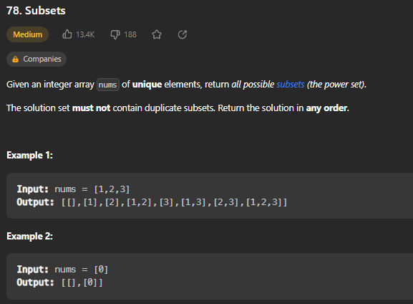

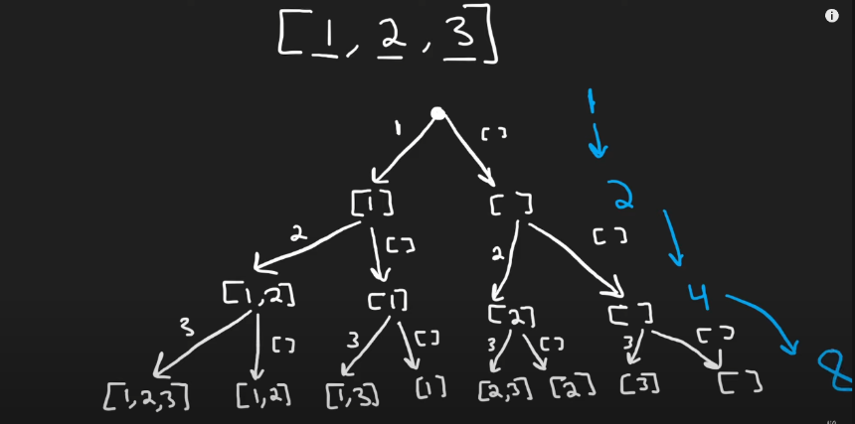

def subsets(self, nums: List[int]) -> List[List[int]]:

        res = []

        subset = []

        def dfs(i): # pass in index of the value we make decisions on

            if i >= len(nums):

                res.append(subset.copy())

                return

            # decision to include nums[i]

            subset.append(nums[i])

            dfs(i + 1)

            # decision to not include nums[i]

            subset.pop()

            dfs(i + 1)

        dfs(0)

        return res

Recursive function that backtracks and at each step either adds the next value or doesn’t.

**Combination Sum**

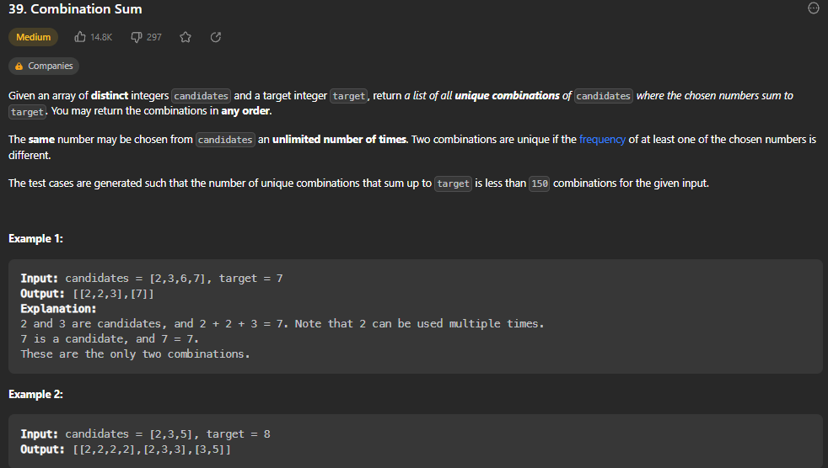

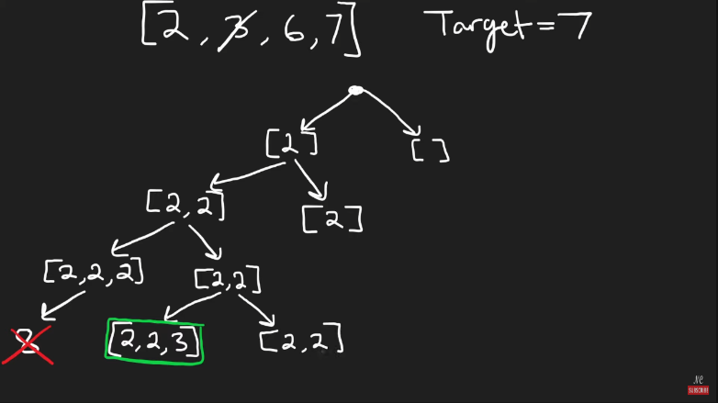

def combinationSum(self, candidates: List[int], target: int) -> List[List[int]]:

        res = []

        def dfs(i, cur, total):

            if total == target:

                res.append(cur.copy()) # return copy so we can keep using cur for future recursive calls

                return

            if i >= len(candidates) or total > target:

                return

            # include previous number again

            cur.append(candidates[i])

            dfs(i, cur, total + candidates[i])

            # don't include previous number again

            cur.pop()

            dfs(i + 1, cur, total)

        dfs(0, [], 0)

        return res

Recursive function that decides whether to repeat an already used number or not to avoid duplicates. (See drawing picture)

**Permutations**



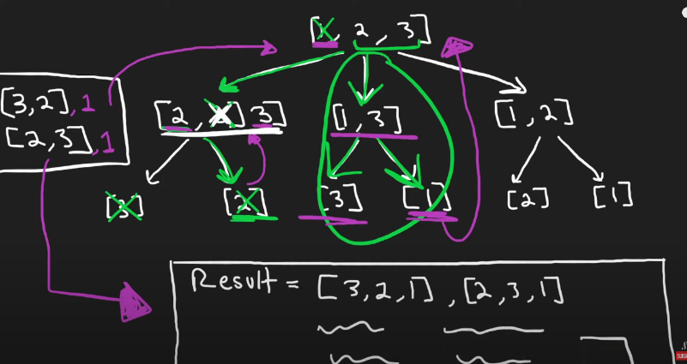

def permute(self, nums: List[int]) -> List[List[int]]:

        if not nums:

            return []

        n = len(nums)

        permutations = []

        def backtrack(path, hashset):

            if len(path) == n:

                permutations.append(path.copy())

                return

            for num in nums:

                if num not in hashset:

                    path.append(num)

                    hashset.add(num)

                    backtrack(path, hashset)

                    path.pop()

                    hashset.remove(num)

        backtrack([], set())

        return permutations

**Subsets II**

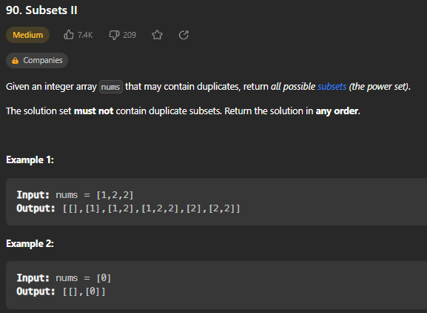

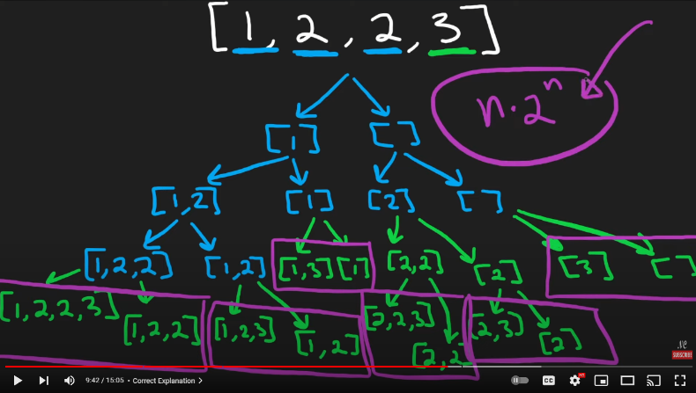

def subsetsWithDup(self, nums: List[int]) -> List[List[int]]:

        result = []

        nums.sort() # O(nlogn) which is insignificant in O(n*2^n) so fine

        def backtrack(i, subset):

            if i == len(nums):

                result.append(subset[::]) # use a copy ([::]) bc array will keep being used recursively

                return

            # All subsets that include nums[i]

            subset.append(nums[i])

            backtrack(i+1, subset)

            subset.pop()

            # All subsets that don't include nums[i]

            while i+1 < len(nums) and nums[i] == nums[i+1]:

                i += 1

            backtrack(i+1, subset)

        backtrack(0, [])

        return result

Recursive function that backtracks and at each step either adds the next value or doesn’t. This method avoids duplicates by moving i pointer more than once if consecutive numbers are equal in input array. (This is possible because we sort at the beginning)

**Combination Sum II**

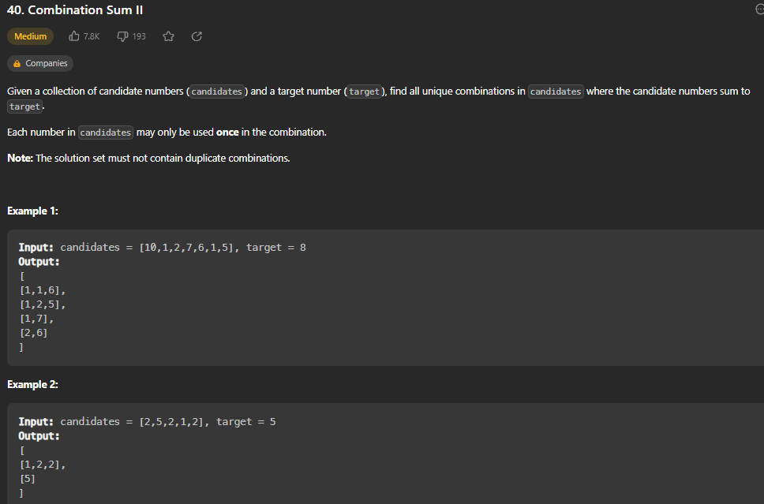 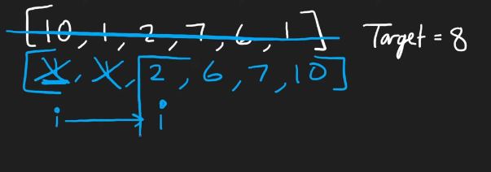

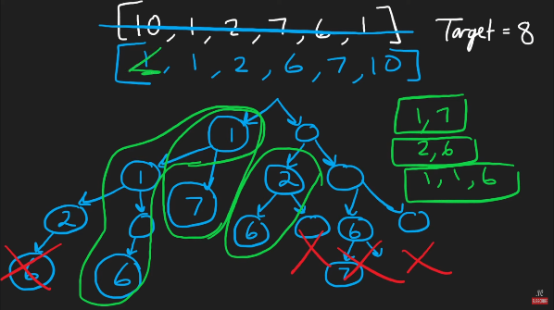

def combinationSum2(self, candidates: List[int], target: int) -> List[List[int]]:

        candidates.sort()

        res = []

        def backtrack(cur, pos, target):

            if target == 0:

                res.append(cur.copy()) # still want to be able to modify cur during recursive calls

            if target <= 0:

                return

            prev = -1 # just initialize it to a value that wont exist in input

            for i in range(pos, len(candidates)):

                if candidates[i] == prev:

                    continue

                cur.append(candidates[i])

                backtrack(cur, i+1, target - candidates[i])

                cur.pop()

                prev = candidates[i]

        backtrack([], 0, target)

        return res

Brute force backtracking problem O(2^n). First, sort the input array, and create an empty list called res. Use a recursive function called backtrack that uses cur (the current combinations), pos (the current position in input array) and target (the target we must sum to). If the target == 0, we know that we have a possible combination and can append a copy of cur to the res array. If target is <= 0, can just return because we wont find any more combinations in this path as its sorted. Set prev to -1 as a default initialization because it cannot be found in input array. Then, for i in range from the current position in array to the end (len(candidates)), if candidates[i] is the same as prev, we continue (this is how we avoid duplicates). Then, append candidates[i] to the current combination, and call backtrack recursively using the cur combination, i+1, and the new target which is the target minus the candidates[i] which we just added. After recursive call, pop it from cur and set previous to that candidates[i] value. At the end, call backtrack with starting parameters and return the res array.

**Word Search**

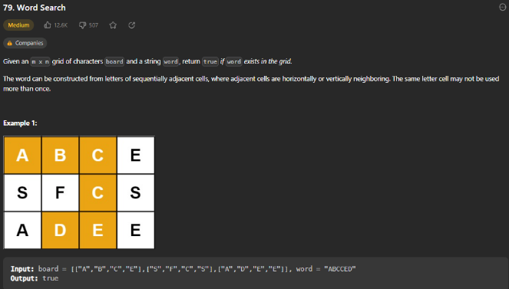

def exist(self, board: List[List[str]], word: str) -> bool:

        ROWS, COLS = len(board), len(board[0])

        path = set() # use set to avoid revisiting a letter

        def dfs(r, c, i):

            if i == len(word):

                return True

            if (r < 0 or c < 0 or r >= ROWS or c >= COLS or word[i] != board[r][c] or (r,c) in path):

                return False

            path.add((r, c))

            result = (dfs(r+1, c, i+1) or

                    dfs(r-1, c, i+1) or

                    dfs(r, c+1, i+1) or

                    dfs(r, c-1, i+1))

            path.remove((r, c)) # no longer visiting this spot

            return result

        # To prevent TLE, reverse the word if frequency of the first letter is more than the last letter's

        count = defaultdict(int, sum(map(Counter, board), Counter()))

        if count[word[0]] > count[word[-1]]:

            word = word[::-1]

        for r in range(ROWS):

            for c in range(COLS):

                if dfs(r, c, 0):

                    return True

        return False

            # O(n * m * dfs) dfs tc = 4^len(word)

            # O(n * m * 4^n)

Store number of rows and columns. Create a set called path. Use a recursive dfs function that takes in r (the current row), c (the current column) and i (the current index). If i == len(word), we can return True because that means word has been found. If r < 0 or c < 0 or r >= ROWS or c >= COLS (pointers are out of bounds), or word[i] is not equal to board[r][c] (letter that we need has not been found) Or (r,c) is in path (we’ve already checked this letter in this path, can’t reuse), return FALSE. Otherwise, add this (r,c) to path set. Then, call it recursively on each possible adjacent square on board and store this Boolean value in result. (if any of the adjacent spots are the next letter needed, it will evaluate to true). At end of all these recursive calls, remove this (r,c) from the path to restart new path. Return result (will be true or false).

**Palindrome Partitioning**

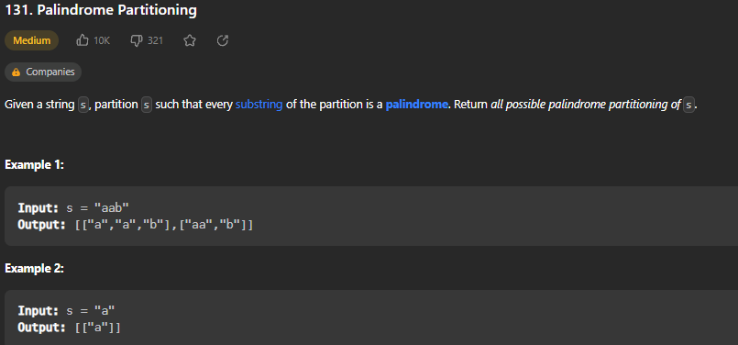

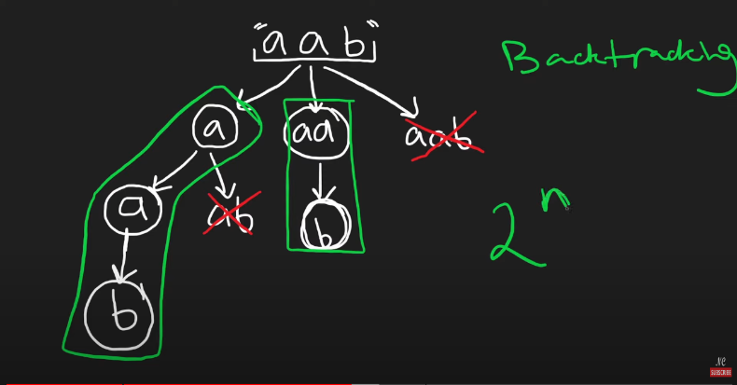

def partition(self, s: str) -> List[List[str]]:

        result = []

        def palindrome(part):

            return part == part[::-1]

        def dfs(i,cur):

            if i == len(s):

                result.append(cur)

                return

            for j in range(i,len(s)):

                part = s[i:j+1]

                if palindrome(part):

                    dfs(j+1, cur + [part] )

            return

        dfs(0,[])

        return result

Create helper function palindrome that takes in a word and returns True or False if it is a palindrome. Use recursive dfs function that passes in the index and cur partition. If i == len(s), add it to the result list because we know there are no more letters to add. For each letter(j) from I to the end of s, store the partition from I to j (j+1 for range functionality). If this partition is a palindrome, call dfs again, moving j over 1 and using cur + the partition as new cur. At start, call dfs with index of 0 and return the result list at end.

**Letter Combinations of a Phone Number**

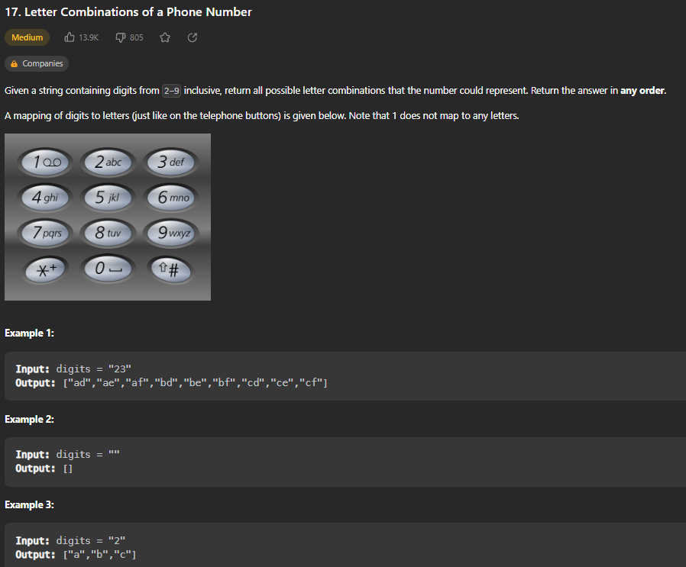

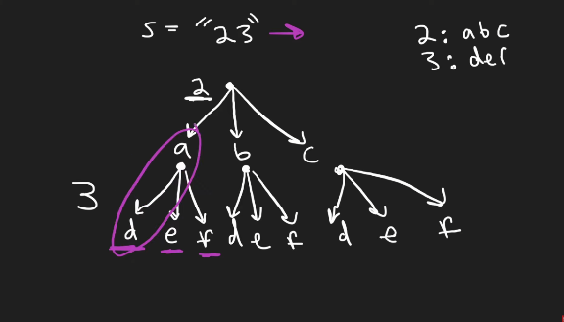

def letterCombinations(self, digits: str) -> List[str]:

        result = []

        chars = {

            "2": "abc",

            "3": "def",

            "4": "ghi",

            "5": "jkl",

            "6": "mno",

            "7": "qprs",

            "8": "tuv",

            "9": "wxyz" }

        def backtrack(i, cur):

            if len(cur) == len(digits):

                result.append(cur)

                return

            for char in chars[digits[i]]:

                backtrack(i+1, cur + char)

        if digits: # because question wants empty list for no digits given, not ""

            backtrack(0, "")

        return result

Hard code the digits to numbers dictionary. Use a recursive backtrack function that takes in the index and current string. If the len(cur) == len(digits), append cur to the results list (no more digits to translate to letters). For each character in the map/dictionary for the digit given, call backtrack again recursively on i+1, and update cur to cur + char that was previously visited. If digits are empty, don’t want this to be called and instead return [] instead of “”.

**N-Queens**

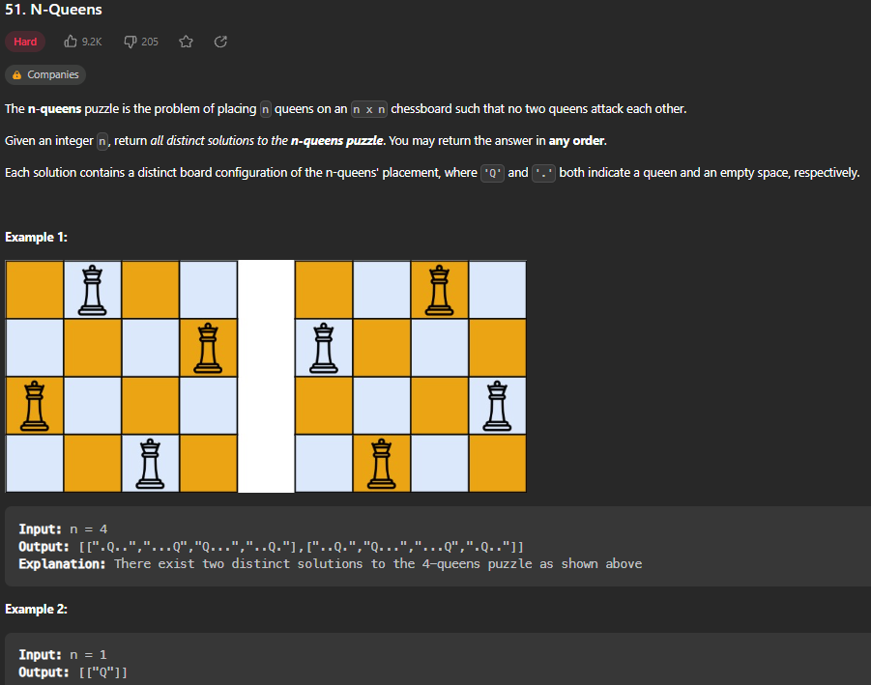

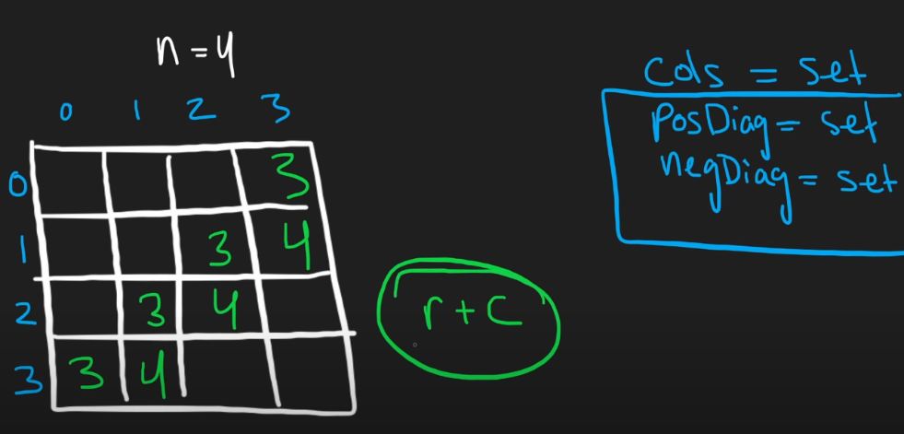

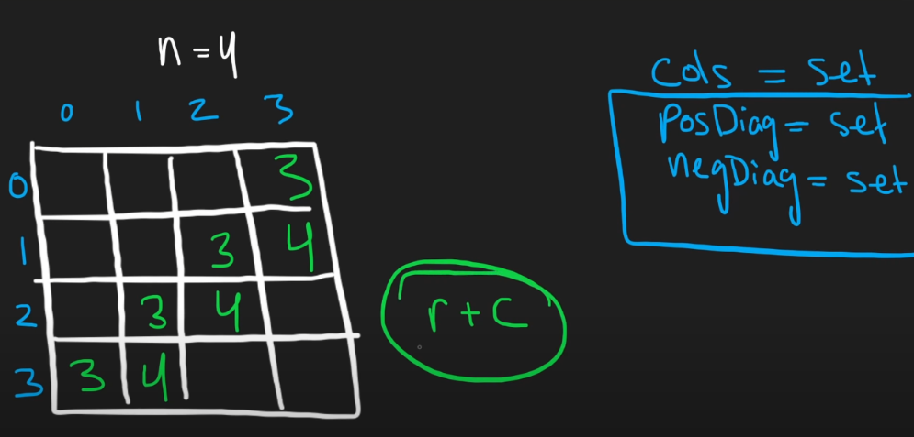

def solveNQueens(self, n: int) -> List[List[str]]:

        col = set()

        posD = set() # r + c

        negD = set() # r - c

        result = []

        board = [["."] * n for i in range(n)] # creates blank board with number of rows = number of queens (n)

        def backtrack(r):

            if r == n:

                copy = ["".join(row) for row in board] # problem wants list of strings for rows

                result.append(copy)

                return

            for c in range(n):

                if c in col or (r+c) in posD or (r-c) in negD:

                    continue

                col.add(c)

                posD.add(r+c)

                negD.add(r-c)

                board[r][c] = "Q"

                backtrack(r+1)

                # cleanup backtrack by removing what we just did to see if there are other possible solutions (doesn’t get to cleanup until something fails or r==n.)

                col.remove(c)

                posD.remove(r+c)

                negD.remove(r-c)

                board[r][c] = "."

        backtrack(0)

        return result

Create 3 sets to store the columns, positive diagonals and negative diagonals used. Create an empty list of boards called result. Then create an empty board with “.” Representing an empty square. If r == n (we’ve gotten to bottom of board and have a solution), create a copy of the board and turn the rows into strings with join(row) function. Then append it to the result list. For each column in range(n), if c is already used, or r+c (positive diagonal) is already used or r-c (negative diagonal) is already used, continue on. If not, add that c to the col set, r+c to the posD set, and r-c to the negD set, and update the board spot at board[r][c] to be a “Q”. Next, call backtrack recursively on the next row (r+1). After backtracking, do cleanup by reversing what was don’t before recursive call. To begin, call backtrack on row 0 and return the result list.

**Number of Islands (BREADTH FIRST SEARCH GRAPH ALGORITHM)**

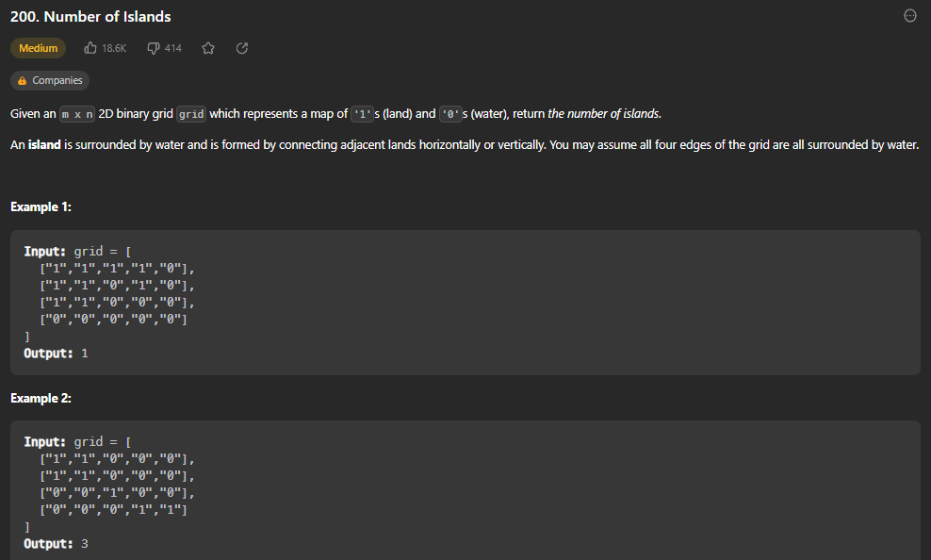

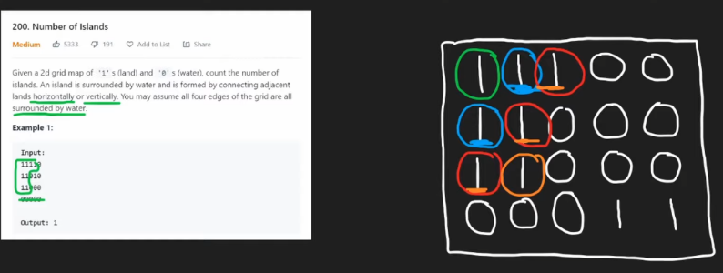

def numIslands(self, grid: List[List[str]]) -> int:

        if not grid:

            return 0

        rows, cols = len(grid), len(grid[0])

        visited = set()

        islands = 0

        def bfs(r, c): # bfs is iterative, not recursive

            q = collections.deque()

            visited.add((r, c))

            q.append((r, c))

            while q:

                row, col = q.popleft()

                directions = [[1,0], [-1,0], [0, 1], [0, -1]]

                for dr, dc in directions:

                    r, c = row + dr, col + dc

                    if (r in range(rows) and c in range(cols) and grid[r][c] == "1" and (r, c) not in visited):

                        q.append((r, c))

                        visited.add((r, c))

        for r in range(rows):

            for c in range(cols):

                if grid[r][c] == "1" and (r,c) not in visited: # (r,c) not in visited means new island

                    bfs(r, c)

                    islands += 1

        return islands

Store number or rows and columns. Create a visited set. Store number of islands and set it to 0. Define BFS function that takes in row and column. In BFS function, create a q using collections.deque(), and add the current spot (r,c) to visited set and append it to queue. While q is not empty, popleft from queue and store the row and column. Create a list of possible directions we need to check from each current spot on grid. For each direction (dr, dc for row and column), if it is in bounds and it is land (“1”) and not yet visited, add it to queue and visited set as well. To start, go through and for each row in range(rows) and each column in range(cols), if the spot is land (“1”) and not visited, call bfs on it and increase islands by 1. Return the number of islands.

**Clone Graphs (DEPTH FIRST SEARCH GRAPH ALGORITHM)**

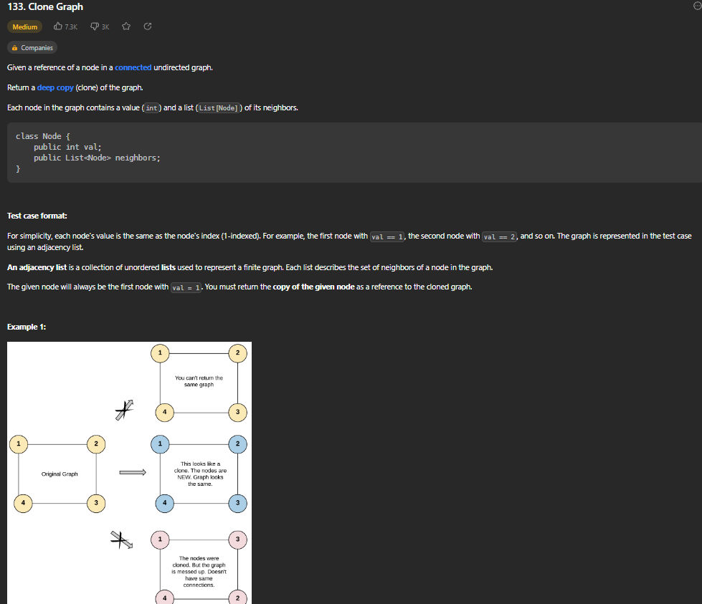

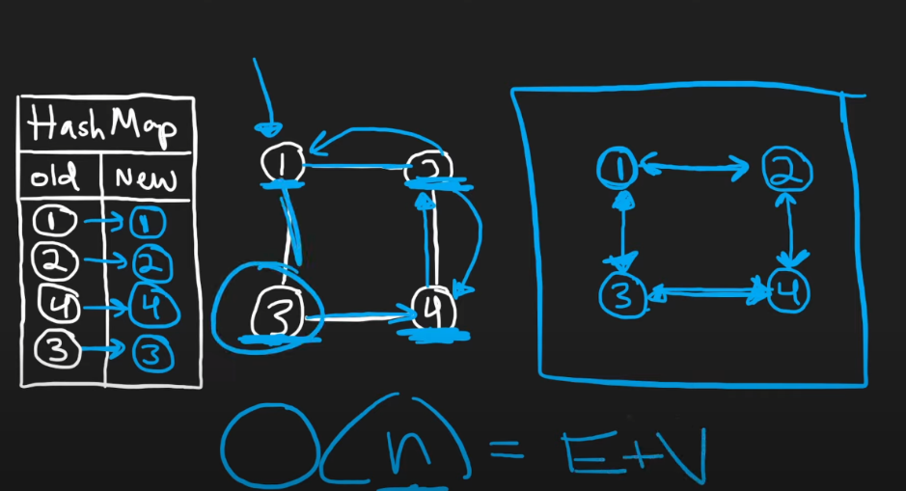

def cloneGraph(self, node: 'Node') -> 'Node':

        if not node:

            return None

        oldToNew = {}

        def dfsClone(node):

            if node in oldToNew:

                return oldToNew[node]

            copy = Node(node.val)

            oldToNew[node] = copy

            for neighbor in node.neighbors:

                copy.neighbors.append(dfsClone(neighbor))

            return copy

        return dfsClone(node)

Create a hashmap called oldToNew. Define a dfsClone method that takes in a node as parameter. If node is already in the oldToNew hashmap, return it. Otherwise, create a copy using the node’s val that is passed in. Then for each node in this node’s neighbor list, append the neighbors of it to the copy’s neighbor list recursively by calling dfsClone again on it. Return the copy node. To start, return dfsClone on the original node given.

**Max Area of Island**

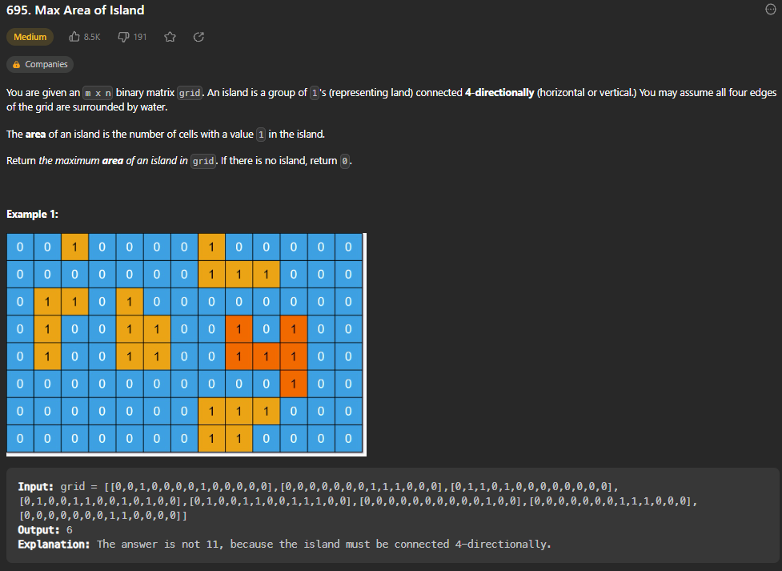

def maxAreaOfIsland(self, grid: List[List[int]]) -> int:

        rows, cols = len(grid), len(grid[0])

        visited = set()

        def dfs(r, c):

            if (r < 0 or r == rows or c < 0 or c == cols or grid[r][c] == 0 or (r,c) in visited):

                return 0

            visited.add((r,c))

            return 1 + dfs(r+1, c) + dfs(r-1, c) + dfs(r, c+1) + dfs(r, c-1)

        area = 0

        for r in range(rows):

            for c in range(cols):

                area = max(area, dfs(r,c))

        return area

Store the number of rows and columns. Create a set for visited spots on grid. Define a recursive dfs function that takes in the current row and column. If it is not inbounds or equals 0 or already been visited, return 0. Otherwise, add it to visited and return 1 + the dfs recursive call of the 4 adjacent spots on grid. Set area = 0. For each spot on the grid (for r in range rows, for c in range columns, area is equal to the max of the current area and the dfs of the current spot on grid. Return area.

**Pacific Atlantic Water Flow**

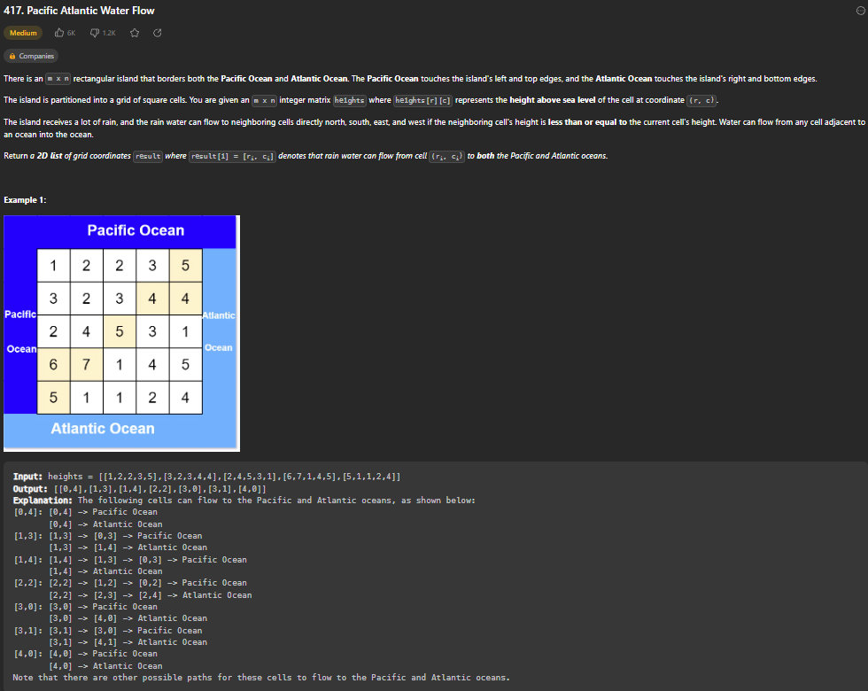

def pacificAtlantic(self, heights: List[List[int]]) -> List[List[int]]:

        ROWS, COLS = len(heights), len(heights[0])

        pacific, atlantic = set(), set()

        def dfs(r, c, visit, prevHeight):

            if ((r,c) in visit or r < 0 or c < 0 or r == ROWS or c == COLS or heights[r][c] < prevHeight):

                return

            visit.add((r,c))

            dfs(r+1, c, visit, heights[r][c])

            dfs(r-1, c, visit, heights[r][c])

            dfs(r, c+1, visit, heights[r][c])

            dfs(r, c-1, visit, heights[r][c])

        for c in range(COLS):

            dfs(0, c, pacific, heights[0][c]) # insert height of current for start

            dfs(ROWS - 1, c, atlantic, heights[ROWS-1][c])

        for r in range(ROWS):

            dfs(r, 0, pacific, heights[r][0])

            dfs(r, COLS - 1, atlantic, heights[r][COLS-1])

        output = []

        for r in range(ROWS):

            for c in range(COLS):

                if (r,c) in pacific and (r,c) in atlantic:

                    output.append([r,c])

        return output

Store the number of rows and columns. Create sets to track which spaces on grid can reach Atlantic and pacific oceans. Create a recursive dfs that takes in the current row, column, visited list, and the previous height. If the r,c is in visit set or rows or columns are out of bounds or the height is less than previous height, return. Otherwise, add this to visited and then do dfs on the surrounding spaces recursively. Then, for each c in range of columns, do dfs on boxes with row 0 (top of grid) and add those to pacific, then do same with right edge of grid for Atlantic. Now do same thing for rows to do left edge for pacific and bottom edge for Atlantic. Create an output list and add the (r,c)s that appear in both pacific and Atlantic. Return output.

**Surrounded Regions**

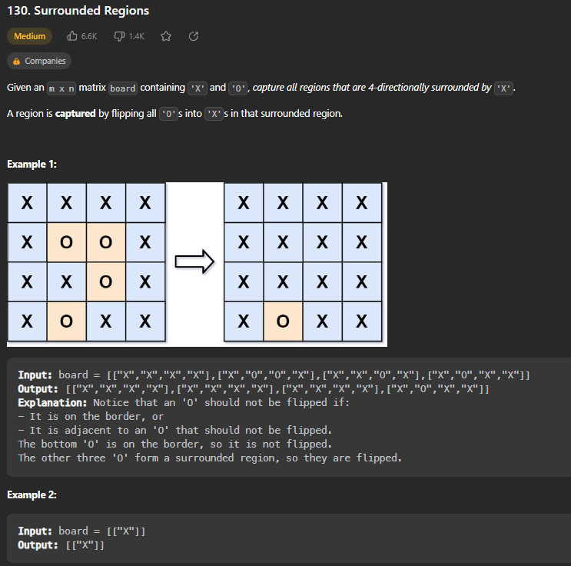

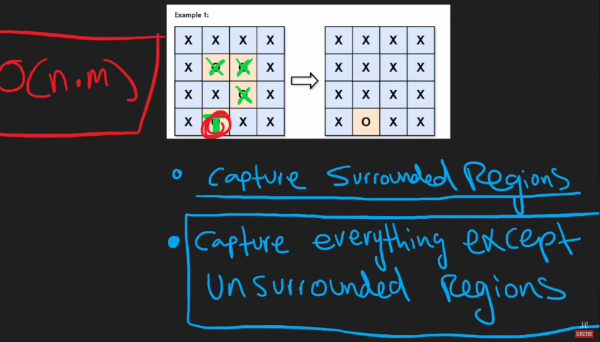

def solve(self, board: List[List[str]]) -> None:

        ROWS, COLS = len(board), len(board[0])

        def capture(r, c):

            if r < 0 or c < 0 or r == ROWS or c == COLS or board[r][c] != "O":

                return

            board[r][c] = "T"

            capture(r+1, c)

            capture(r-1, c)

            capture(r, c+1)

            capture(r, c-1)

        # Capture unsurrounded regions (O -> T) -- DFS

        for r in range(ROWS):

            for c in range(COLS):

                if (board[r][c] == "O" and (r in [0, ROWS - 1] or c in [0, COLS - 1])):

                    capture(r, c)

        # Capture surrounded regions (remaining Os -> X)

        for r in range(ROWS):

            for c in range(COLS):

                if board[r][c] == "O":

                    board[r][c] = "X"

        # Uncapture unsurrounded regions (T -> O)

        for r in range(ROWS):

            for c in range(COLS):

                if board[r][c] == "T":

                    board[r][c] = "O"

Store the number of rows and columns. Create a recursive capture function that takes in current r and c. If (r,c) is out of bounds or is not an “O”, return. Else, turn that space into a temporary value “T” and then run again on all surrounding spaces. Then, go through entire grid and turn the remaining O’s into X’s, and the remaining T’s back into O’s. REVERSE THINKING

**Rotting Oranges (Multi-Source BFS)**

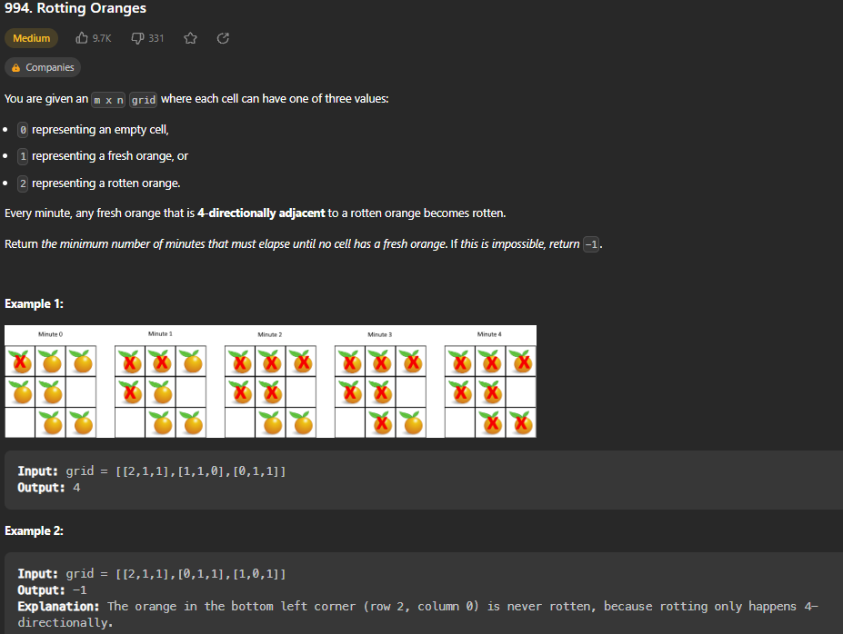

def orangesRotting(self, grid: List[List[int]]) -> int:

        q = deque()

        time, fresh = 0, 0

        ROWS, COLS = len(grid), len(grid[0])

        for r in range(ROWS):

            for c in range(COLS):

                if grid[r][c] == 1:

                    fresh += 1

                if grid[r][c] == 2:

                    q.append([r,c])

        directions = [[0, 1], [0, -1], [1, 0], [-1, 0]]

        while q and fresh > 0:

            for i in range(len(q)):

                r, c = q.popleft()

                for dr, dc in directions:

                    row, col = dr + r, dc + c

                    # if in bounds and fresh, make rotten

                    if (row < 0 or row == len(grid) or col < 0 or col == len(grid[0]) or grid[row][col] != 1):

                        continue

                    grid[row][col] = 2

                    q.append([row, col])

                    fresh -= 1

            time += 1

        return time if fresh == 0 else -1

Create a deque so we can use Breadth First Search. Initialize time and fresh counter to 0. Store ROWS and COLS. Use a nested for loop to go through each spot on grid and if it is a fresh orange (1), increase the fresh count. If it is rotten (2), append it’s (r,c) coordinates to the q. Then, create a list of directions to make it easier to check adjacents later. While q is not empty and fresh > 0, for each value in the q, popleft the left most rotten orange. For each dr, dc in directions (each possible movement up, down, left, and right), update the new row and col of what we are checking and if they are in bound and not fresh (!= 1), continue. Otherwise, set the fresh orange(1) to rotten (2) and append it to the q. decrement the number of fresh and then increment time by 1. Return time if all oranges have been affected, otherwise -1 if there is an orange that could not be touched.

**Course Schedule (Graph Adjacency List) - O(N+P)**

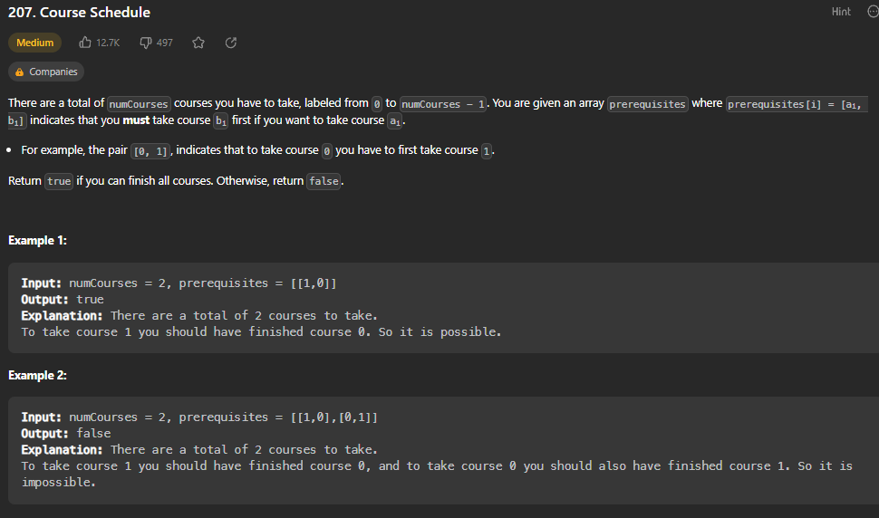

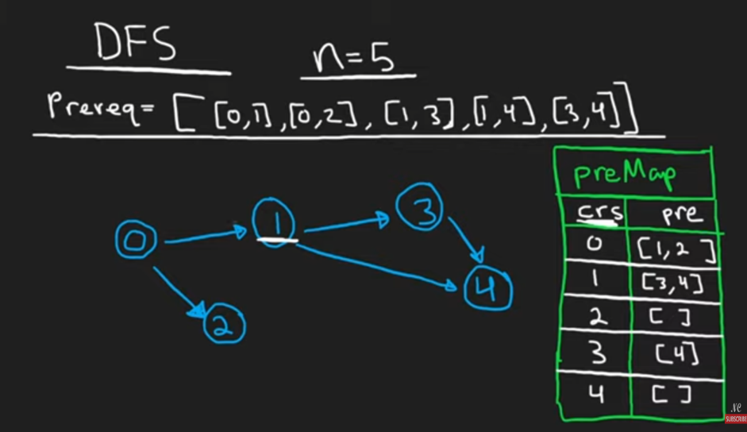

def canFinish(self, numCourses: int, prerequisites: List[List[int]]) -> bool:

        preMap = {i:[] for i in range(numCourses)} # maps each course to prereq list

        for crs, pre in prerequisites:

            preMap[crs].append(pre)

        #visitSet = all courses along the curr DFS path

        visitSet = set()

        def dfs(crs):

            if crs in visitSet:

                return False

            if preMap[crs] == []:

                return True

            visitSet.add(crs)

            for pre in preMap[crs]:

                if not dfs(pre): return False

            visitSet.remove(crs)

            preMap[crs] = []

            return True

        for crs in range(numCourses):

            if not dfs(crs): return False

        return True

Use a hashmap to store Adjacency List for graph. {i:[] for i in range(numCourses) means create an empty list for each value of i from 0 to number of courses. Then, for each course and its prereqs, append the pre to list for each crs key. Create a visited set. Define a dfs function that takes in the crs. If that crs is in visited set, return False. If it has no prereqs, return True. Otherwise, add the crs to the visitSet. Then, for each pre in that crs’s hashmap list, if not dfs(pre), return false. (If dfs returns false, meaning crs is not in visitSet). Otherwise, remove that crs from the visitSet and then clear its preMap list and return True. Do this for every course and at the end if you haven’t returned false yet, return True.

**Course Schedule II (Topological Sort) – O(N+P)**

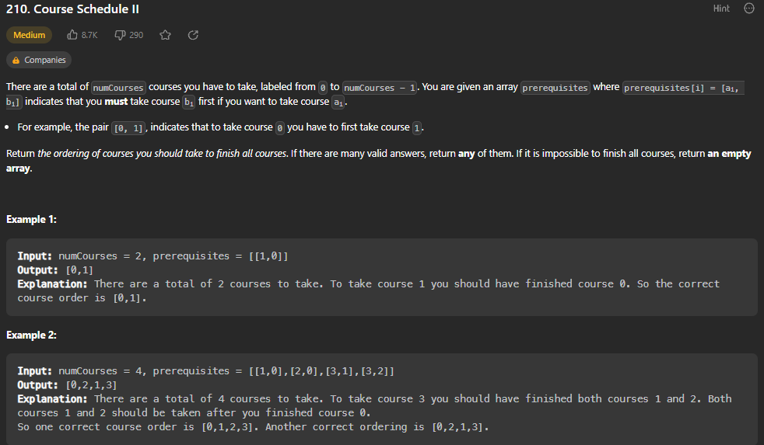

def findOrder(self, numCourses: int, prerequisites: List[List[int]]) -> List[int]:

        prereq = { c:[] for c in range(numCourses)}

        for crs, pre in prerequisites:

            prereq[crs].append(pre)

        output = []

        visit, cycle = set(), set()

        def dfs(crs):

            if crs in cycle:

                return False

            if crs in visit:

                return True

            cycle.add(crs)

            for pre in prereq[crs]:

                if dfs(pre) == False:

                    return False

            cycle.remove(crs)

            visit.add(crs)

            output.append(crs)

            return True

        for c in range(numCourses):

            if dfs(c) == False:

                return []

        return output

Use a hashmap to store Adjacency List for graph. {c:[] for c in range(numCourses) means create an empty list for each value of i from 0 to number of courses. Then, for each course and its prereqs, append the pre to list for each crs key. Create a visited and cycle set. Define a dfs function that takes in the crs. If that crs is in cycle set, return False. If that crs is in visit set, return True. Otherwise, add the crs to the cycle set. Then, for each pre in that crs’s hashmap list, if dfs(pre) == False, return False. Otherwise, remove that crs from the cycle and then add it to visit set. Append crs to output list and return True. Then, for each course, run dfs on them and if any dfs(c) is False, return an empty list. Otherwise, return the output list.

**Redundant Connection (UNION FIND)**

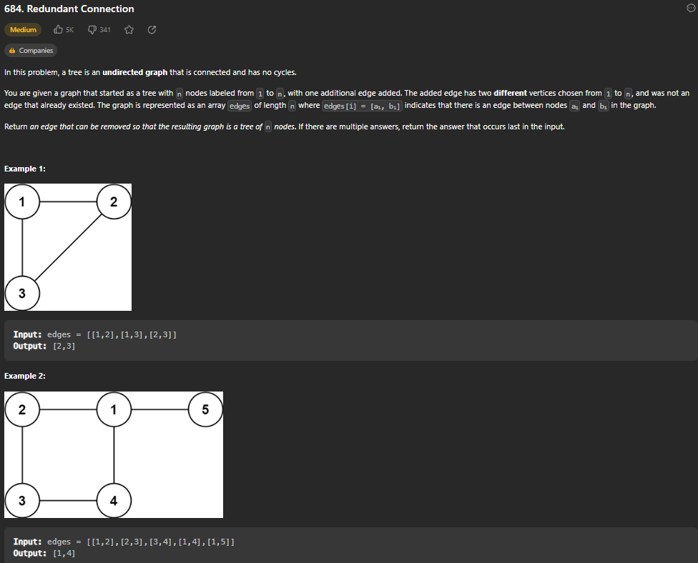

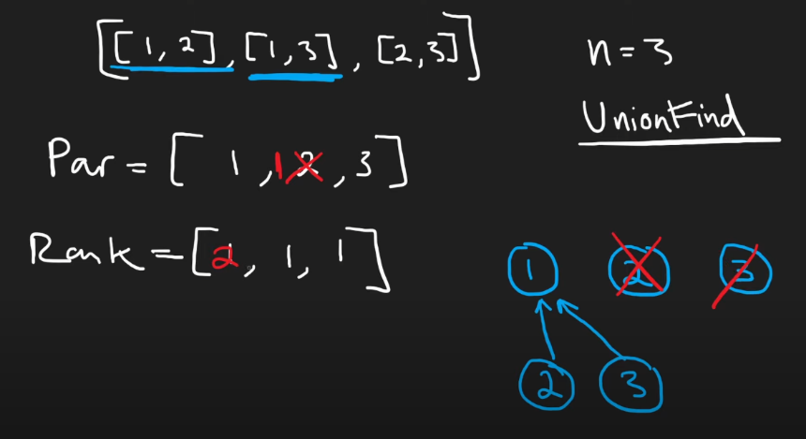

def findRedundantConnection(self, edges: List[List[int]]) -> List[int]:

        parent = [i for i in range(len(edges)+1)]

        rank = [1] * (len(edges)+1)

        def find(n):

            p = parent[n]

            while p != parent[p]:

                parent[p] = parent[parent[p]]

                p = parent[p]

            return p

        # Return false if cannot complete (already merged)

        def union(n1, n2):

            p1, p2 = find(n1), find(n2)

            if p1 == p2:

                return False

            if rank[p1] > rank[p2]: # p1 is parent

                parent[p2] = p1

                rank[p1] += rank[p2]

            else:

                parent[p1] = p2

                rank[p2] += rank[p1]

            return True # if can successfully union them

        for n1, n2 in edges:

            if not union(n1, n2):

                return [n1, n2] # this is redundant edge

Create a list of parents and a list of each parent’s respective rank, starting with each parent node being a separate node with rank(size) 1. Define a find function that takes in n, sets p to that parent node. Then, while p is not equal to parent[p], update parent[p] to be parent[parent[p]], and p to parent[p]. Return p. Example on paper makes it easier to understand. POSSIBLY LOOK UP OTHER SOLUTION.

**Word Ladder**

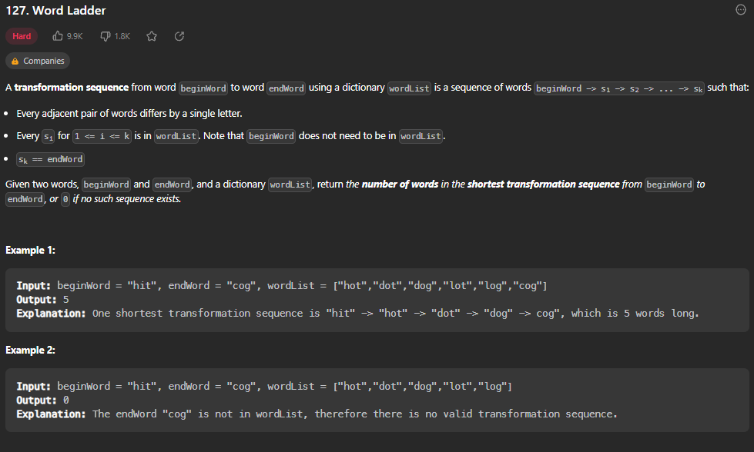

def ladderLength(self, beginWord: str, endWord: str, wordList: List[str]) -> int:

        if endWord not in wordList:

            return 0

        neighbors = collections.defaultdict(list) # when adding to a dictory, default is empty list

        wordList.append(beginWord)

        for word in wordList:

            for j in range(len(word)):

                pattern = word[:j] + "*" + word[j+1:]

                neighbors[pattern].append(word)

        visit = set([beginWord])

        q = deque([beginWord])

        res = 1 # start at 1 because of begin word

        while q:

            for i in range(len(q)):

                word = q.popleft()

                if word == endWord:

                    return res

                for j in range(len(word)):

                    pattern = word[:j] + "*" + word[j+1:]

                    for neighborWord in neighbors[pattern]:

                        if neighborWord not in visit:

                            visit.add(neighborWord)

                            q.append(neighborWord)

            res += 1

        return 0

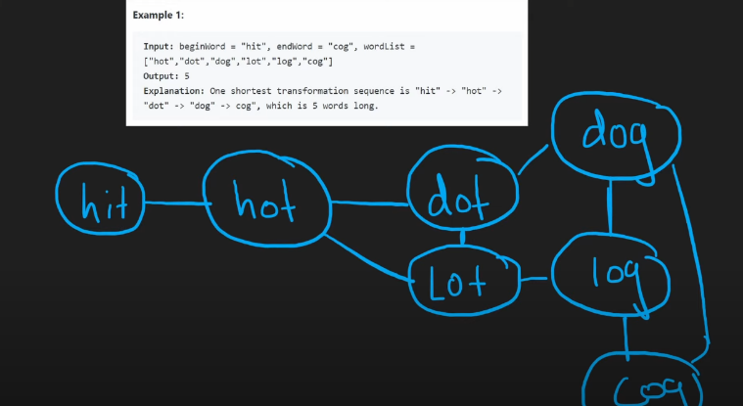

If endWord is not in wordList, return 0. Now, create a dictionary to keep track of neighbor words. Add the beginning word to the wordList given. Now, for each word in wordList, go through each possible pattern (*ot, h*t, ho* for hot) and add the pattern to the neighbors dictionary as key with the word as the value. Now, create a visited set and a q, each with the beginning word at start. Set result to 1. Now while the q is not empty, for each word in the q, popleft from q and if word == endWord, return the result. Otherwise, for each word, find the pattern again and for each neighborWord, if it not in visit set, add it and append it to the q. Increment result by 1. Return 0 if you get to end of q and haven’t found a possibly path.

**DYNAMIC PROGRAMMING**

* DYNAMIC PROGRAMMING CAN BE USED TO CUT OUT REPEATED WORK OF RECURSIVE PROBLEMS

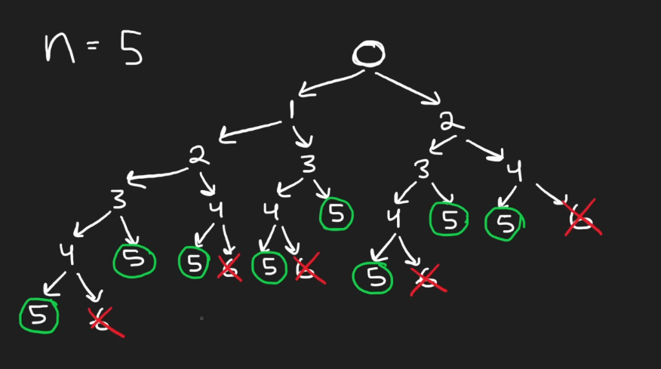

NOTE: In brute force approach above (reaching top step when you can climb 1 or 2 steps each time), you repeat a lot of work because every you are at a certain number, 4 for example, it has the same outcomes regardless of what came before it.

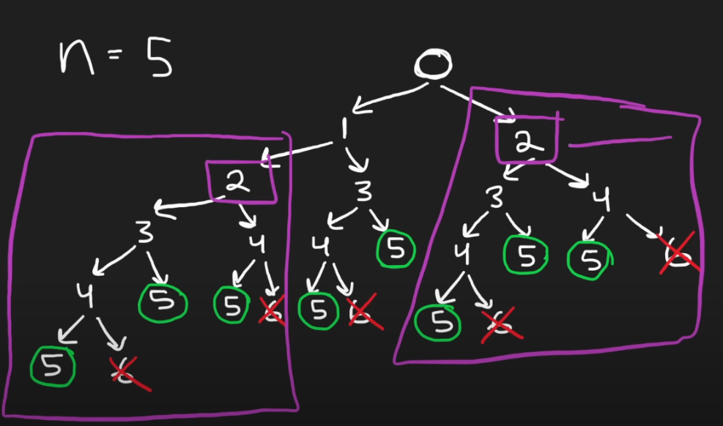

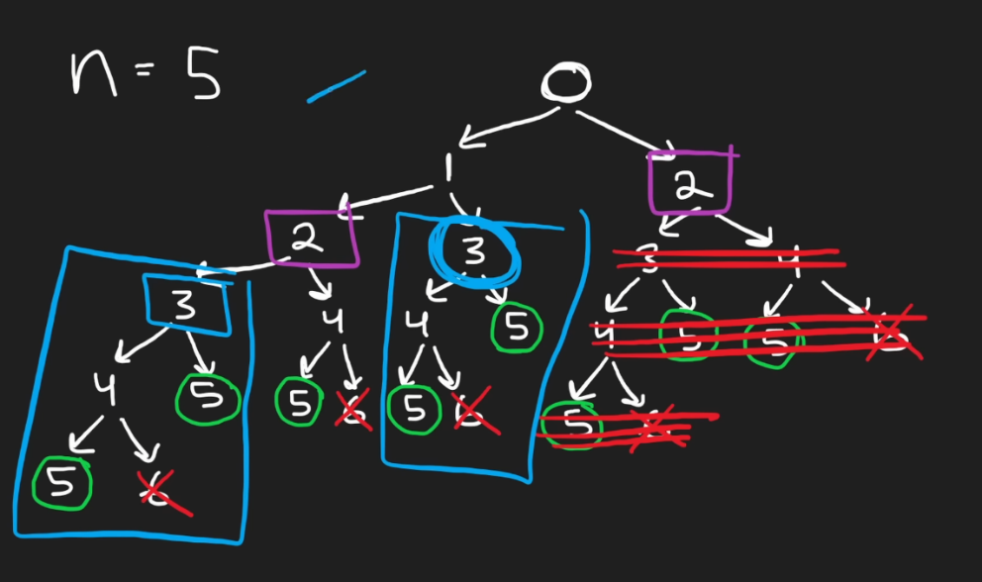

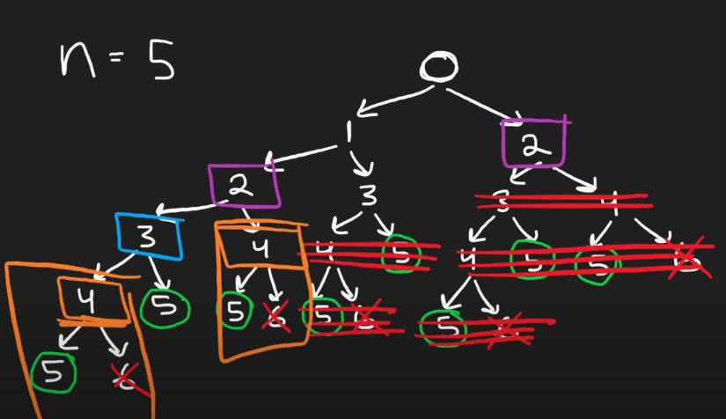

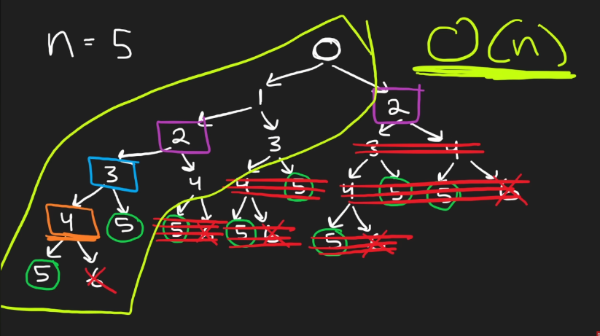

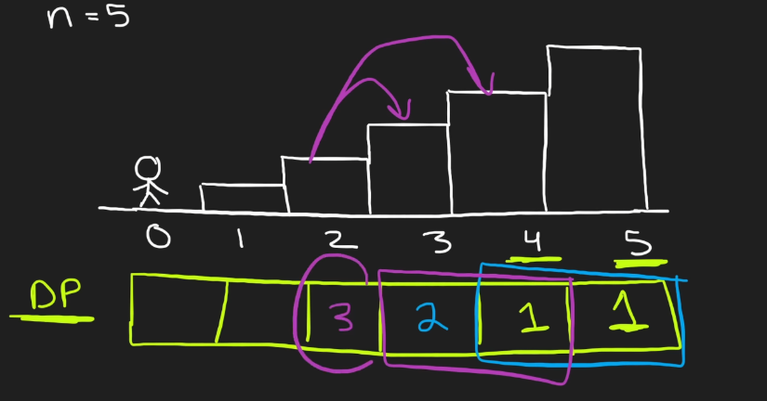

Ends up being O(n) because you are only solving each solution once, and storing it in memory/cache (MEMOIZATION). Use Bottom Up Dynamic Programming Solution starting at the 5 in this example (base case).

**Climbing Stairs**

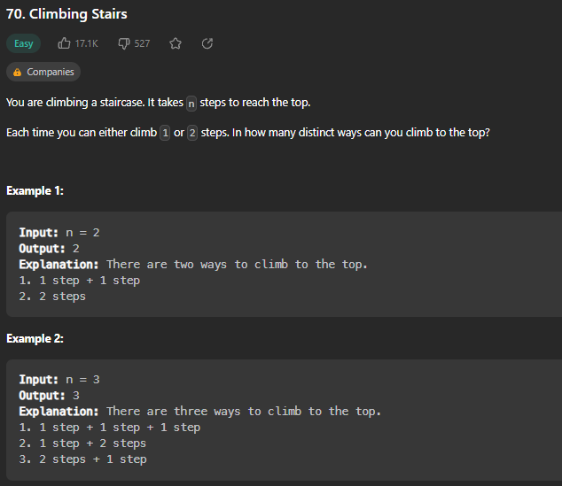

def climbStairs(self, n: int) -> int:

        one, two = 1, 1

        for i in range(n-1):

            temp = one

            one = one + two

            two = temp

        return one

Don’t even need a full array in memory like the last picture on previous page, only need to keep track of the last two numbers. Set each one to 1 at the start, because from last step there is 1 way you can step, and from the second to last step there is only 1 way you can step. Then, for each I in range n-1, store the first step (one) in a temp variable, update one to be one + 2, and then set two to the temp. At the end you will have result.

**Min Cost Climbing Stairs**

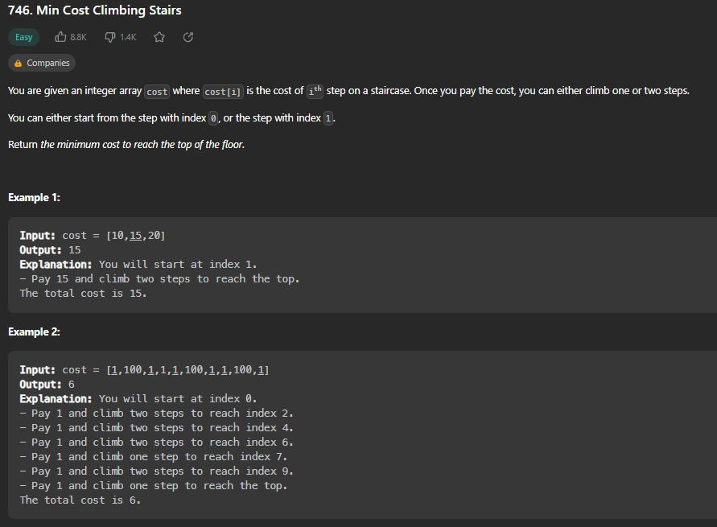

def minCostClimbingStairs(self, cost: List[int]) -> int:

        cost.append(0) # just add 0 to end of array to make math easier

        for i in range(len(cost) -3, -1, -1): # iterate starting at -1, by -1 each iteration

            cost[i] += min(cost[i+1], cost[i+2])

        return min(cost[0], cost[1])

Append a 0 to end of cost array. Then, for i in range(len(cost)-3), starting at -1 (last element in array) and decrementing by 1 each time, update cost[i] to be the minimum of the cost of the two steps after it. At the end, return the minimum of cost[0] and cost[1].

**House Robber**

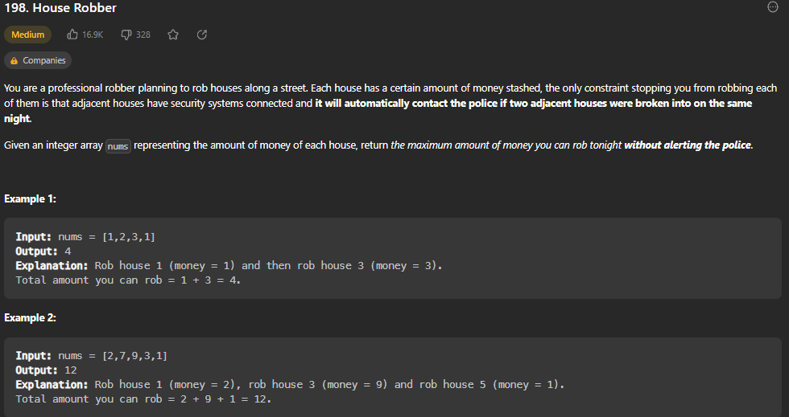

def rob(self, nums: List[int]) -> int:

        rob1, rob2 = 0, 0

        # [rob1, rob2, n, n+1, ...]

        for n in nums:

            temp = max(n+rob1, rob2)

            rob1 = rob2

            rob2 = temp

        return rob2

Declare rob1 and rob2 values and set them to 0. Then, for each n in nums, store the max of n+rob1(house that was robbed previously plus current n) and rob2 (house next to n) in a temp value. Then, update rob1 to rob2, and rob2 to temp to move along line. Return rob2 because at end of array that will be max of entire array.

**House Robber II**

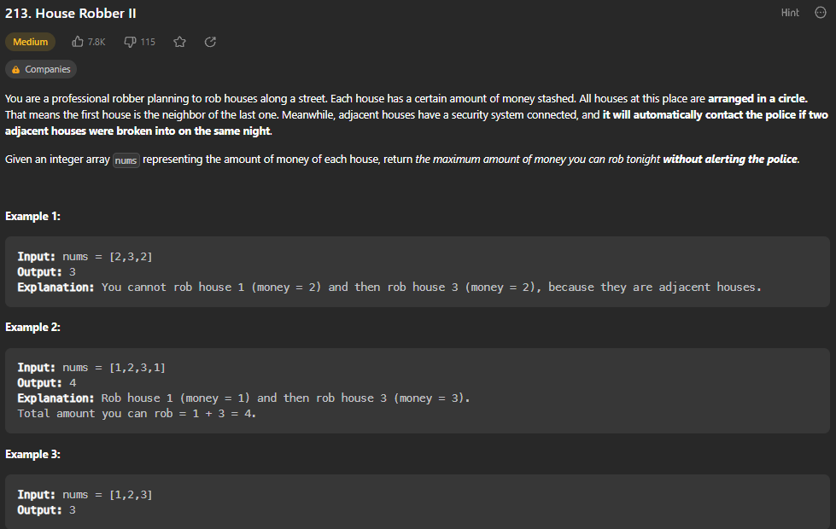

def rob(self, nums: List[int]) -> int:

        if len(nums) <= 3:

            return max(nums)

        return max(self.houseRobber1(nums[1:]), self.houseRobber1(nums[:-1]))

    def houseRobber1(self, nums: List[int]) -> int:

        rob1, rob2 = 0, 0

        # [rob1, rob2, n, n+1, ...]

        for n in nums:

            temp = max(n+rob1, rob2)

            rob1 = rob2

            rob2 = temp

        return rob2

If there are 3 or less houses, return the maximum value of the array because you can only rob one house. Then, run houseRobber1 once on the subarray that ignores first element in array and again on subarray that ignores the last element in array, because there should now be considered adjacent. Return the max of the two.

**Longest Palindromic Substring**

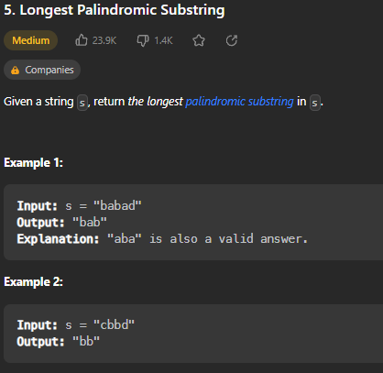

def longestPalindrome(self, s: str) -> str:

        result = ""

        resultLen = 0

        for i in range(len(s)):

            # odd length

            l, r = i, i

            while l >= 0 and r < len(s) and s[l] == s[r]:

                if (r - l + 1) > resultLen:

                    result = s[l:r+1]

                    resultLen = r - l + 1

                l -= 1

                r += 1

            # even length

            l, r = i, i+1

            while l >= 0 and r < len(s) and s[l] == s[r]:

                if (r - l + 1) > resultLen:

                    result = s[l:r+1]

                    resultLen = r - l + 1

                l -= 1

                r += 1

        return result

Create an empty result string and resultLen value. For each character in the input string, start at that character and find the longest palindrome going outward using that character as the center. Need two cases for whether palindrome being tested is odd or even length. Return result.

**Palindromic Substrings**

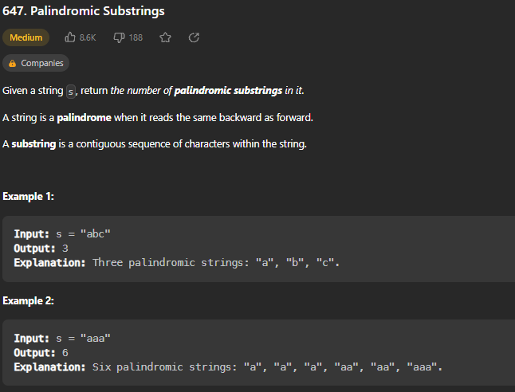

def countSubstrings(self, s: str) -> int:

        output = 0

        for i in range(len(s)):

            # odd length

            l, r = i, i

            while l >= 0 and r < len(s) and s[l] == s[r]:

                output += 1

                l -= 1

                r += 1

            # even length

            l, r = i, i+1

            while l >= 0 and r < len(s) and s[l] == s[r]:

                output += 1

                l -= 1

                r += 1

        return output

Same as previous problem “Longest Palindromic Substring” but instead of storing the longest palindrome, just update the counter by 1 each step.

**Decode Ways**

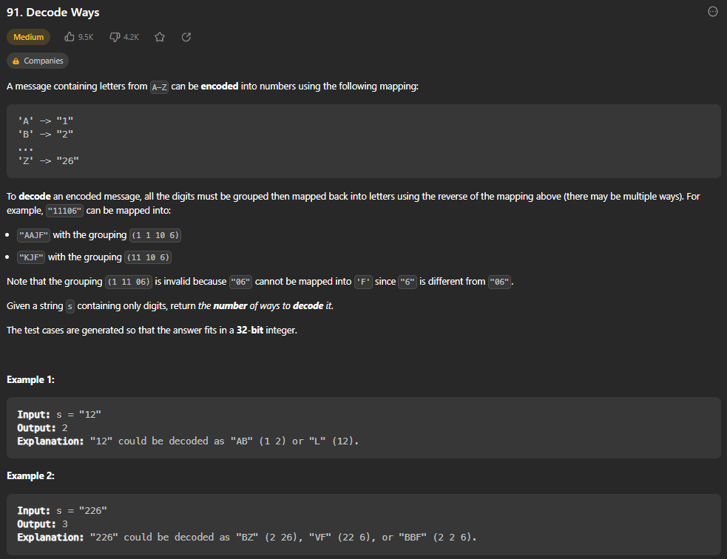

def numDecodings(self, s: str) -> int:

        dp = {len(s) : 1}

        def dfs(i):

            if i in dp:

                return dp[i]

            if s[i] == "0":

                return 0

            res = dfs(i + 1)

            if (i+1 < len(s) and (s[i] == "1" or s[i] == "2" and s[i+1] in "0123456")):

                res += dfs(i+2)

            dp[i] = res

            return res

        return dfs(0)

Create a cache called dp and store the len of s as a key with 1 as the value. Create a recursive dfs function that takes in I and returns the amount of combinations possible at that index, depending on what whether next element in string is. Start by calling dfs on i=0. HAD TROUBLE UNDERSTANDING STEPS. REVIEW.

**Coin Change**

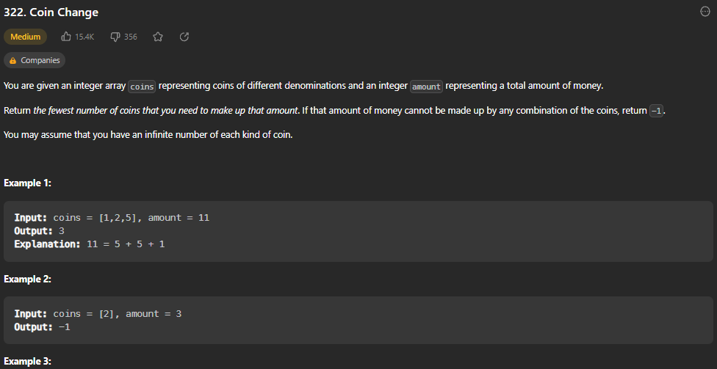

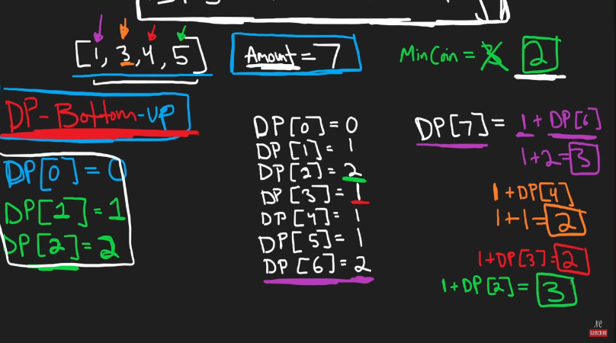

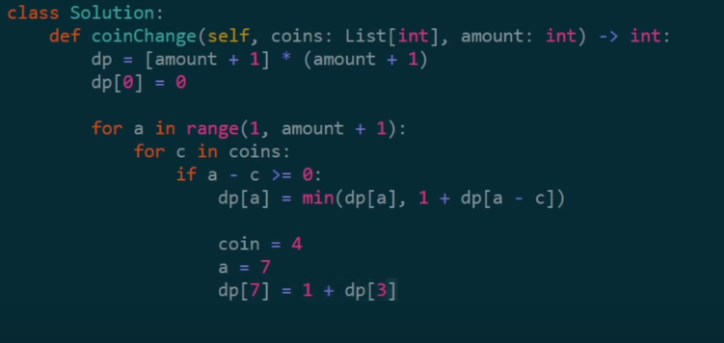

def coinChange(self, coins: List[int], amount: int) -> int:

        dp = [amount + 1] * (amount + 1) # we will go from 0 to amount, just set a max value for all spots in array

        dp[0] = 0 # base case, need 0 coins to get to amount 0

        for a in range(1, amount+1):

            for c in coins:

                if a-c >= 0:

                    dp[a] = min(dp[a], 1+dp[a-c]) # recurrence relation

        return dp[amount] if dp[amount] != amount + 1 else -1 # if its not default value, else -1 bc no solution

        # time - O(amount * len(coins))

        # memory - O(amount)

Create an array the size of amount + 1 and make each value be equal to amount + 1 as a base max value. Set dp[0] to 0 as a base case, because it takes 0 coins to get to amount 0. Then, for each amount in range(1, amount+1), for each coin in coins, if a-c >= 0, dp[a] is equal to the minimum of dp[a] (base value) and 1+dp[a-c]. (coding example picture for coin = 4, a = 7. Return the dp[amount] if it is not default amount+1 value, otherwise -1.

**Maximum Product Subarray**

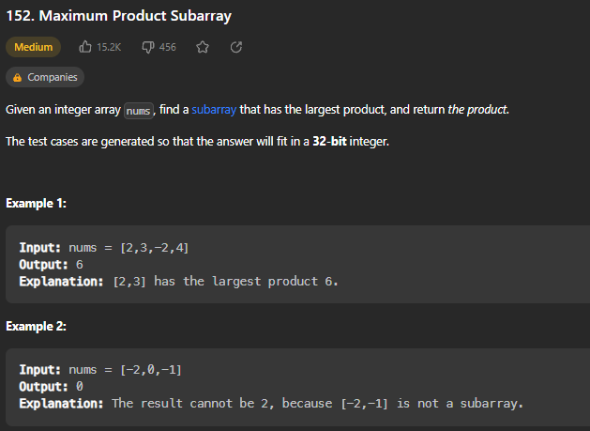

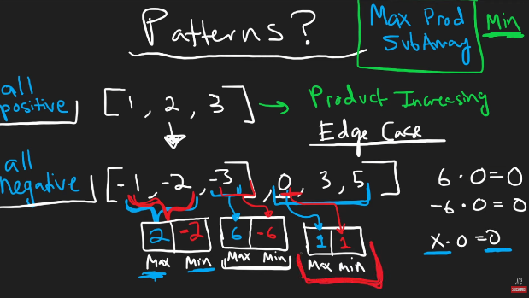

def maxProduct(self, nums: List[int]) -> int:

        res = max(nums)

        curMin, curMax = 1, 1

        for n in nums:

            temp = curMax * n

            curMax = max(n * curMax, n * curMin, n)

            curMin = min(temp, n * curMin, n)

            res = max(res, curMax)

        return res

Set a result value to be the max of input array. Then, set curMin and curMax to 1. For each n in nums, store the new curMax * n in temp. Then set the curMax to be the max of n * curMax, n * curMin, and n. (This covers all possibilities of n being negative or positive. Do the same with temp. Update res to be the max of current res and curMax. Return res at the end. Example on paper.

**Word Break**

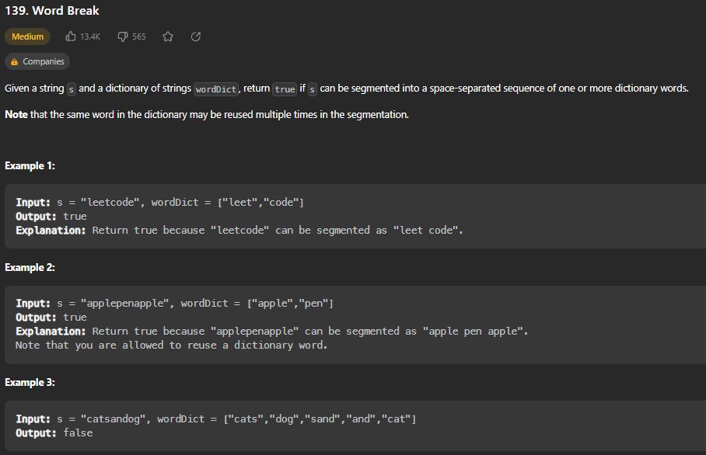

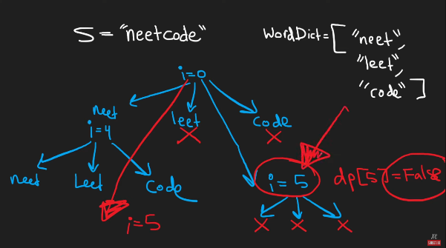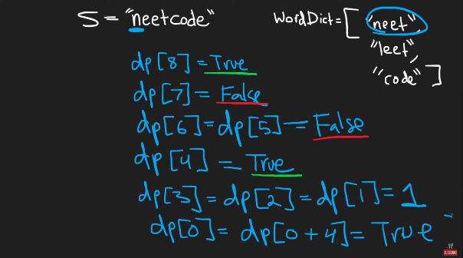

def wordBreak(self, s: str, wordDict: List[str]) -> bool:

        dp = [False] * (len(s) + 1)

        dp[len(s)] = True # base case

        for i in range(len(s) -1, -1, -1):

            for w in wordDict:

                if (i + len(w)) <= len(s) and s[i : i + len(w)] == w:

                    dp[i] = dp[i + len(w)]

                if dp[i]:

                    break # if you find one way, you dont have to keep going at this spot

        return dp[0]

Create an 1D array to store cache and set each value to False. Then, set the base case dp[len(s)] to be True. Now, for each index in range of len(s), starting at the end and decrementing by 1 each time (Bottom Up Dynamic Programming Approach), for each word in wordDict, see if that word matches the substring of s starting at each respective I position. If it does, update dp[i] to dp[i + len(w)]. Because we are working backwards and have already set dp[len(s)] to True as base case, this will set dp[i] to True the first time it finds a match. If dp[i] is True after this, we break because we do not need to continue at this i. Return dp[0] which will be where the final answer is stored at the end of for loop.

**Longest Increasing Subsequence**

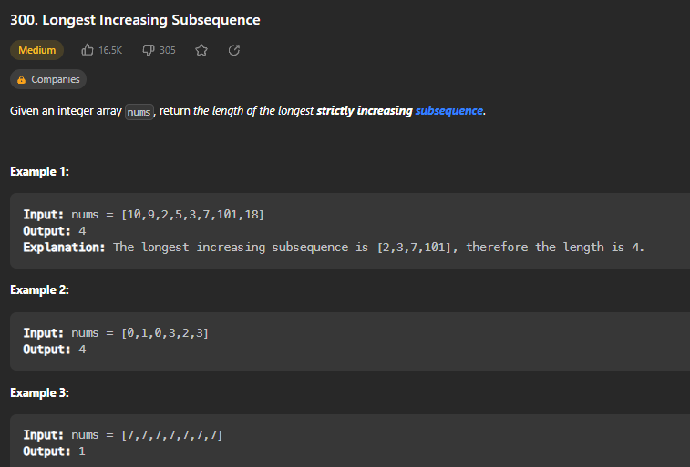

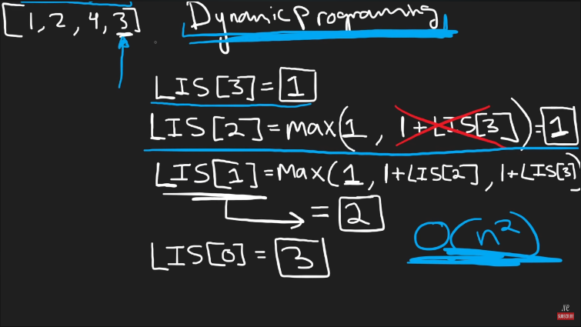

def lengthOfLIS(self, nums: List[int]) -> int:

        dp = [1] * len(nums)

        for i in range(len(nums) -1, -1, -1):

            for j in range(i + 1, len(nums)):

                if nums[i] < nums[j]:

                    dp[i] = max(dp[i], 1 + dp[j])

        return max(dp)

Create a cache array the length of nums and set each value to 1. Then, for each index in nums working backwards from the end, for each j in range of the value after I (i+1) until the end of nums (len(nums)), if nums[i] < nums[j], set dp[i] to be the max of itself and 1 + dp[j] (1 plus the longest increasing subsequence after it, if i can be added to beginning of it. Return the max of the cache list dp.

**Partition Equal Subset Sum**

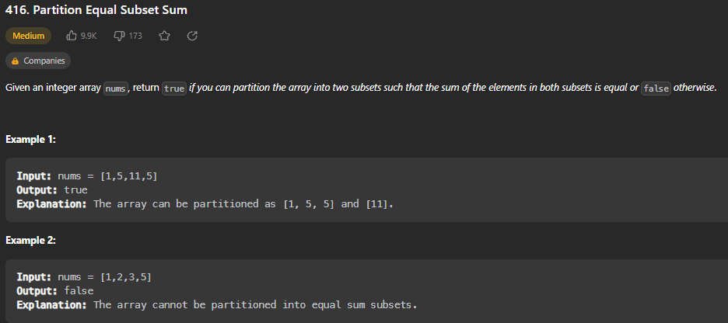

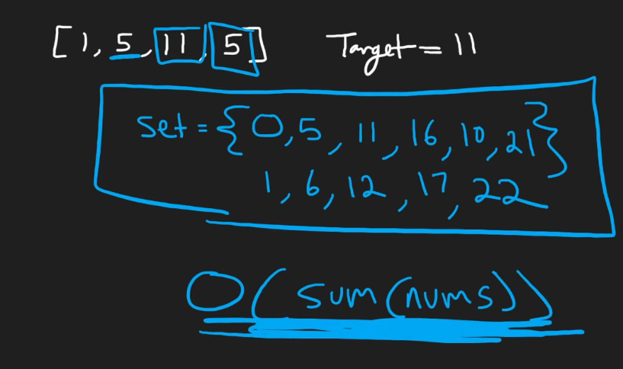

def canPartition(self, nums: List[int]) -> bool:

        if sum(nums) % 2:

            return False # if sum of nums is odd, can't create two equal subsets

        dp = set()

        dp.add(0)

        target = sum(nums) // 2

        for i in range(len(nums)-1, -1, -1):

            nextdp = set()

            for t in dp:

                if (t + nums[i]) == target:

                    return True

                nextdp.add(t + nums[i])

                nextdp.add(t)

            dp = nextdp

        return True if target in dp else False

Create a set called dp to store all of the possible sums. Add 0 to the set. Store target as half of the sum of nums. Then, for each index in range of nums, create a second set called nextdp. Then, for each t in dp, if t + nums[i] == target (starting as 0 + last value in nums, and work backwards), return True. Otherwise, add t+nums[i] to the new set nextdp, as well as t itself (duplicating dp in a sense). At the end, set dp = nextdp. This will give you a set of all possible sums of subsequences. Return True if target is in dp otherwise False.

**Unique Paths**

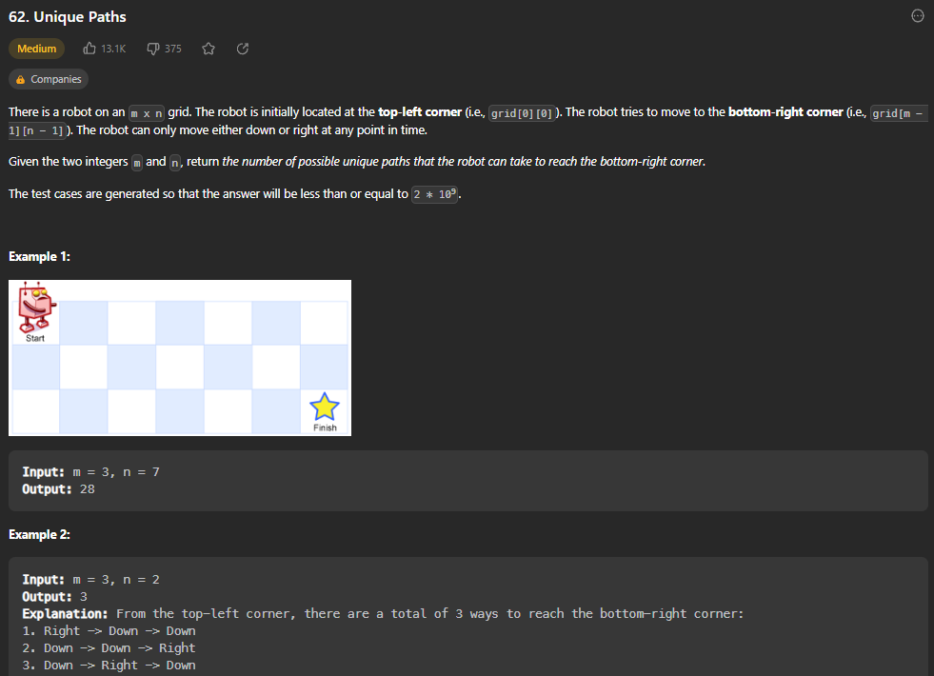

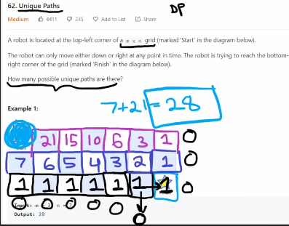

def uniquePaths(self, m: int, n: int) -> int:

        row = [1] * n

        for i in range(m-1):

            newRow = [1] * n

            for j in range(n-2, -1, -1):

                newRow[j] = newRow[j+1] + row[j]

            row = newRow

        return row[0]

Because you can only move down or to the right, the last row and column are automatically 1 as base case. Each other box is the sum of the box below and to the right of it. Start by initializing a row of [1] * n. Then, for i in range(m-1), (each row), create a newRow = [1] * n, and then for each j in range (n-2, -1, -1) (starting at the second to last box in each row (ignore last one because it is edge case of 1) and working backwards, update this newRow[j] to be newRow[j+1] (right value) + row[j] (down value). At the end of each, update row = newRow. (Don’t actually need to store entire grid in memory, only care about the top row at the end. Return row[0].

**Longest Common Subsequence \*\***

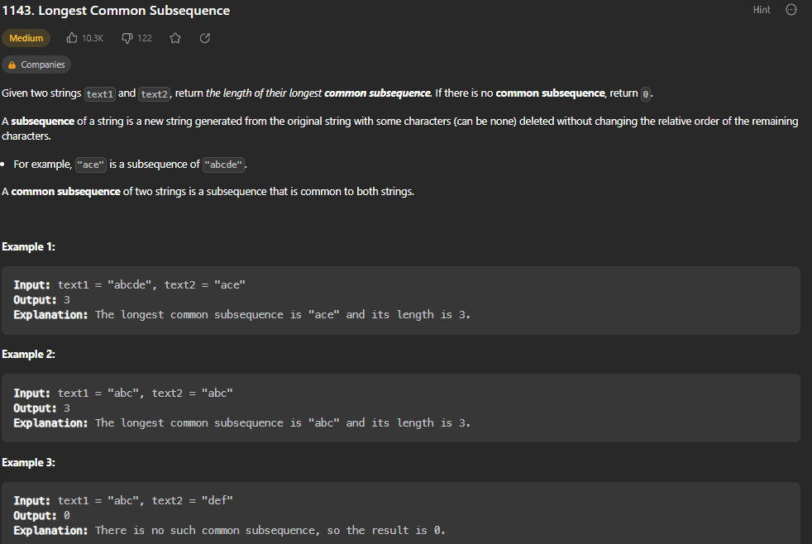

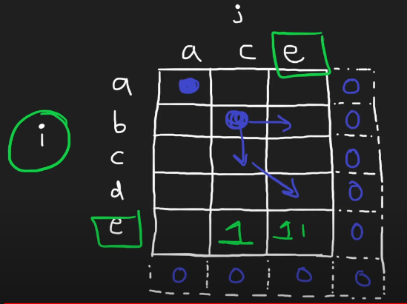

def longestCommonSubsequence(self, text1: str, text2: str) -> int:

        dp = [[0 for j in range(len(text2)+1)] for i in range(len(text1)+1)]

        for i in range(len(text1)-1, -1, -1):

            for j in range(len(text2)-1, -1, -1):

                if text1[i] == text2[j]:

                    dp[i][j] = 1 + dp[i+1][j+1]

                else:

                    dp[i][j] = max(dp[i][j+1], dp[i+1][j])

        return dp[0][0]

Create a 2D array called DP with the length of text2 being number of columns and length of text1 being number of rows. Then, for each row starting at bottom and working your way up, if text1[i] == text2[i], set dp[i][j] to 1 + do[i+1][j+1] (the diagonal value down and to right), otherwise, set it to the max of dp[i][j+1] and dp[i+1][j] (max of value to right and value below). Return dp[0][0] at the end of bottom-up formula.

**Best Time to Buy and Sell Stock with Cooldown**

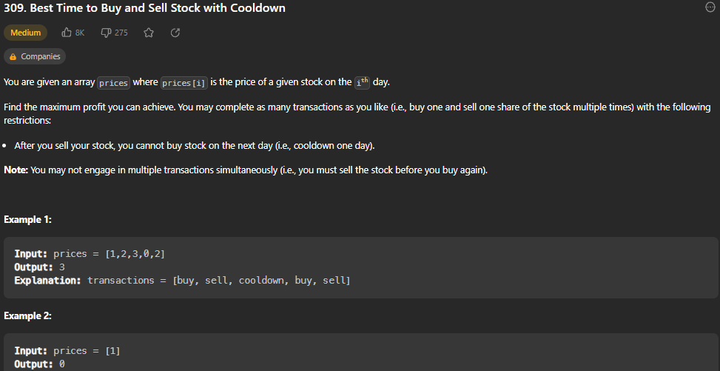

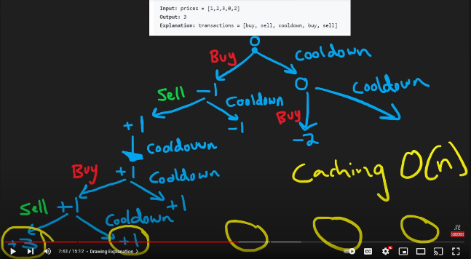

def maxProfit(self, prices: List[int]) -> int:

        dp = {} #key=(i, buying) val=maxProfit

        def dfs(i, buying):

            if i >= len(prices):

                return 0

            if (i, buying) in dp:

                return dp[(i, buying)]

            if buying:

                buy = dfs(i + 1, not buying) - prices[i] # if buying, want to not buy the next day

                cooldown = dfs(i+1, buying)

                dp[(i, buying)] = max(buy, cooldown)

            else:

                sell = dfs(i + 2, not buying) + prices[i] # i + 2 because we have to take cooldown day

                cooldown = dfs(i+1, buying)

                dp[(i, buying)] = max(sell, cooldown)

            return dp[(i, buying)]

        return dfs(0, True)

Create a cache (hashmap) called dp that will store a tuple (i, buying) as key and maxProfit as value. Define a recursive dfs function that takes in current i and buying Boolean. Set the base cases as if i>=len(prices) (out of bounds), return 0 and if (i, buying) is already in dp cache, return that value (avoids extra work bc of dynamic programming). If buying status is true, buy = dfs of i+1 (next day) and flip the buying boolean, minus the prices[i] of that day. Cooldown would be skipping buy, so run dfs on the next day with buying Boolean unchanged. If not buying, do the same except sell = dfs(i+2, not buying) + prices[i] (skip 2 days because of cooldown, add prices[i] because you are profiting by selling). Update dp[(I, buying)] at that day to be the max of sell and cooldown. At end of dfs, return that dp[(i, buying)] value. To begin the problem, run dfs(0, True) for day 0 and wanting to buy because we don’t currently own stock.

**Coin Change II**

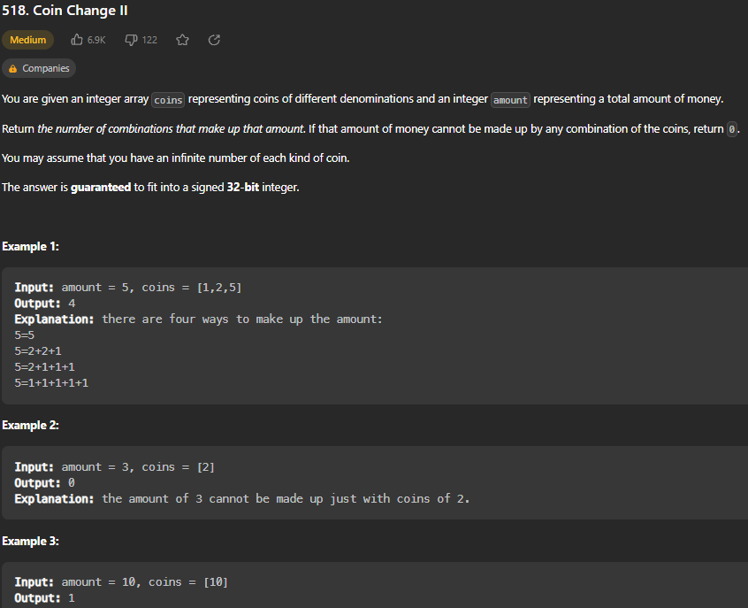

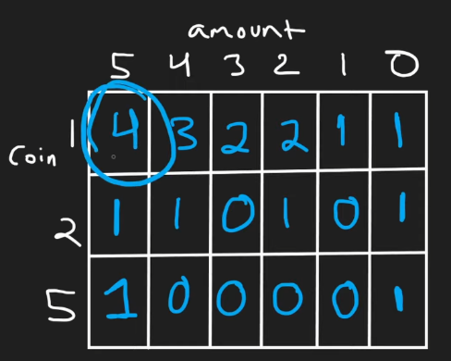

def change(self, amount: int, coins: List[int]) -> int:

        cache = {}

        def dfs(i, a):

            if a == amount:

                return 1

            if a > amount:

                return 0

            if i == len(coins): # we dont have any coins left to try

                return 0

            if (i, a) in cache:

                return cache[(i,a)] # memoization dynamic programming to avoid repeated work

            cache[(i, a)] = dfs(i, a+coins[i]) + dfs(i+1, a) # recursive case

            return cache[(i, a)]

        return dfs(0,0)

Memoization version that is least efficient. Create a cache (hashmap). Define a recursive dfs that takes in i and a. if a == amount, return 1. If a > amount, return 0. If i=len(couns): return 0. If (i,a) in cache, return that value from cache (memoization). Update the cache[(i, a)] to be dfs(I, a+coins[i]) + dfs(i+1, a) and return cache[(i,a)]. This version is O(m*n) time complexity.

def change(self, amount: int, coins: List[int]) -> int:

        dp = [[0] * (len(coins) + 1) for i in range(amount+1)]

        dp[0] = [1] * (len(coins) + 1)

        for a in range(1, amount+1):

            for i in range(len(coins)-1, -1, -1):

                dp[a][i] = dp[a][i+1]

                if a - coins[i] >= 0:

                    dp[a][i] += dp[a - coins[i]][i]

        return dp[amount][0]

Create a 2D array like the drawing on page before. Number of rows is len(coins)+1 and number of columns is amount+1, valued from 0 to amount+1. Then, for a in range(1, amount+1), for I in range(len(coins)-1, -1, -1) (working backwards), dp[a][i] = dp[a][i+1]. If a- coins[i] >= 0, dp[a][i] += dp[a-coins[i]][i]. Return dp[amount][0]. Memory complexity is O(n*m)

def change(self, amount: int, coins: List[int]) -> int:

        dp = [0] * (amount+1)

        dp[0] = 1

        for i in range(len(coins)-1, -1, -1):

            nextDP = [0] * (amount + 1)

            nextDP[0] = 1

            for a in range(1, amount+1):

                nextDP[a] = dp[a]

                if a - coins[i] >= 0:

                    nextDP[a] += nextDP[a-coins[i]]

            dp = nextDP

        return dp[amount]

Same concept as solution above, except there is no reason to store an entire 2D array in memory, as you work from bottom up and the only important value at end is dp[0][0]. Therefore, only need to store one dp row and a next row, and continually update dp = nextDP as you move up. Return dp[amount] at the end.

**Target Sum**

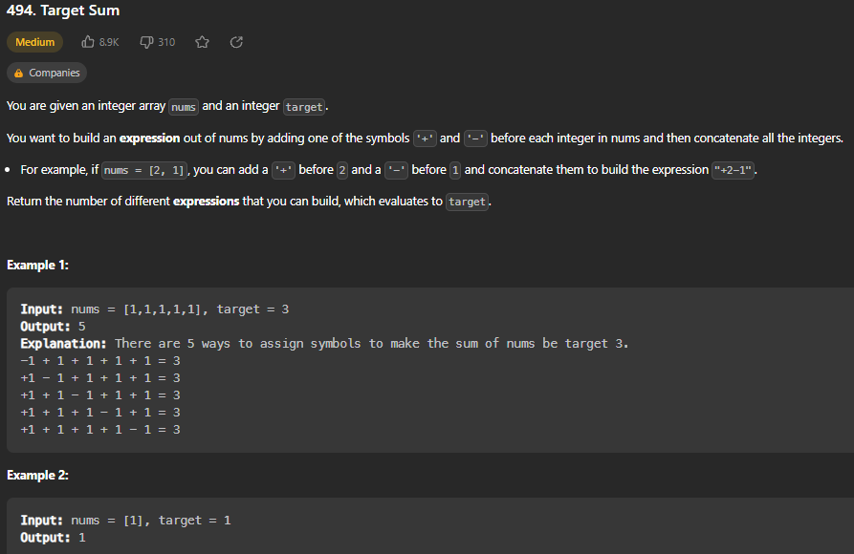

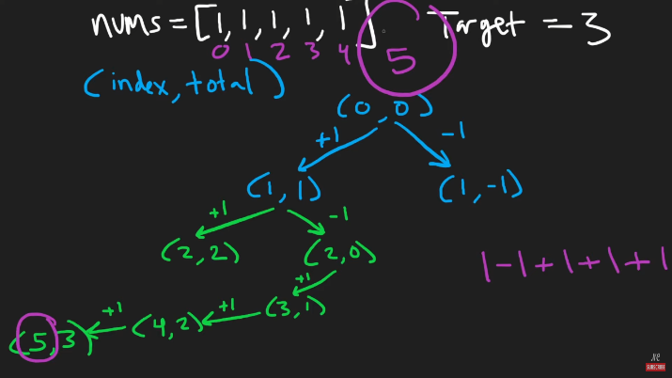

def findTargetSumWays(self, nums: List[int], target: int) -> int:

        dp = {} # (index, total) -> number of ways we can reach target value if we start at this index/value

        def backtrack(i, total):

            if i == len(nums):

                return 1 if total == target else 0

            if (i, total) in dp:

                return dp[(i, total)]

            dp[(i, total)] = (backtrack(i+1, total + nums[i]) + backtrack(i+1, total - nums[i]))

            # This will tell us the number of ways starting at index i with this total we can sum up to target

            return dp[(i, total)]

        return backtrack(0, 0)

Create a cache (hashmap) called dp that will store a tuple (i, total) as key and the number of ways we can reach target value if we start at this index/value as value. Define a recursive backtrack function that takes in current i and total. Set the base cases as if i == len(nums) (out of bounds), return 1 and if (i, total) is already in dp cache, return that value (avoids extra work bc of dynamic programming). Update the cache at (i, total) to be the result of backtrack(i+1, total + nums[i]) + backtrack(i+1, total – nums[i]) – This will tell us number of ways starting at index I with this total can sum to target by either adding or subtracting. Return dp[(i, total)] in backtrack function. To begin algorithm, return backtrack(0,0) for starting position and 0.

**Interleaving String**

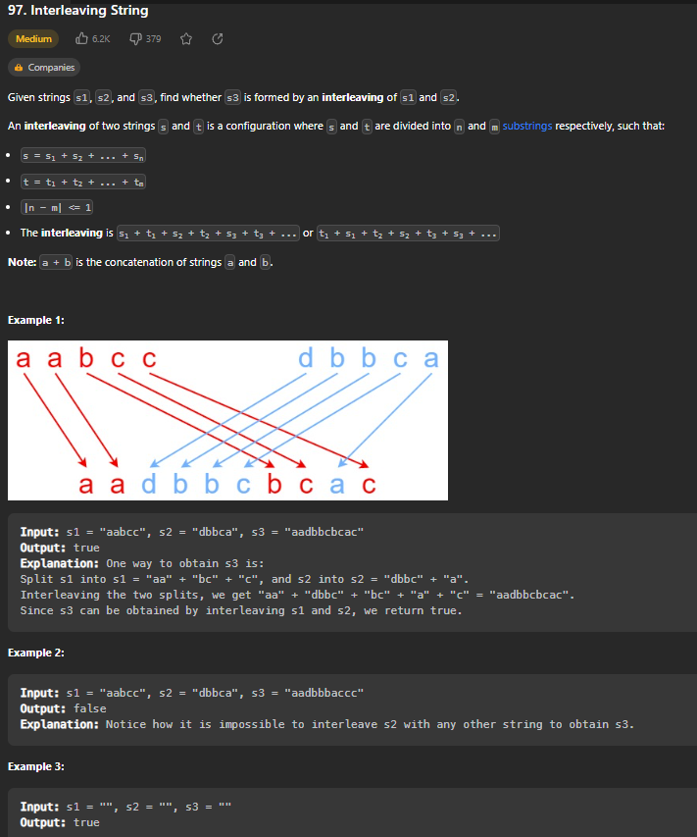

Create a cache (hashmap) called dp that will store a tuple (i, total) as key and the number of ways we can reach target value if we start at this index/value as value. Define a recursive backtrack function that takes in current i and total. Set the base cases as if i == len(nums) (out of bounds), return 1 and if (i, total) is already in dp cache, return that value (avoids extra work bc of dynamic programming). Update the cache at (i, total) to be the result of backtrack(i+1, total + nums[i]) + backtrack(i+1, total – nums[i]) – This will tell us number of ways starting at index I with this total can sum to target by either adding or subtracting. Return dp[(i, total)] in backtrack function. To begin algorithm, return backtrack(0,0) for starting position and 0.